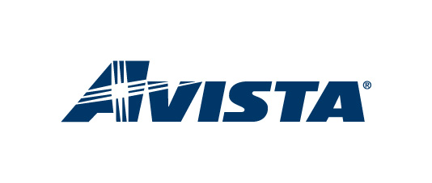
UPDATED: February 10, 2011 (KLD)

Avista is currently in the process of updating registries in the Western Interchange Tool (“WIT”), and paths and postings in its OATI WebTrans and WebOASIS systems to meet compliance with FERC Orders 676 and 729.
Order 676 incorporates NAESB Business Practices V2.1, which requires Transmission Providers to list folders and documents on OASIS in a certain order and manner. Avista will be updating its document folders and document postings on the left side of its OASIS page from February 9, 2011 through April 1, 2011. During that time, additional folders and files may be posted.
Order 729 adopts the MOD Standards, and requires that Transmission Providers be compliant by April 1, 2011. In order to become compliant with the applicable MOD Standards, Avista has begun the process of reorganizing and restricting its paths, most notably its interchanges with the Bonneville Power Administration. Accordingly, the current interchange points with BPA at Hatwai, BellWestside, Benton and AddyKettle will be combined into one single point, BPA.AVAT. To accomplish this change, you will see adjustments to the WIT registry between now and March 1, 2011. During the month of March, all four existing BPA points will remain enabled, and the new BPA.AVAT point will also be available. Customers will be able to purchase monthly transmission only on the BPA.AVAT point starting March 1, 2011 for service taken April 1, 2011 and beyond.
If you have any questions, don’t hesitate to contact Kenneth Dillon at (509) 495-4436 or the Transmission Preschedulers.

