NorthWestern Energy Transmission Advisory Committee
Thursday, October 24, 2013
NorthWestern Energy Building – 1st Floor Conference Room
9 West Granite - Butte, Montana
9:30 a.m. – 12:00 p.m. (Mountain time)
Note that the time allocated for each item is approximate and subject to change.

Phone Conference: 1-(877) 820-7831 access code 178140
GoTo meeting: https://www1.gotomeeting.com/join/269262472
Meeting ID: 269-262-472

TRANSAC Meeting Agenda

9:30 a.m. Welcome and Introductions

9:35 a.m. Administration
- Anti-Trust & Standards of Conduct (Kathy Bauer)
- Review Meeting Agenda (Gerald Mueller)
- Accept July 26th Meeting Summary (Gerald Mueller)
- Action Item List Update (Kathy Bauer - none)
- WECC L&R Data Request (Cathy Mathews)
- Compliance Efforts (Cathy Mathews)
- Generation Interconnection Update (Corinne Osborne)

10:00 a.m. Regional & Bulk Electric System Updates (John Leland)
- FERC Order 1000 Interregional Filing
  - Changes to Attachment K
- Biennial Plan Update – Document being drafted and reviewed

10:15 a.m. Local Area Plan
- Local Area Economic Studies Update (Kim McClafferty
- Public Meetings Update (Don Bauer)
- Draft Local Area Plan Document (Kathy Bauer)

11:55 a.m. Action Item List Review

11:59 a.m. Suggested Future Meeting dates:
Thursday, December 12, 2013 – Distribution of Local Area Plan Document, Report on completed Economic Studies, discussion of what needs to happen in Quarter 1 of the 2014-2015 Local Area Planning Cycle.

12:00 p.m. Adjourn

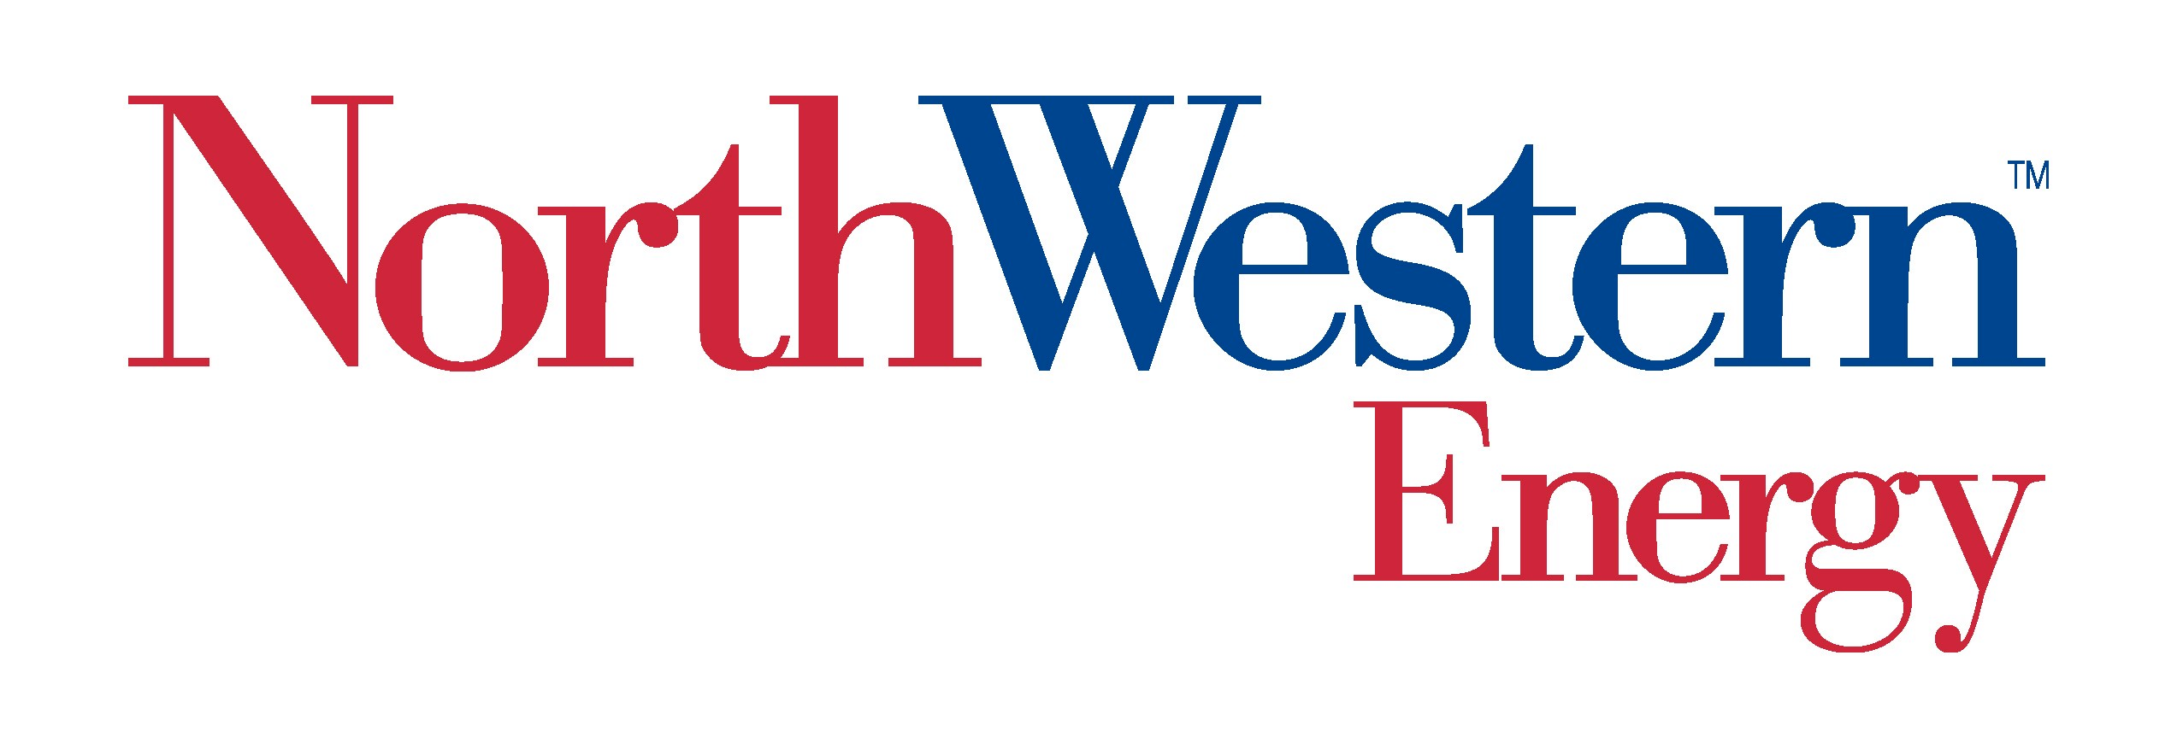

Transmission Advisory Committee (TRANSAC)

Antitrust Policy

The Antitrust Policy of the Transmission Advisory Committee (TRANSAC) is as set forth below and shall be acknowledged at the beginning of every TRANSAC meeting.
It is the policy of TRANSAC to fully comply with federal and state antitrust laws. Participants shall be mindful that an essential objective of TRANSAC is promoting or enhancing competition. Discussions in the following areas in particular can be very problematic and in some cases prohibited, and require careful attention for antitrust compliance:
- your company’s prices for products or services;
- prices charged by your competitors;
- allocating markets, customers, or products;
- limiting production; and
- excluding dealings with other companies.

Transmission Advisory Committee (TRANSAC)

Standards of Conduct Policy and Safeguards

Policy

The membership of the Transmission Advisory Committee (“TRANSAC”) includes individuals who are considered “Transmission Function Employees” or “Undesignated Employees” under the Standards of Conduct for Transmission Providers promulgated by the Federal Energy Regulatory Commission (“Standards of Conduct”). “Transmission Function Employees” with access to non-public Transmission Information have an obligation under the Standards of Conduct not to disclose it, unless they disclose such information to all interested parties via the OASIS. Additionally, Transmission Function employees are expressly prohibited under the Standards of Conduct from disclosing non-public Transmission Information to its Marketing Function employees. “Undesignated Employees” under the Standards of Conduct may have access or knowledge of non-public Transmission Information but may also work with the Market Function Employees of a Transmission Provider. However, “Undesignated” Employees are prohibited from disclosing non-public Transmission Information or acting as a conduit for non public transmission information to flow from the Transmission Function Employees to its Marketing Function. FERC has the authority to impose significant financial sanctions for violations of the Standards of Conduct. As such, it is the policy of the TRANSAC to conduct its business in a manner consistent with the Standards of Conduct.
Therefore, it is the policy of the TRANSAC to conduct its business in accordance with the following principles:
- At the outset of TRANSAC meetings the Standards of Conduct shall be acknowledged and participants shall be reminded of the obligations of Transmission Function Employees, Undesignated Employees, and Market Function Employees under the terms of the Standards of Conduct.

- If during the course of the TRANSAC’s work it becomes necessary for a Transmission Provider’s Transmission Function Employees and Market Function Employees to participate in a joint meeting in the context of a TRANSAC meeting, it is the expectation that the Transmission Provider will comport itself with the Standards of Conduct and any internal policy that may have been adopted by their respective organization implementing the Standards of Conduct. When a Joint Meeting arises within the context of a TRANSAC meeting, the Transmission Provider should consider:

  - whether advance notice of a public meeting needs to be posted on its OASIS. If so, such a posting should be made at least 10 days prior to the meeting.
  - whether All “Eligible Customers,” as that term is defined in the pro forma OATT, must be invited to attend the public meeting either in person or telephonically.
  - whether any materials circulated at the meeting should be posted on the OASIS.
  - whether meeting notes should be taken and posted on the OASIS during the meeting by an individual approved as the note-taker by the Transmission Provider’s Chief Compliance Officer (“CCO”) or his/her designee.
  - whether the Transmission Provider’s Chief Compliance Officer or designee should participate in the meeting.

