PacifiCorp NERC Reliability Compliance

NERC Standards PRC-006-1 and
WECC Regional Criteria PRC-006-WECC –CRT-1.

UFLS Plan – PacifiCorp Program Details

Document Security Category

Confidential
Restricted
Internal
External (Public)
Critical Infrastructure Information (CII)

Approved File Location: | TBD
File Number-Name: | Tab 10 - UFLS Plan - PacifiCorp Program Details.docx

Approved: J.D. Podlesnik 9/17/2013
Printed Name of Approver Date

Director, Transmission Planning & Capital Investment
Title of Approver

TABLE OF CONTENTS

1. Scope / Program Objectives 3
2. Program 3

1. Scope / Program Objectives
This document describes PacifiCorp's plans for implementing the Under Frequency Load Shedding (UFLS) program to comply with the North American Electric Reliability Corporation ("NERC") Reliability Standards PRC-006-1 and Western Electric Coordinating Council (WECC) Regional Criteria PRC-006-WECC –CRT-1.

Under Frequency Load Shedding Plan – PacifiCorp Program Details
Per the latest WECC Off-Nominal Frequency Load Shedding Plan, PacifiCorp, as a Planning Coordinator, has adopted a combination of Sub Area UFLS plans where the frequency set-points are illustrated in Sub Area WECC Plan E.1a. and Sub Area Northwest Power Pool (NWPP) Plan E.1b. of the WECC Load Shedding Plan. The following information describes the UFLS program that PacifiCorp has developed to follow the WECC Coordinated Plan for its Balancing Authorities.

Click here to enter text.

2. Program
PACE Balancing Authority
PacifiCorp’s PACE Balancing Authority (BA) follows Sub Area WECC Plan E.1a. in which Entities are required to shed their first block of load as soon as frequency has declined to 59.1 Hertz (Hz), with additional minimum requirements for further load shedding steps as set forth in the following table:
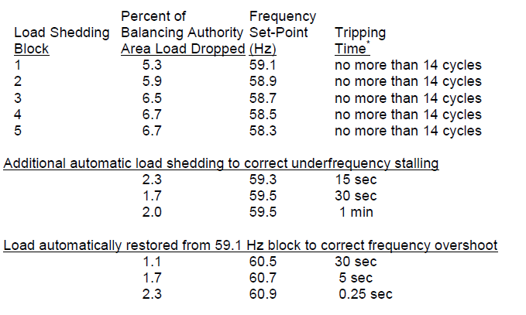
PacifiCorp’s PACE BA has balanced the load dropped per the frequency set-points and load shedding blocks per the Coordinated Plan. PACE BA Entities were notified to establish a frequency set-point of 59.5 Hz with a 1 min delay for their total UFLS obligations (35 % of their peak load). The relays selected must be on radial circuits with less than 1 megawatt of generation. The load dropped per frequency will be evaluated annually to determine a frequency set point for PACE BA Entities as their load increases. The Entities within the PACE BA receive an annual notification and schedule for implementation to meet the requirements of the Sub Area WECC Plan.

PACW Balancing Authority
PacifiCorp’s PACW BA follows Sub Area Northwest Power Pool (NWPP) Plan E.1b. in which Entities participating in the NWPP sub-area are required to shed their first block of load as soon as frequency has declined to 59.3 Hz, with additional minimum requirements for further load shedding steps as set forth in the following table:
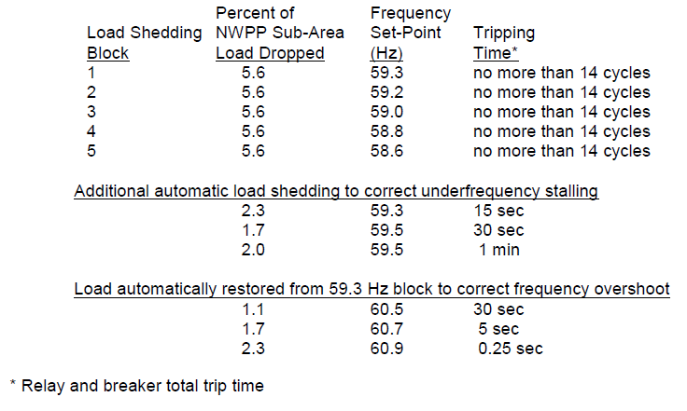

PacifiCorp’s PACW BA has balanced the load dropped per the frequency set-points and load shedding blocks per the Coordinated Plan. PACW BA Entities were notified to establish a frequency set-point of 58.8 Hz within 14 cycles for their total UFLS obligations (35 % of their peak load). The relays selected must be on radial circuits with less than 1 megawatt of generation. The load dropped per frequency will be evaluated annually to determine a frequency set point for PACW BA Entities as their load increases. The Entities within the PACW BA receive an annual notification and schedule for implementation to meet the requirements of the Sub Area NWPP.

