Generating Facility Name: IC- Revision Date:
Interconnection Service Capacity (Maximum Net Export Capability at POI): MW
Gross Generating Facility Capability (at Inverter Terminals): 0.00 MVA (= Item 6.a * Item 6.b)

- Simplified One-Line Diagram. This should be similar to Figure below. If it is different, please mark the difference on the diagram below.

- Interconnection Transmission Line.
Provide either absolute or per unit impedance values.
  - Point of Interconnection (utility substation/line name):
  - Line voltage: kV, line rating at 95°F ambient: MVA, line length
  - R₁ = ohm or pu on 100 MVA and line kV base (positive sequence)
  - X₁ = ohm or pu on 100 MVA and line kV base (positive sequence)
  - B₁ = μF or pu on 100 MVA and line kV base (positive sequence)
  - R₀ = ohm or pu on 100 MVA and line kV base (zero sequence)
  - X₀ = ohm or pu on 100 MVA and line kV base (zero sequence)
  - B₀ = μF or pu on 100 MVA and line kV base (zero sequence)

- Main Transformer. Number of main transformers:
Provide data for either two-winding or three-winding transformer as appropriate.
Two-Winding Main Transformer Data (as applicable):
  - Rating at 95°F ambient (OA/FA/FA): / / MVA
  - Nominal Voltage for each winding (Low/High): / kV
  - Winding Connections (Low/High): /
  - Available tap positions: / / / / kV or % # of taps.
  - Positive sequence impedance Z₁: %, X/R on self-cooled (OA) MVA rating above.
  - Zero sequence impedance Z₀: %, X/R on self-cooled (OA) MVA rating above.
  - For padmount transformer, construction:
Three-Winding Main Transformer Data (if applicable)
  - GSU connection and winding (please attach diagram and mark to reference this form).
 | H Winding Data | X Winding Data | Y Winding Data
Full load ratings at 95°F ambient (OA/FA/FA) | / / MVA | / / MVA | / / MVA
Rated winding voltage base | kV  connected | kV  connected | kV  connected
Tap positions available | / / / / kV | / / / / kV | / / / / kV
Present Tap Setting  (if applicable) | kV | kV | kV
Neutral solidly grounded? (or) Neutral Grounding Resistor (if applicable) | Ohms | Ohms | Ohms
BIL rating | kV | kV | kV
Three-Winding Main Transformer Impendance Data (if applicable)
 | H-X Winding Data | H-Y Winding Data | X-Y Winding Data
Transformer base for impedances provided | MVA | MVA | MVA
Positive sequence impedance Z₁ | % X/R | % X/R | % X/R
Zero sequence impedance Z₀ | % X/R | % X/R | % X/R
Additional Data for either Two-Winding or Three-Winding Main Transformer
  - Air core inductance: pu (From H winding side on MVA Base)
  - No load test results:
    - Rated Voltage of Winding at which current is determined: kV
    - Current at 90% / 100% / 110% of rated voltage: / / A
    - Losses at 90% / 100% / 110% of rated voltage: / / W
  - Provide Rapid Voltage Change (RVC) mitigation strategy on main transformer energization (required if valid air core inductance and no load test data cannot be provided, or if deficiency is identified):
Main Transformer to be energized from the high side with a switching device that is equipped with pre-insertion resistors.
Other mitigation:

- Collector System Equivalent Model.
Provide either absolute or per unit impedance values.
  - Collector system voltage = kV
  - Collector system equivalent model rating at 95°F ambient = MVA
  - R₁ = ohm or pu on 100 MVA and collector kV base (positive sequence)
  - X₁ = ohm or pu on 100 MVA and collector kV base (positive sequence)
  - B₁ = μF or pu on 100 MVA and collector kV base (positive sequence)
  - R₀ = ohm or pu on 100 MVA and collector kV base (zero sequence)
  - X₀ = ohm or pu on 100 MVA and collector kV base (zero sequence)
  - B₀ = μF or pu on 100 MVA and collector kV base (zero sequence)

- Wind-turbine generator (WTG) Step-up Transformers.
Provide data for either two-winding or three-winding transformer as appropriate
  - Number of WTG step-up transformers:
Two-Winding WTG Step-up Transformer Data (if applicable):
  - Nameplate Rating (at 95°F ambient): MVA
  - Maximum Rating (if applicable): MVA
  - Nominal Voltage for each winding (Low/High): / kV
  - Winding Connections (Low/High): /
  - Available taps: / / / / kV or % # of taps.
  - Positive sequence impedance (Z₁) %, X/R on MVA rating above.
  - Zero sequence impedance (Z₀) %, X/R on MVA rating above.

Three-Winding WTG Step-up Transformer Data (if applicable)
  - GSU connection and winding (please attach diagram and mark to reference this form).
 | H Winding Data | X Winding Data | Y Winding Data
Full load ratings at 95°F ambient (OA/FA/FA) | / / MVA | / / MVA | / / MVA
Rated winding voltage base | kV  connected | kV  connected | kV  connected
Tap positions available | / / / / kV | / / / / kV | / / / / kV
Present Tap Setting  (if applicable) | kV | kV | kV
Neutral solidly grounded? (or) Neutral Grounding Resistor (if applicable) | Ohms | Ohms | Ohms
BIL rating | kV | kV | kV
Three-Winding WTG Step-up Transformer Impendance Data (if applicable)
 | H-X Winding Data | H-Y Winding Data | X-Y Winding Data
Transformer base for impedances provided | MVA | MVA | MVA
Positive sequence impedance Z₁ | % X/R | % X/R | % X/R
Zero sequence impedance Z₀ | % X/R | % X/R | % X/R

- WTG Module Data.
  - Number of WTGs:
  - Nameplate Rating (each WTG): MW/ MVA
  - Full load rating (each WTG): MVA
Type 1 – Squirrel-cage induction generator
Type 2 – Wound rotor induction machine with variable rotor resistance
Type 3 – Doubly-fed asynchronous generator
Type 4 – Full converter interface

  - WTG Manufacturer and Model:
  - WTG Type:
For Type 1 or Type 2 WTGs:
- Uncompensated power factor at full load:
- Power factor correction capacitors at full load: Mvar
- Complete the Interconnection Request application Induction Generator data section.
For Type 3 or Type 4 WTGs:
- Maximum over-excited power factor at full load: Mvar
- Maximum under-excited power factor at full load: Mvar
- Control mode (e.g., voltage, power factor, or reactive power):

- Plant Reactive Power Compensation (beyond the inverters built-in reactive capability).
  - Type of reactive compensation device(s):
  - Individual fixed shunt reactive device type:
    - Number and size of each: × MVA
  - Dynamic reactive control device (e.g., SVC, STATCOM):
  - Control range at rated MW output: Mvar (lead and lag)
  - Control mode (e.g., voltage, power factor, reactive power):
  - Regulation point:
  - Describe the overall reactive power control strategy:

- Dynamic Modeling Data.
  - Provide with this form 2nd generation standard/generic dynamic models for the inverter, and any additional dynamic reactive control devices. Standard/Generic Models Attached
    - Include plant volt/var control function model and active power/frequency control function model.
    - All the associated files, including source code for user-written models, for dynamic modeling should be in PSS/E version 33, and must be shareable on an interconnection-wide basis to support use in the interconnection-wide cases.
    - Model parameters must be set for the inverter to operate per Southern Companies’ Interconnection Requirements for Inverter-Based Generation , including:
      - Voltage response and ride-thru settings.
      - Frequency response and ride thru settings.
      - Control mode (voltage control for POI >100 kV, power factor control for POI < 100 kV).
      - Q-Priority enabled.
      - Any plant-level real power limits.
  - In addition, if the standard model does not accurately represent the equipment’s dynamic response, user-written models should be submitted along with the standard model. The user-written models must include the model characteristics, including block diagrams, values and names for all model parameters and a list of all state variables.
User-Written Models Attached

- Three-Phase Modeling Data.
  - Provide with this form a three-phase model for the for the inverter, and any additional dynamic reactive control devices. Attached

- Short Circuit Response of WTG.
  - Provide plots of maximum and minimum short circuit output of wind turbine generator units vs. MV bus voltage for 0-3 cycles and for 3 cycles + (examples on following page):
  - Per-unit MV bus voltage at which crowbar is initiated:
  - Equivalent per-unit machine impedance when crowbar is initiated:

- Short Circuit Contribution of the plant at the Point of Interconnection.
  - Maximum Three Phase Fault Current: Amps and Duration:
  - Maximum Single Line to Ground Fault* Current: Amps and Duration:
* Single Line to Ground Fault at the Point of Interconnection with ties to utility open.

- Harmonic Distortion of the plant at the Point of Interconnection.
  - Total Harmonic Current Distortion: %
  - Provide with this data form the individual harmonic currents through 49th harmonic, in % of fundamental current rating. Attached

- Data Revisions.
  - If submitting revised data, record the date and a summary of the sections that have been updated:

Example of Momentary Short Circuit Output
- Per-Unit Momentary Short Circuit Capability (0-3 cycles) vs. MV bus voltage (MV bus of wind turbine unit transformer)
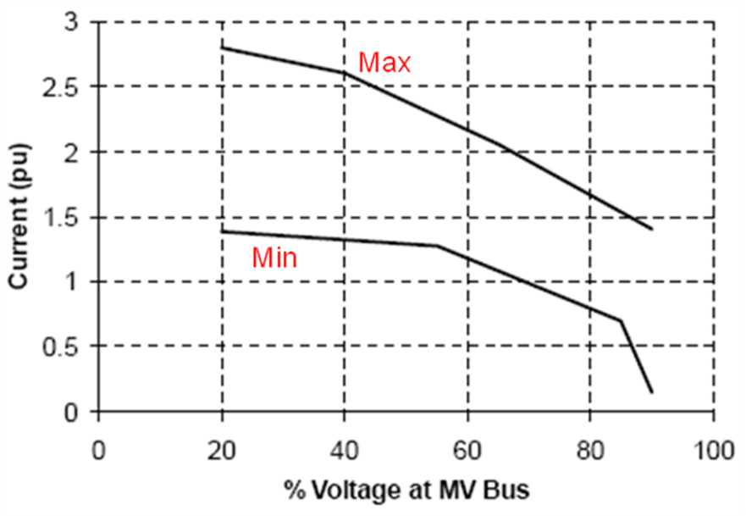

Example of Short Circuit Output After 3 Cycles
- Per-Unit Short Circuit Capability (3 cycles+) vs. MV bus voltage (MV bus of wind turbine unit transformer)
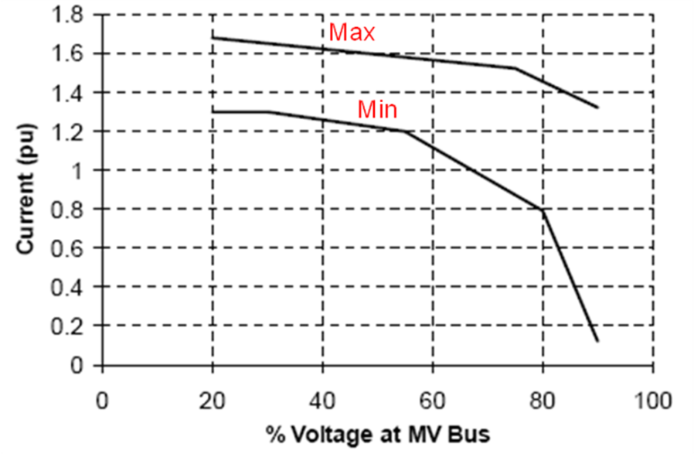

The Generating Facility will be required to comply with the RVC limits set forth in the Southern Companies’ Power Quality Policy prior to being approved for Commercial Operation. Southern Companies’ Power Quality Policy can be found in the Generator Interconnection folder on Southern Companies OASIS website at https://www.oasis.oati.com/SOCO.
As required by NERC Reliability Standard MOD-32-1.
Southern Companies’ Interconnection Requirements for Inverter-Based Generation document can be found in the Generator Interconnection folder on Southern Companies OASIS website at https://www.oasis.oati.com/SOCO.
A three-phase model (in EMTP-RV format) is not required for the Interconnection studies, but will be required prior to Notice to Proceed under a Generator Interconnection Agreement.
Harmonic values should represent the total harmonics present at the POI, including all customer equipment, such as all inverters, cap banks, transformers, etc. If data for the harmonics produced by individual inverters is provided, that data will be screened during the Interconnection Studies; however, the Generating Facility will be required to comply with Southern Companies’ Power Quality Policy prior to being approved for Commercial Operation. Southern Companies’ Power Quality Policy can be found in the Generator Interconnection folder on Southern Companies OASIS website at https://www.oasis.oati.com/SOCO.

