BPR Number | BPR007 | BPR Title | Posting Timeline for Non-Firm Transmission Service
Business Practice Section(s) Requiring Revision (include Section No., Title, and Protocol Version) |  | Business Practice 2.10 – bullet 3
Impact Analysis Required  (Yes or No) |  | Yes
MMU Report Required  (Yes or No) |  | No
Requested Resolution (Normal or Urgent) |  | Normal
Revision Description |  | Require Attestations to be submitted via webOASIS instead of fax via “Application to Designate a New Network Resource” form.
Reason for Revision |  | The webOASIS system contains the functionality to allow customers to electronically submit an attestation for a New Designated Network Resource. The system can be configured to require the attestation to be performed upon submittal of the transmission service request, prior to the customer’s confirmation of the transmission service reservation, or at any time.
Tariff Implications or Changes (Yes or No; If yes include a summary of impact and/or specific changes)
Criteria Implications or Changes (Yes or No; If yes include a summary of impact and/or specific changes) |  | No
Credit Implications (Yes or No, and summary of impact) |  | No

Sponsor
Name
E-mail Address
Company
Company Address
Phone Number
Fax Number

Proposed Business Practice Language Revision

2.10. REQUESTING NETWORK INTEGRATION TRANSMISSION SERVICE FROM NEW DESIGNATED NETWORK RESOURCES

The SPP OATT allows a network customer to add or modify its Network Resources designated in the initial application for NITS55. The following practices apply to the initial application for NITS under the SPP OATT.
Business Practice
- •
A new request for NITS from designated Network Resources must be submitted on the SPP OASIS for each new resource. Multiple resources to be added at the same time located within the same transmission zone may be combined in one request.

- •
Additional Network Resources may be designated to serve Network Load for a term of one day or greater.

- •
An attestation confirming that the resource qualifies as a designated Network Resource must be received by SPP prior to confirmation of the OASIS request. In order to qualify as a designated Network Resource, schedules from the resource cannot be interrupted for economic reasons. Sources of generation referred to as firm LD (or financially firm) products, will be allowed as designated Network Resources provided these products cannot be interrupted for economic reasons. A customer may properly designate resources from system purchases not linked to a specific unit provided the purchases cannot be interrupted for economic reasons.

...

Screenshots of webOASIS DNR Attestation
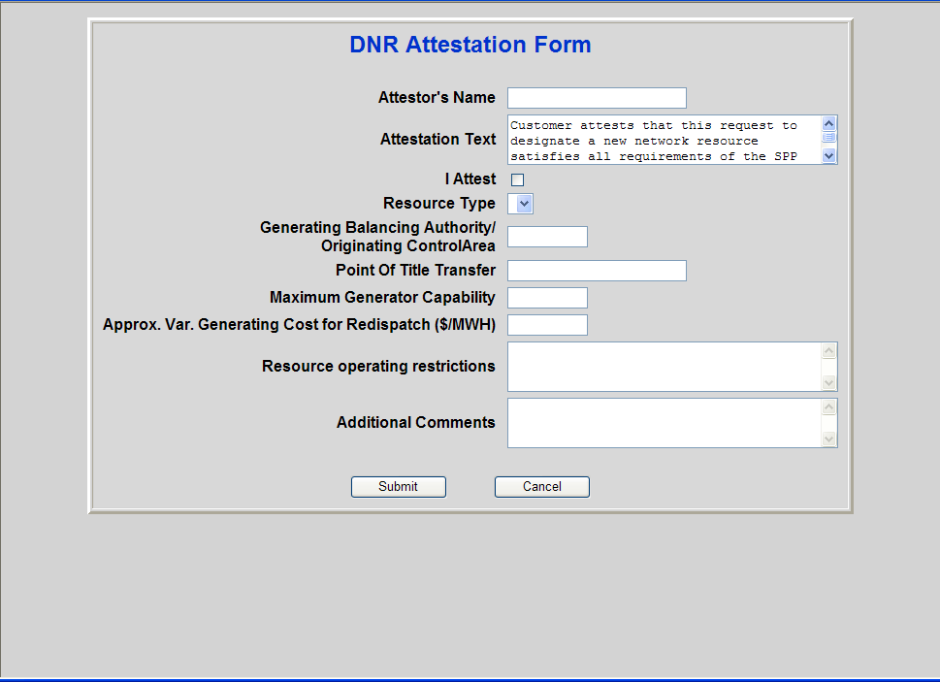

Attestation text:
“Customer attests that this request to designate a new network resource satisfies all requirements of the SPP Open Access Transmission Tariff, specifically Part III Sections 28.6, 29.1, 29.2, 30.2, 30.4, 30.5, 30.6, 30.7, and 30.8.”

28.6 Restrictions on Use of Service: The Network Customer shall not use Network
Integration Transmission Service for (i) sales of capacity and energy to nondesignated
loads, or (ii) direct or indirect provision of transmission service by the
Network Customer to third parties. All Network Customers taking Network
Integration Transmission Service shall use Point-To-Point Transmission Service
under Part II of the Tariff for any Third-Party Sale which requires use of the
Transmission Provider's Transmission System except for service where the
purchaser is a Network Customer of the Transmission Provider. In the event that
a Network Customer uses Network Integration Transmission Service or secondary
service pursuant to Section 28.4 to facilitate a wholesale sale that does not serve
its Network Load, it shall pay the penalty set forth in Section 13.7 for the amount
of the service used to facilitate the wholesale sale.

29.1 Condition Precedent for Receiving Service: Subject to the terms and
conditions of Part III of the Tariff, the Transmission Provider will provide
Network Integration Transmission Service to any Eligible Customer, provided
that (i) the Eligible Customer completes an Application for service as provided
under Part III of the Tariff, (ii) the Eligible Customer and the Transmission
Provider in coordination with the affected Transmission Owner(s) complete(s) the technical arrangements set forth in Sections 29.3 and 29.4, (iii) the Eligible
Customer executes a Service Agreement pursuant to Attachment F for service
under Part III of the Tariff or requests in writing that the Transmission Provider
file a proposed unexecuted Service Agreement with the Commission, and (iv) the
Eligible Customer executes a Network Operating Agreement with the
Transmission Provider pursuant to Attachment G, or requests in writing that the
Transmission Provider file a proposed unexecuted Network Operating
Agreement.

29.2 Application Procedures: An Eligible Customer requesting service under Part III
of the Tariff must submit an Application, which includes all information required
for SPP to complete a Credit Assessment pursuant to its Credit Policy set out in
Attachment X and satisfaction of all requirements set out therein. Unless subject
to the procedures in Section 2, Completed Applications for new or changed
designated network resources, having a term of one year or longer, associated
with Network Integration Transmission Service will be part of the Aggregate
Transmission Service Study as defined in Attachment Z1. Completed
Applications for new designated network resources, having a term of less than
one year, will be assigned a priority according to the date and time the
Application is received, with the earliest Application receiving the highest
priority. Applications should be submitted by entering the information listed
below on the Transmission Provider's OASIS. A Completed Application shall
provide all of the information included in 18 CFR § 2.20 including but not limited
to the following:
(i) The identity, address, telephone number and facsimile number of the party
requesting service;
(ii) A statement that the party requesting service is, or will be upon
commencement of service, an Eligible Customer under the Tariff;
(iii) A description of the Network Load at each delivery point. This
description should separately identify and provide the Eligible Customer's
best estimate of the total loads to be served at each transmission voltage
level, and the loads to be served from each Transmission Provider
substation at the same transmission voltage level. The description should
include a ten (10) year forecast of summer and winter load and resource
requirements beginning with the first year after the service is scheduled to
commence;
(iv) The amount and location of any interruptible loads included in the Network
Load. This shall include the summer and winter capacity requirements for
each interruptible load (had such load not been interruptible), that portion of
the load subject to interruption, the conditions under which an interruption
can be implemented and any limitations on the amount and frequency of
interruptions. An Eligible Customer should identify the amount of
interruptible customer load (if any) included in the 10 year load forecast
provided in response to (iii) above;
(v) A description of Network Resources (current and 10-year projection). For
each on-system Network Resource, such description shall include:
- Unit size and amount of capacity from that unit to be designated as
Network Resource
- VAR capability (both leading and lagging) of all generators
- Operating restrictions
- Any periods of restricted operations through-out the year
- Maintenance schedules
- Minimum loading level of unit
- Normal operating level of unit
- Any must-run unit designations required for system reliability
- or contract reasons
- Approximate variable generating cost ($/MWH) for redispatch
computations
- Arrangements governing sale and delivery of power to third parties
from generating facilities located in the Transmission Provider
Control Area, where only a portion of unit output is designated as a
Network Resource:
-
For each off-system Network Resource, such description shall include:
- Identification of the Network Resource as an off-system resource
- Amount of power to which the customer has rights
- Identification of the control area from which the power will
originate
- Delivery point(s) to the Transmission Provider's Transmission System
- Transmission arrangements on the external transmission system(s)
- Operating restrictions, if any
- Any periods of restricted operations throughout the year
- Maintenance schedules
- Minimum loading level of unit
- Normal operating level of unit
- Any must-run designations required for system reliability or
contract reasons
- Approximate variable generating cost ($/MWH) for redispatch
computations:
(vi) Description of Eligible Customer's transmission system:
- Load flow and stability data, such as real and reactive parts of the
load, lines, transformers, reactive devices and load type, including normal and emergency ratings of all transmission equipment in a load
flow format compatible with that used by the Transmission Provider
- Operating restrictions needed for reliability
- Operating guides employed by system operators
- Contractual restrictions or committed uses of the Eligible Customer's
transmission system, other than the Eligible Customer's Network
Loads and Resources
- Location of Network Resources described in subsection (v) above
- 10 year projection of system expansions or upgrades
- Transmission System maps that include any proposed expansions or
upgrades
- Thermal ratings of Eligible Customer's Control Area ties with other
Control Areas;
(vii) Service Commencement Date and the term of the requested Network
Integration Transmission Service. The minimum term for Network
Integration Transmission Service is one year; however, if service is
provided hereunder pursuant to a state retail pilot program, the minimum
term may be the lesser of one year or the remainder of the pilot, but not
less than one month;
(viii) A statement signed by an authorized officer from or agent of the Network
Customer attesting that all of the network resources listed pursuant to
Section 29.2(v) satisfy the following conditions: (1) the Network
Customer owns the resource, has committed to purchase generation
pursuant to an executed contract, or has committed to purchase generation
where execution of a contract is contingent upon the availability of
transmission service under Part III of the Tariff; and (2) the Network
Resources do not include any resources, or any portion thereof, that are
committed for sale to non-designated third party load or otherwise cannot
be called upon to meet the Network Customer's Network Load on a
noninterruptible basis, except for purposes of fulfilling obligations under a
reserve sharing program; and
(ix) Any additional information required of the Transmission Customer as
specified in the Transmission Provider’s planning process established in
Attachment O.
Unless the Parties agree to a different time frame, the Transmission Provider must
acknowledge the request within ten (10) days of receipt. The acknowledgment
must include a date by which a response, including a Service Agreement, will be
sent to the Eligible Customer. If an Application fails to meet the requirements of
this section, the Transmission Provider shall notify the Eligible Customer
requesting service within fifteen (15) days of receipt and specify the reasons for such failure. Wherever possible, the Transmission Provider will attempt to
remedy deficiencies in the Application through informal communications with the
Eligible Customer. If such efforts are unsuccessful, the Transmission Provider
shall return the Application without prejudice to the Eligible Customer filing a
new or revised Application that fully complies with the requirements of this
section. The Eligible Customer will be assigned a new priority consistent with the
date of the new or revised Application. The Transmission Provider shall treat this
information consistent with the standards of conduct contained in Part 37 of the
Commission's regulations. The Transmission Provider may, on a nondiscriminatory
basis, waive the requirements of subsections 29.2 (iii), (iv), (v) and
(vi), to the extent such information is not applicable or, in the case of service
being requested for retail access load, is unknown at the time of the application.

30.2 Designation of New Network Resources: The Network Customer may
designate a new Network Resource by providing the Transmission Provider with
as much advance notice as practicable. A designation of a new Network Resource
must be made through the Transmission Provider’s OASIS by a request for modification of service pursuant to an Application under Section 29. This
request must include a statement that the new network resource satisfies the
following conditions: (1) the Network Customer owns the resource, has
committed to purchase generation pursuant to an executed contract, or has
committed to purchase generation where execution of a contract is contingent
upon the availability of transmission service under Part III of the Tariff; and (2)
The Network Resources do not include any resources, or any portion thereof, that
are committed for sale to non-designated third party load or otherwise cannot be
called upon to meet the Network Customer's Network Load on a non-interruptible
basis, except for purposes of fulfilling obligations under a reserve sharing
program. The Network Customer’s request will be deemed deficient if it does not
include this statement and the Transmission Provider will follow the procedures
for a deficient application as described in Section 29.2 of the Tariff.
Requests for new or changed Network Resources having a term of one year or
longer associated with Network Integration Transmission Service shall be part of
the Aggregate Transmission Service Study as specified in Attachment Z1. The
Transmission Provider shall combine all transmission service requests, having a
term of one year or longer, received during each pair of open seasons as specified
in Section III of Attachment Z1, into a single and distinct Aggregate Transmission
Service Study. Requests for new or changed Network Resources, having a term
of less than one year, shall be assigned a priority according to the date and time
the Application is received, with the earliest Application receiving the highest
priority.

30.4 Operation of Network Resources: The Network Customer shall not operate its
designated Network Resources located in the Network Customer's or
Transmission Owner’s(s') Control Area(s) such that the output of those facilities
exceeds its designated Network Load, plus Non-Firm Sales delivered pursuant to
Part II of the Tariff, plus losses, plus power sales under a reserve sharing
program, plus sales that permit curtailment without penalty to serve its designated
Network Load. This limitation shall not apply to changes in the operation of a
Transmission Customer's Network Resources at the request of the Transmission
Provider to respond to an emergency or other unforeseen condition which may
impair or degrade the reliability of the Transmission System. For all Network
Resources not physically connected with the Transmission Provider’s Transmission System, the Network Customer may
not schedule delivery of energy in excess of the Network Resource’s capacity, as
specified in the Network Customer’s Application pursuant to Section 29, unless
the Network Customer supports such delivery within the Transmission Provider’s
Transmission System by either obtaining Point-to-Point Transmission Service or
utilizing secondary service pursuant to Section 28.4. In the event that a Network
Customer’s schedule at the delivery point for a Network Resource not physically
interconnected with the Transmission Provider's Transmission System exceeds
the Network Resource’s designated capacity, excluding energy delivered using
secondary service or Point-to-Point Transmission Service, it shall pay the penalty
set forth in Section 13.7 for the amount of the service exceeding the Network
Resource’s designated capacity.

30.5 Network Customer Redispatch Obligation: As a condition to receiving
Network Integration Transmission Service, the Network Customer agrees to
redispatch its Network Resources as requested by the Transmission Provider
pursuant to Section 33.2 and in accordance with Attachment K. The Network
Customer also shall submit an offer to redispatch in accordance with Attachment
K, Part I, with the charges subject to approval by the Commission where
appropriate. To the extent practical, the redispatch of resources pursuant to this
section shall be on a least cost, non-discriminatory basis between all Network
Customers, and the Transmission Owner(s). Transmission Owners and Network
Customers will not have any redispatch obligation to sustain Non-Firm
Transmission Service under this provision.

30.6 Transmission Arrangements for Network Resources Not Physically
Interconnected With The Transmission Provider: The Network Customer
shall be responsible for any arrangements necessary to deliver capacity and
energy from a Network Resource not physically interconnected with the
Transmission System. The Transmission Provider will undertake reasonable
efforts to assist the Network Customer in obtaining such arrangements, including
without limitation, providing any information or data required by such other entity
pursuant to Good Utility Practice.

30.7 Limitation on Designation of Network Resources: The Network Customer
must demonstrate that it owns or has committed to purchase generation pursuant
to an executed contract in order to designate a generating resource as a Network
Resource. Alternatively, the Network Customer may establish that execution of a
contract is contingent upon the availability of transmission service under Part III
of the Tariff.

30.8 Use of Interface Capacity by the Network Customer: There is no specific
limitation upon a Network Customer's use of the Transmission System at the
interface(s) to the Control Area (where the Network Customer's load is located) to
integrate the Network Customer's Network Resources (or substitute economy
purchases) with its Network Loads. However, a Network Customer's use of the
interface capacity with other transmission systems may not exceed the Network
Customer's Load.

