Scenario Analyzer FAQ (webSmartOASIS)
Scenario Analyzer can help determine the amount of available MW capacity prior to submitting a TSR on OASIS. Scenario Analyzer displays the results as of the time the scenario is entered. There is always a possibility that the request may fail once you enter the actual transmission service request.
Complete the following steps to enter a scenario:
- From the webSmartOASIS home page, click Reports, and then select AFC/Flowgate Reports.
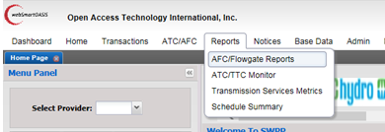
- Select provider SWPP. (The page will refresh and more options will display.)
- Click Scenario Analyzer.
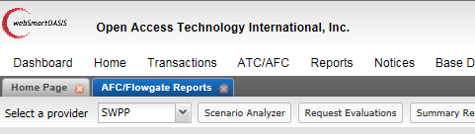
- Enter SWPP in the Provider field. (The page will refresh and additional fields will display.)
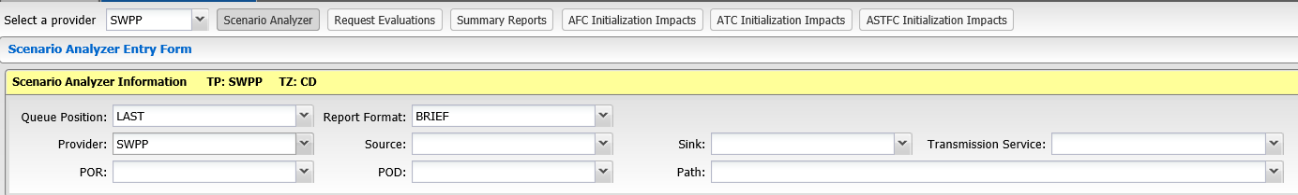

- Enter the proposed TSR information in the Scenario Analyzer Entry Form that displays.
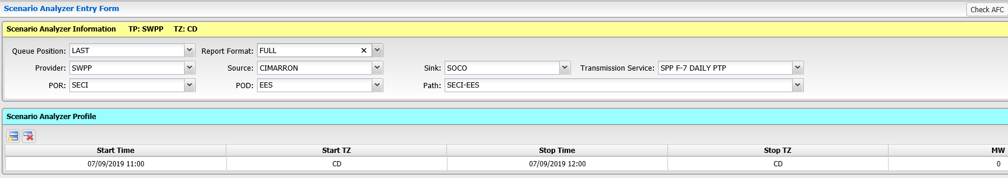
NOTES:
- For Queue Position, select LAST.
- For Report Format, choose either:
  - BRIEF for top 10-15 limiting constraints/flowgates, or
  - FULL for all constraints/flowgates

- To view results (pass or fail) and a scenario (SA) number, click:
- Check AFC to see AFC results
- Check ATC to see ATC results
NOTE: Check ATC will return results if there is an ATC interface on the path. For example, if you are reserving transmission over an ERCOT tie or between the Western and Eastern Interconnects, you would perform an AFC scenario and an ATC scenario. If both results indicate pass, the transmission is available.
IMPORTANT: Make note of the SA number.
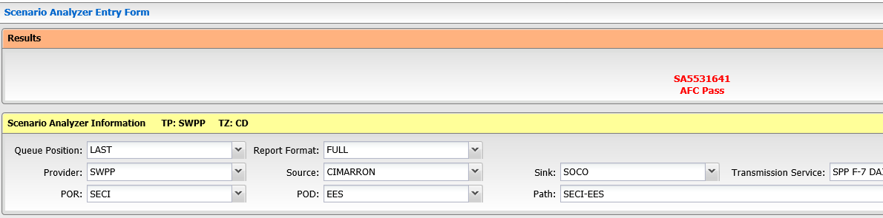

Complete the following steps to obtain more information about a scenario:
- Click Request Evaluations.
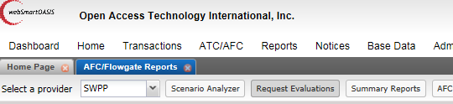
- Using the filter options, enter:
- SWPP in the Provider field
- The “SA” number in the AssignRef field
- ALL in the CalcType field.
- Today in the Updated field.
NOTE: This functionality can also be used to access the detailed report of TSRs that are submitted. However, you will only be able to access information about TSRs that are submitted by your company.
- Click Apply.
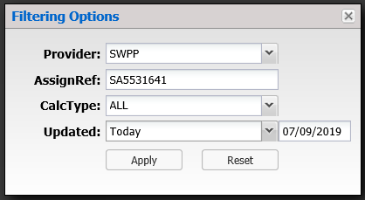
- Click the hyperlink in the AssignRef column.
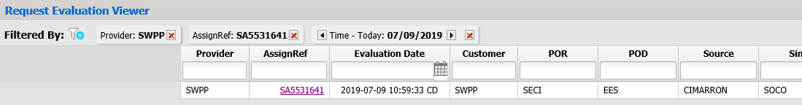
- The Request Evaluation Detail will show you the details of the request’s impact on the system. The Final AFC column is the most important data along with the PTDF/OTDF. If the value in the PTDF/OTDF column is >.03 and the value in the Final AFC column <0, the request would fail the AFC check.
