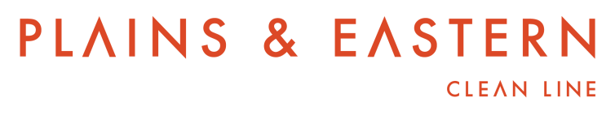

Plains & Eastern Clean Line Transmission Project
Notice of Open Solicitation
Starting on May 22, 2014, Plains and Eastern Clean Line LLC and Plains and Eastern Clean Line Oklahoma LLC (“Plains and Eastern”) will commence an open solicitation process for capacity on the proposed Plains & Eastern Clean Line transmission project (the “Project”). Plains and Eastern may conduct subsequent open solicitation processes for the Project in the future. Plains and Eastern intends to allocate up to 100% of the Project’s capacity to customers through an open and transparent solicitation and capacity allocation process. This process will be conducted pursuant to the FERC Policy Statement issued on January 17, 2013, Allocation of Capacity on New Merchant Transmission Projects and New Cost-Based, Participant-Funded Transmission Projects, 142 FERC ¶ 61,038. Plains and Eastern plans to file for negotiated rate authority under this Policy Statement.

The Project is a proposed 700-mile, multi-terminal ±600 kV HVDC transmission line and associated facilities. The Project will originate in Texas County, Oklahoma, and will terminate at TVA’s Shelby Substation in Shelby County, Tennessee, where it will be capable of delivering 3,500 MW of power. There is also a proposed intermediate converter station located in Central Arkansas that would have the capacity to deliver up to 500 MW of power to the Entergy 500 kV transmission system. The associated facilities will include transmission facilities to connect the converter stations to the existing transmission grid and a collector system comprised of AC transmission lines to connect generators to the western terminus of the line. Plains and Eastern expects to commence construction of the Project in 2016 and place the Project in service at the end of 2018. Additional information about the Project is available at www.plainsandeasterncleanline.com.
Interested parties should contact Alexandra Landon by June 21, 2014 at the contact information set forth below in order to become a registered participant in the open solicitation process.

Alexandra Landon
Capacity@CleanLineEnergy.com
c/o Clean Line Energy Partners LLC
1001 McKinney Street, Suite 700
Houston, Texas 77002
832.319.6364

Registered participants will have the opportunity to receive electronic updates regarding the Project at a password-protected website administered by Plains and Eastern. Further information regarding the Project will be available to registered participants on this website, and Plains and Eastern will post answers to all questions posed by registered participants on this website. Registered participants may also request preliminary meetings to discuss transmission service request considerations. Additionally, Plains and Eastern will host a conference, at which registered participants will have an opportunity to ask questions. Transmission service requests will be due to Capacity@CleanLineEnergy.com by July 21, 2014. Registered participants are not required to submit a transmission service request.

Plains and Eastern will use the following customer selection criteria as initial screening factors: (1) first mover status; (2) firm transmission service reservation for at least 5 years; (3) firm transmission service reservation for at least 50 MW of capacity; and (4) creditworthiness.

Registered participants that satisfy the selection criteria will then be ranked according to the following ranking criteria for purposes of phasing negotiations: (1) level of creditworthiness; (2) early commitment in the Project’s development cycle; (3) Project risk-sharing through phased deposits or similar financial commitments during the Project’s development cycle; (4) ability to assist with the Project’s development needs; (5) longer term of service; (6) larger capacity reservation; (7) ability to access Project converter stations; (8) completion of generation development milestones; (9) commercial operation date for generation; (10) evidence of need for Project capacity; (11) timing of transmission service commencement date; and (12) material price terms. There will be time-defined, phased negotiation windows, with the first phase beginning on or around July 28, 2014.

