Western Area Power Administration Sierra Nevada Region

2009
Annual Ten-Year Transmission Plan Assessment Report

Report Attachment 3
NERC Planning Standard TPL-001

October 30, 2009

For information or questions regarding this Transmission Assessment Report, please contact Larry Tobias via (916) 353-4766 or email at Tobias@wapa.com

Attachment 3: Category A (NERC Planning Standard TPL-001): All Facilities in Service, (N-0) Includes Power Flow, Post Transient and Dynamic Stability Plots

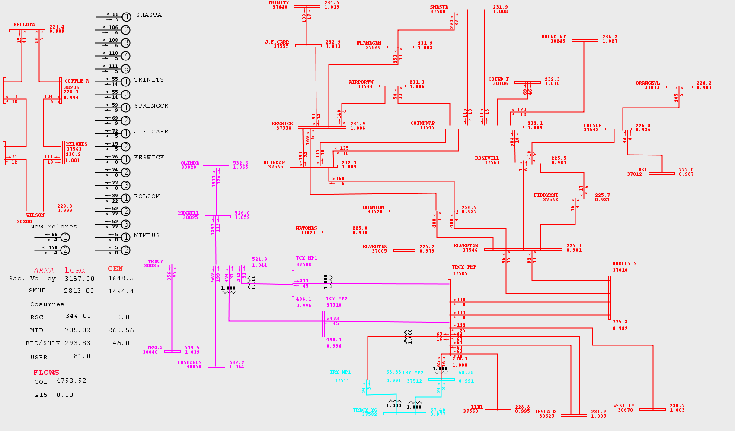

Figure 3-1 2010 Peak Summer
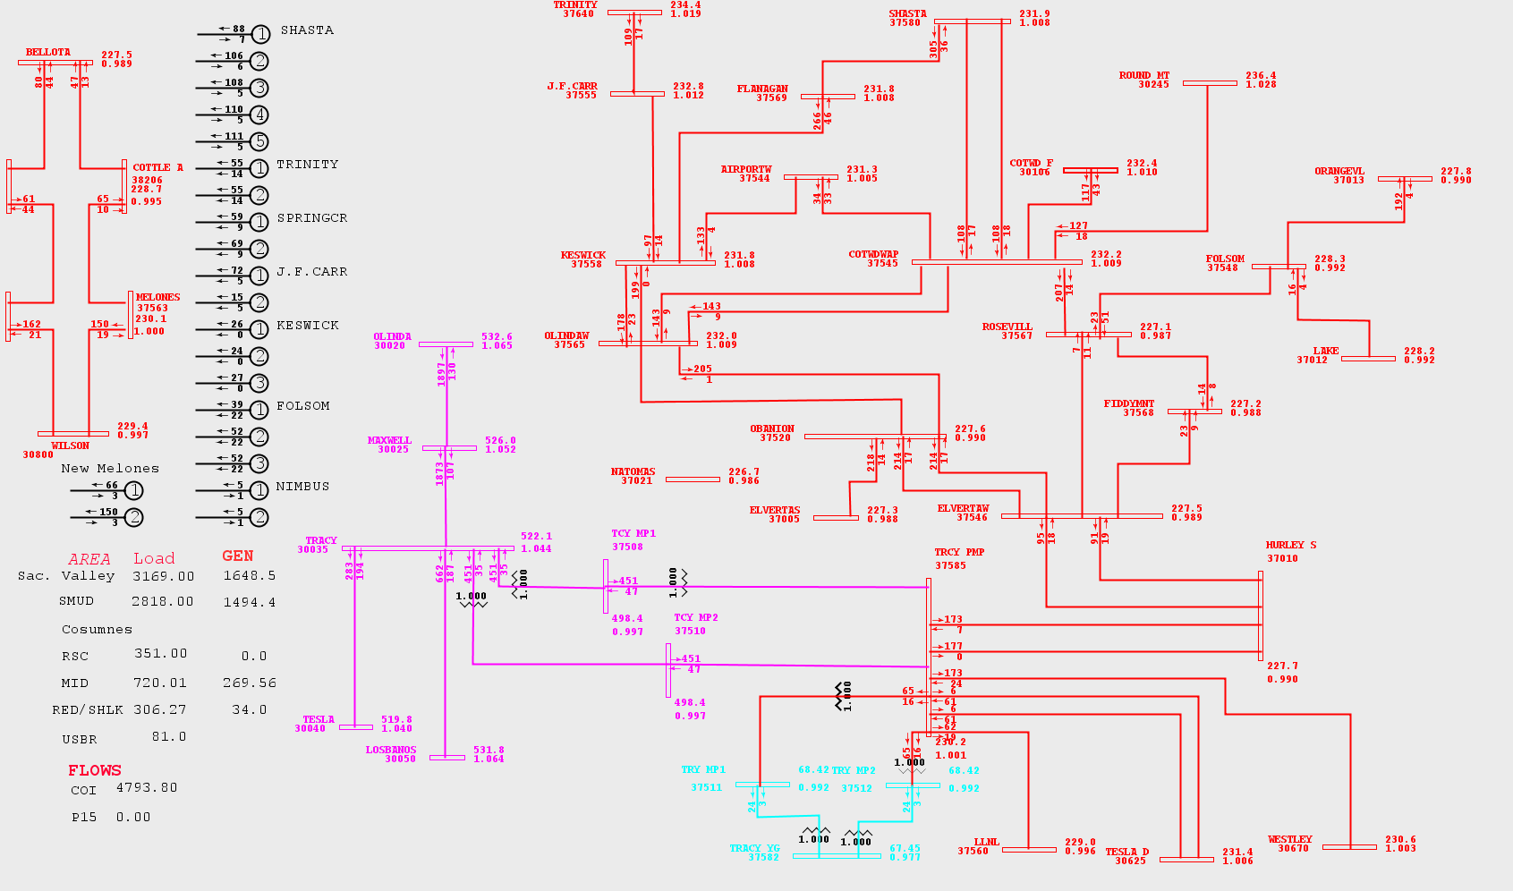
Figure 3-2 2011 Peak Summer

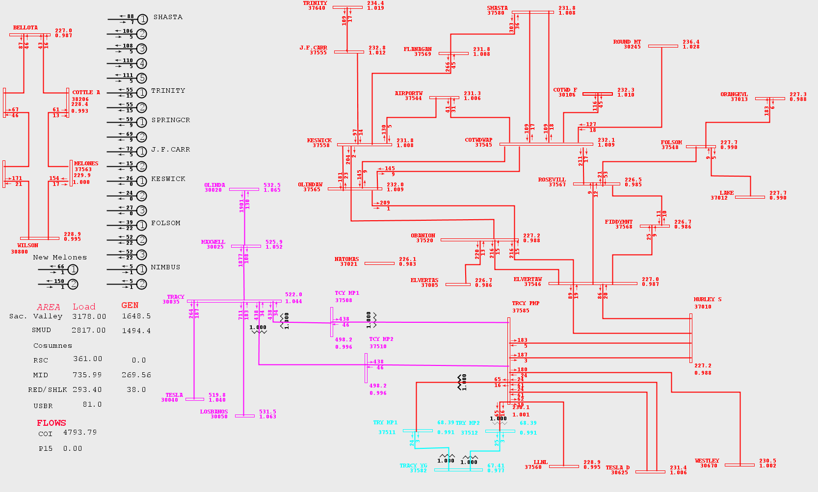

Figure 3-3 2012 Peak Summer
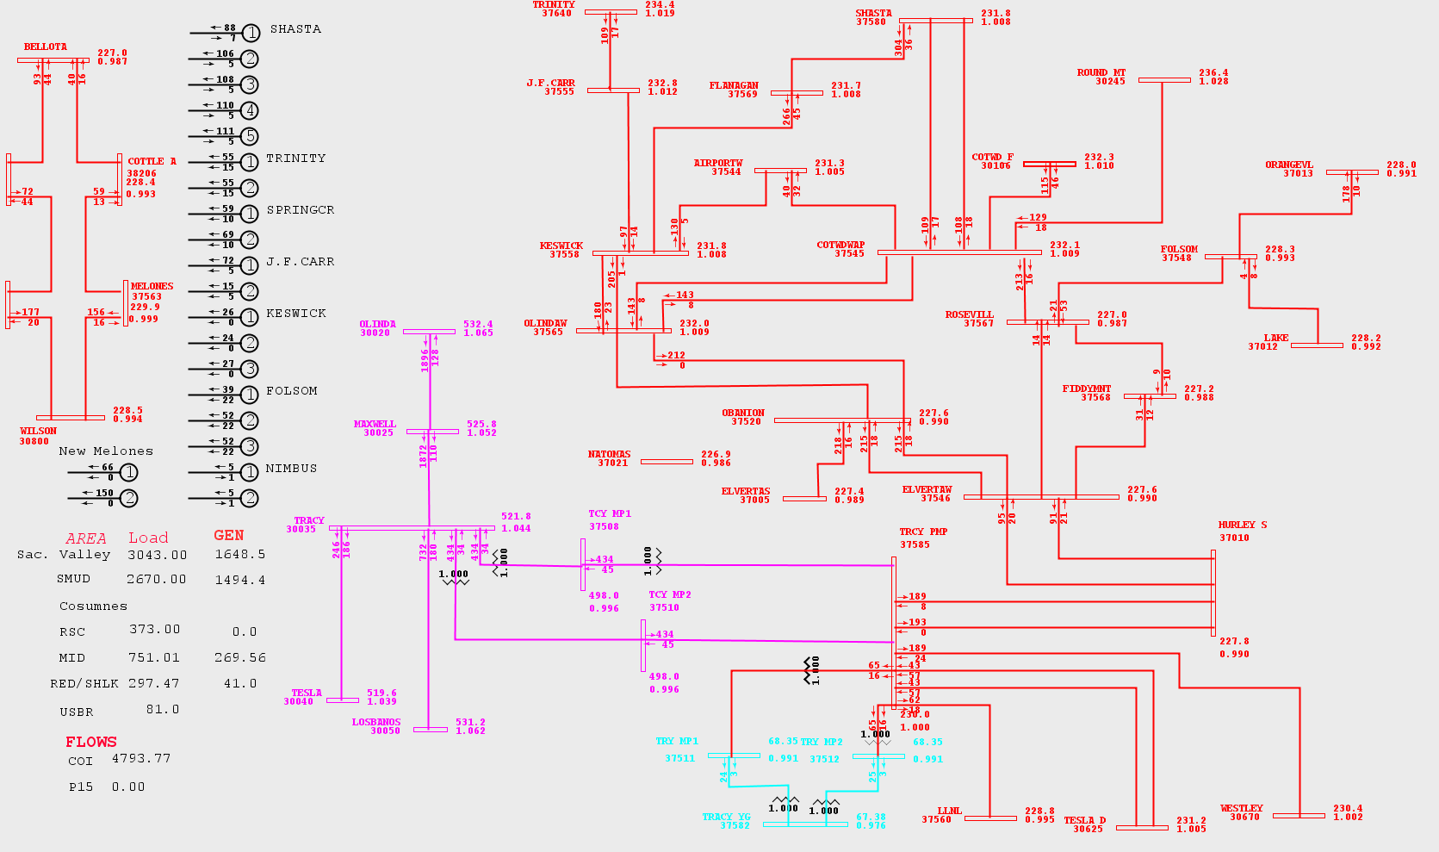

Figure 3-4 2013 Peak Summer
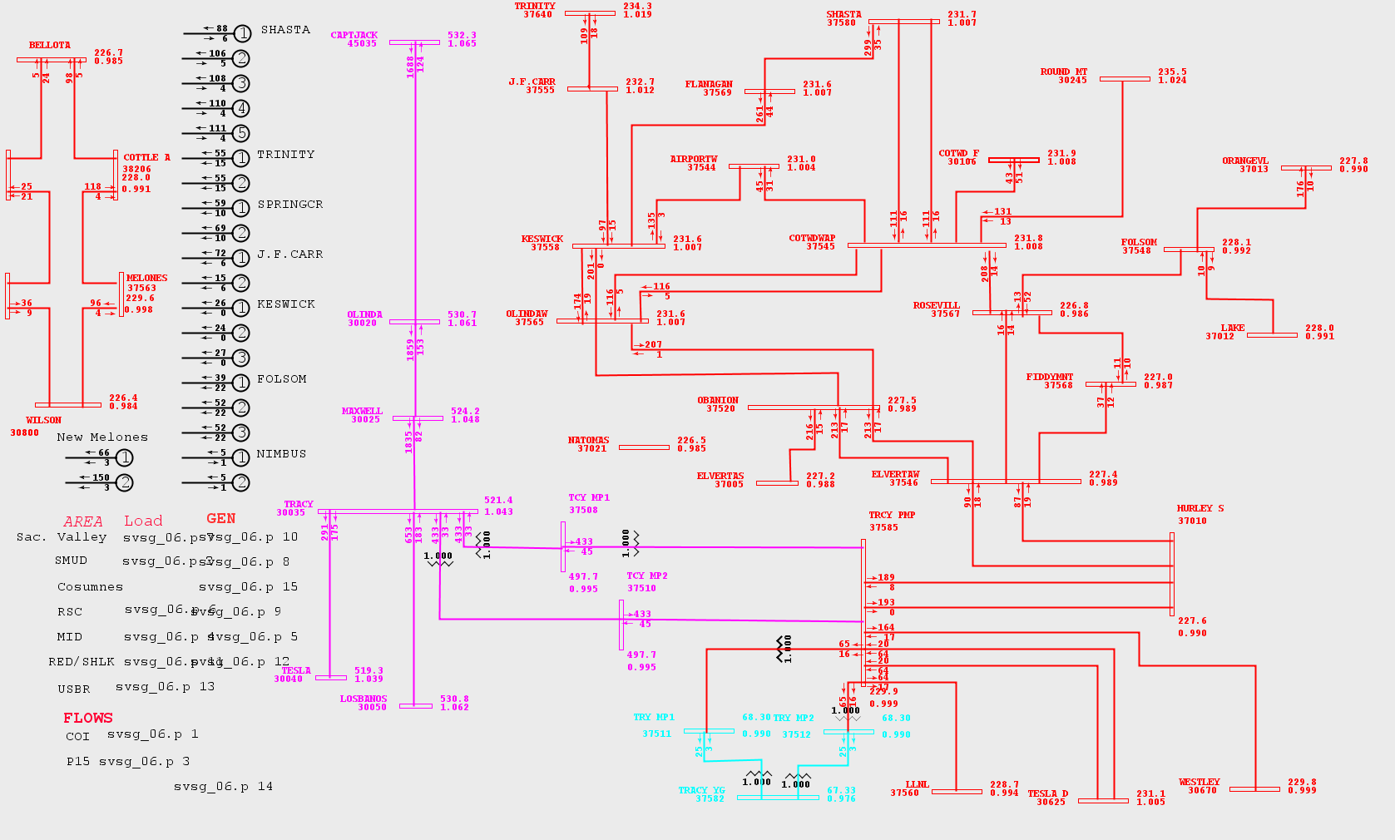
Figure 3-5 2014 Peak Summer

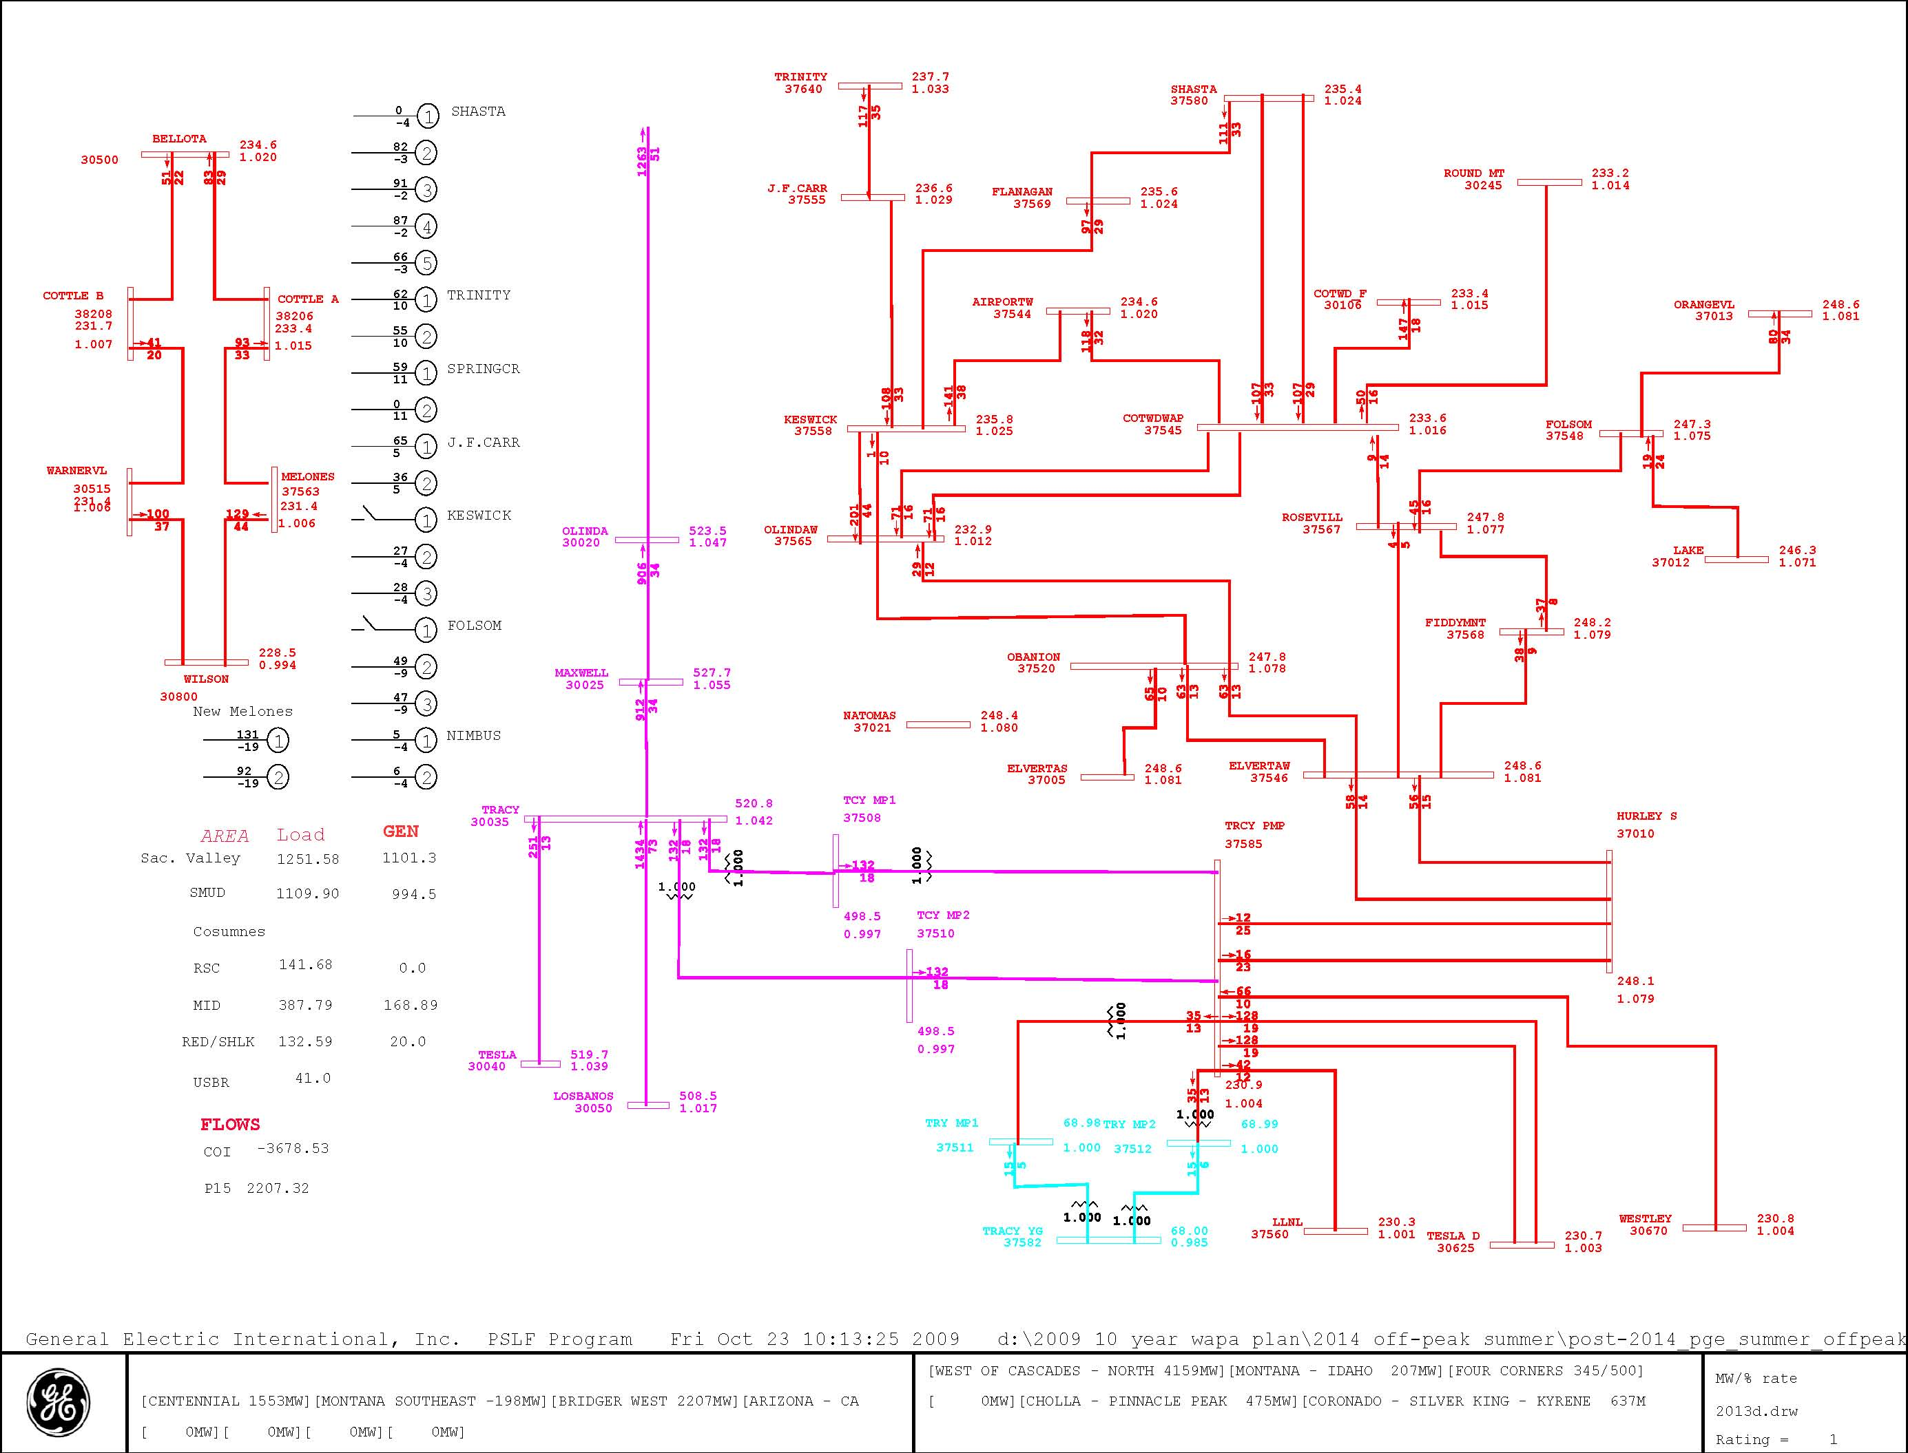
Figure 3-6 2014 Off-Peak Summer

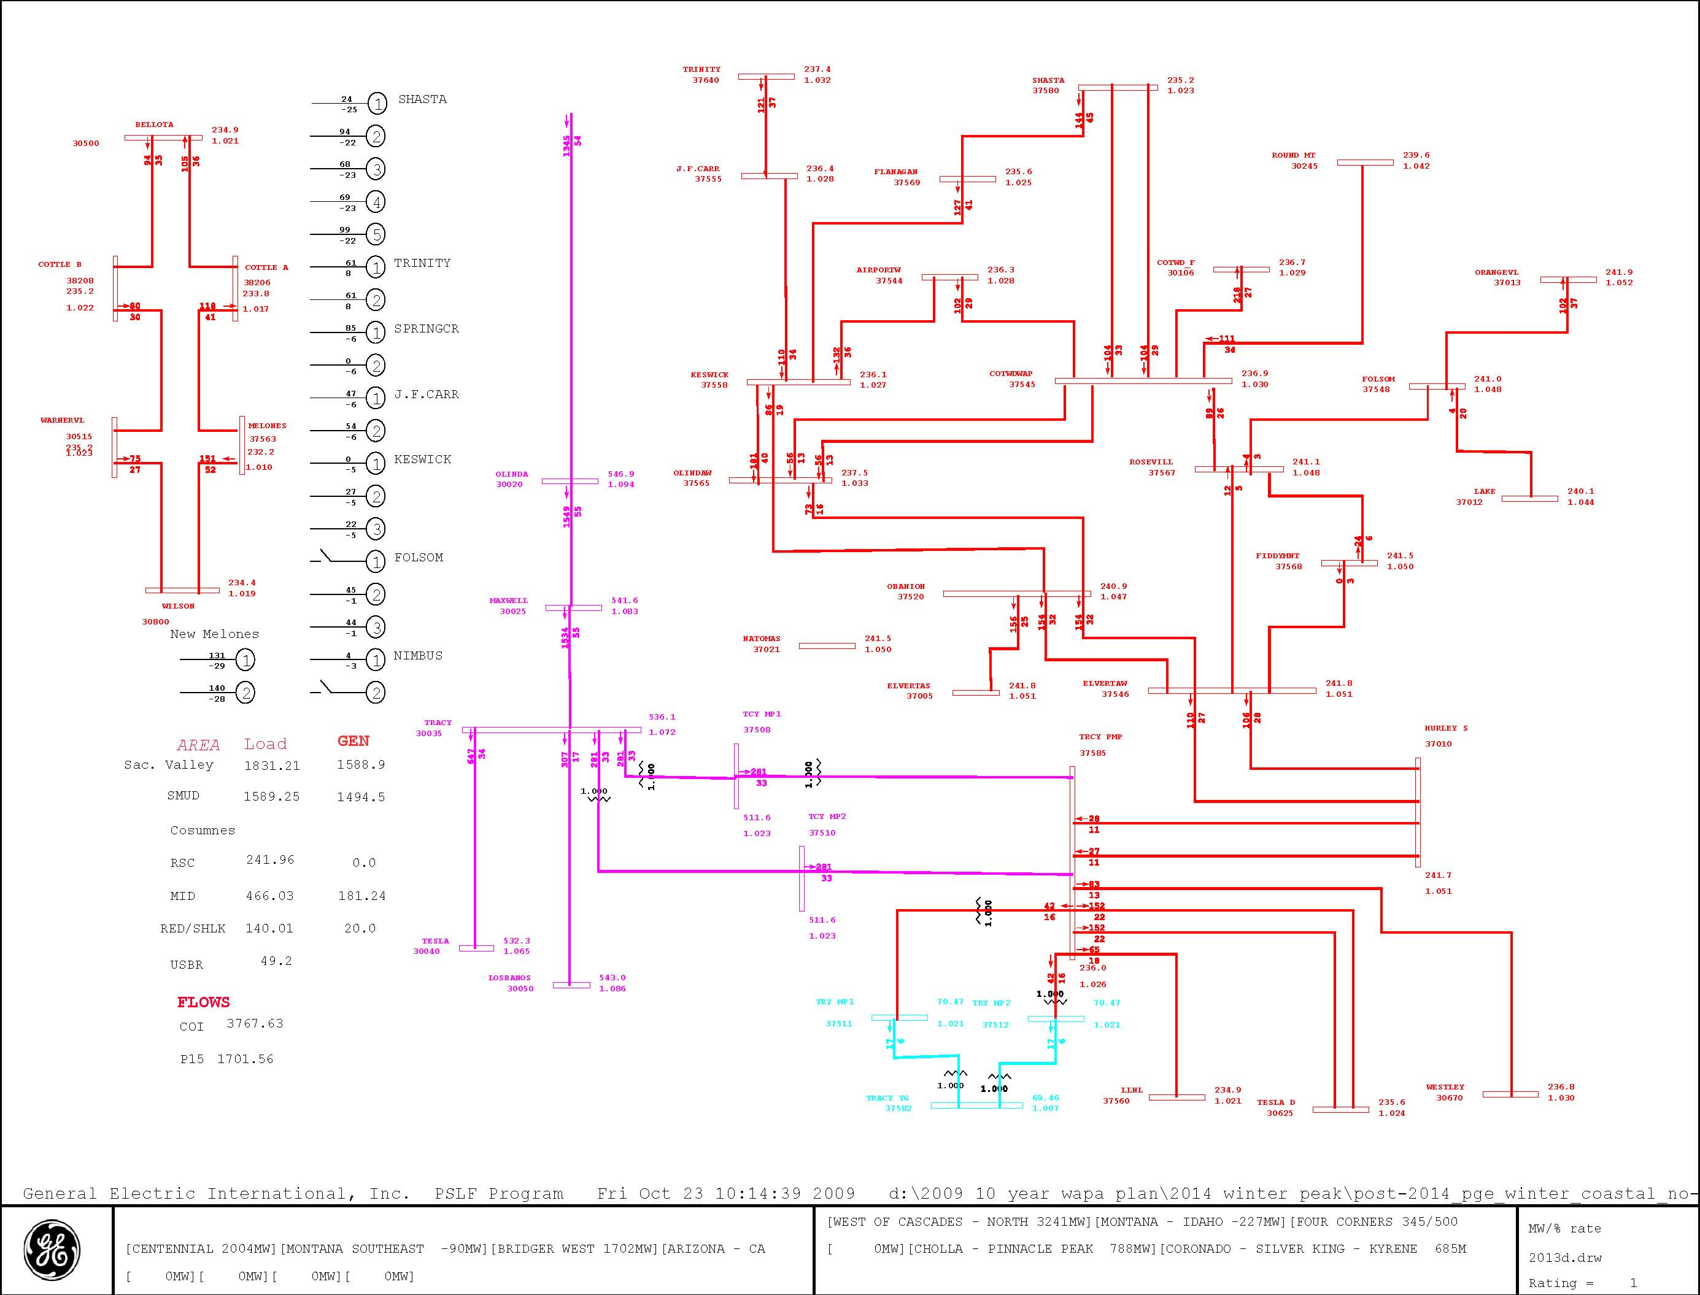
Figure 3-7 2014-15 Peak Winter

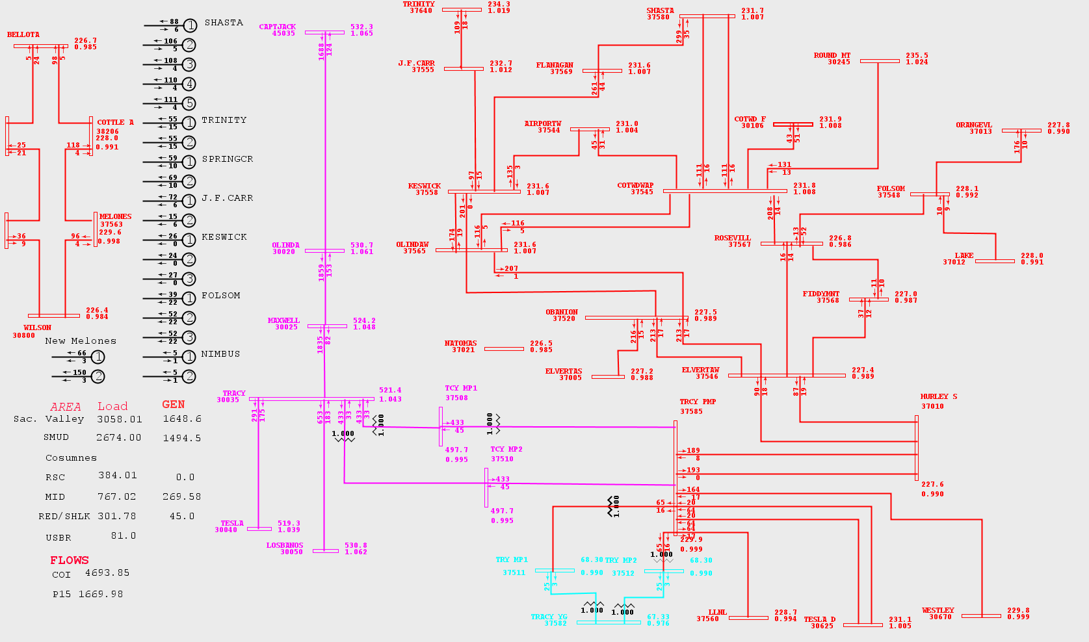
Figure 3-8 2019 Peak Summer

Figure 3-9 ElvertaW Voltage

Figure 3-10 ElvertaW Voltage

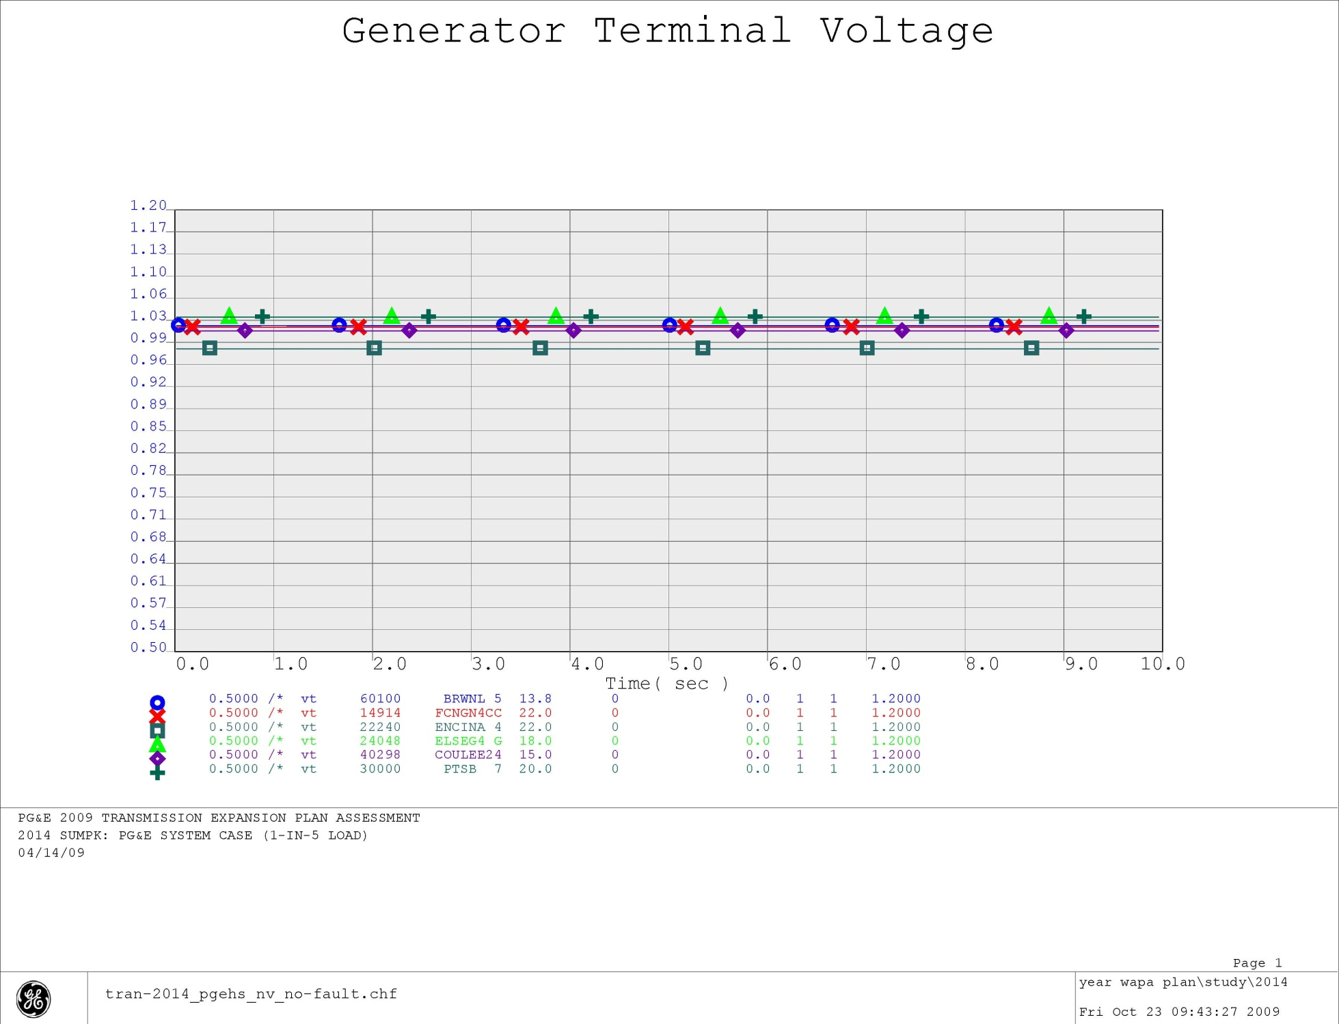
Figure 3-11

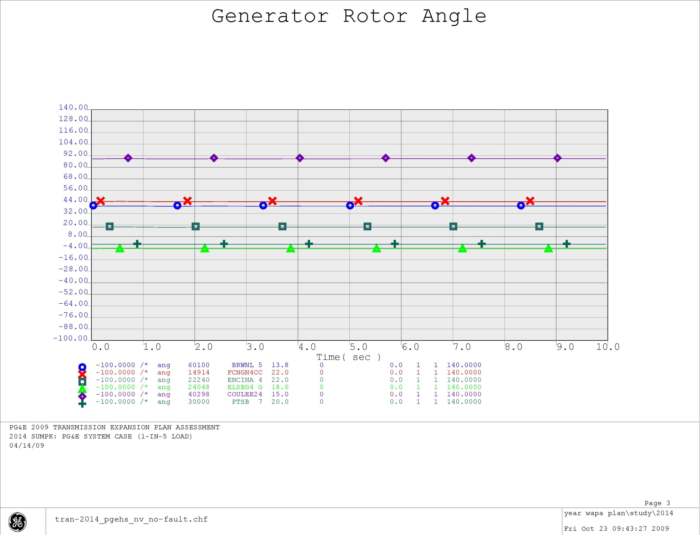
Figure 3-12
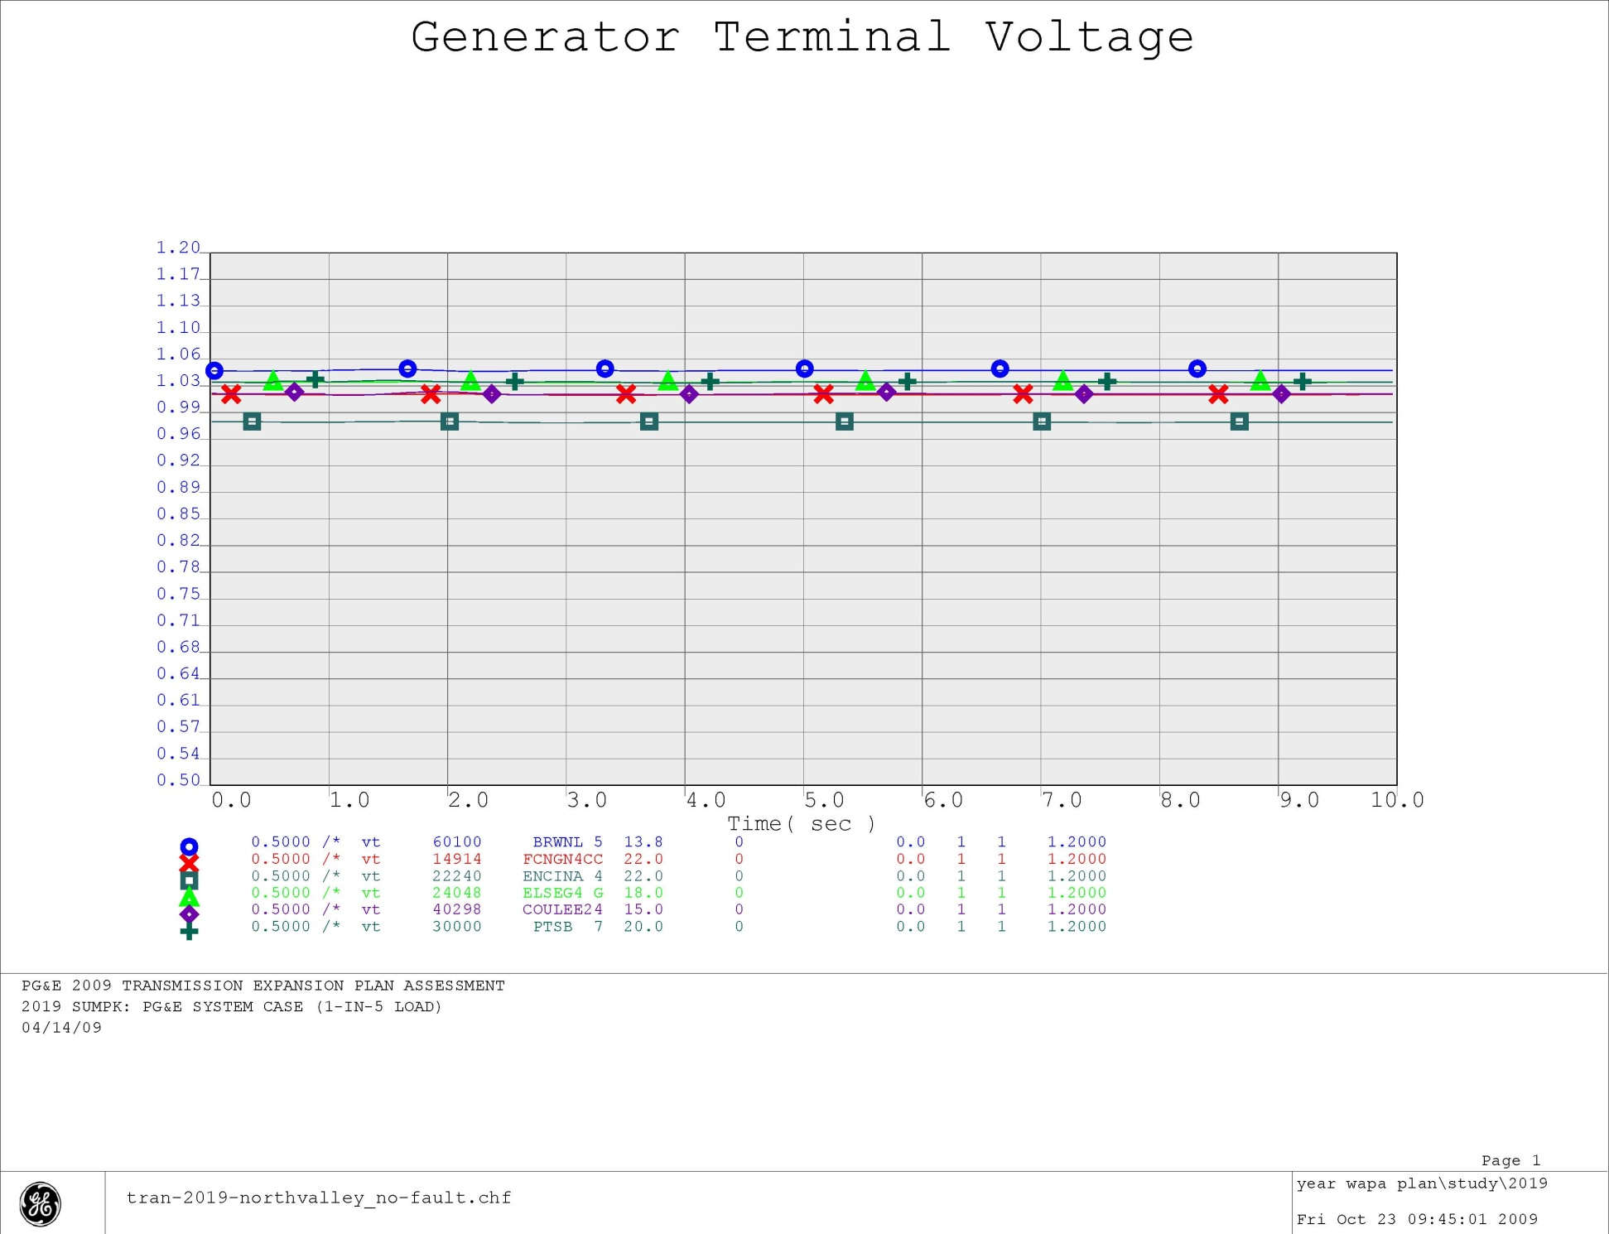
Figure 3-13
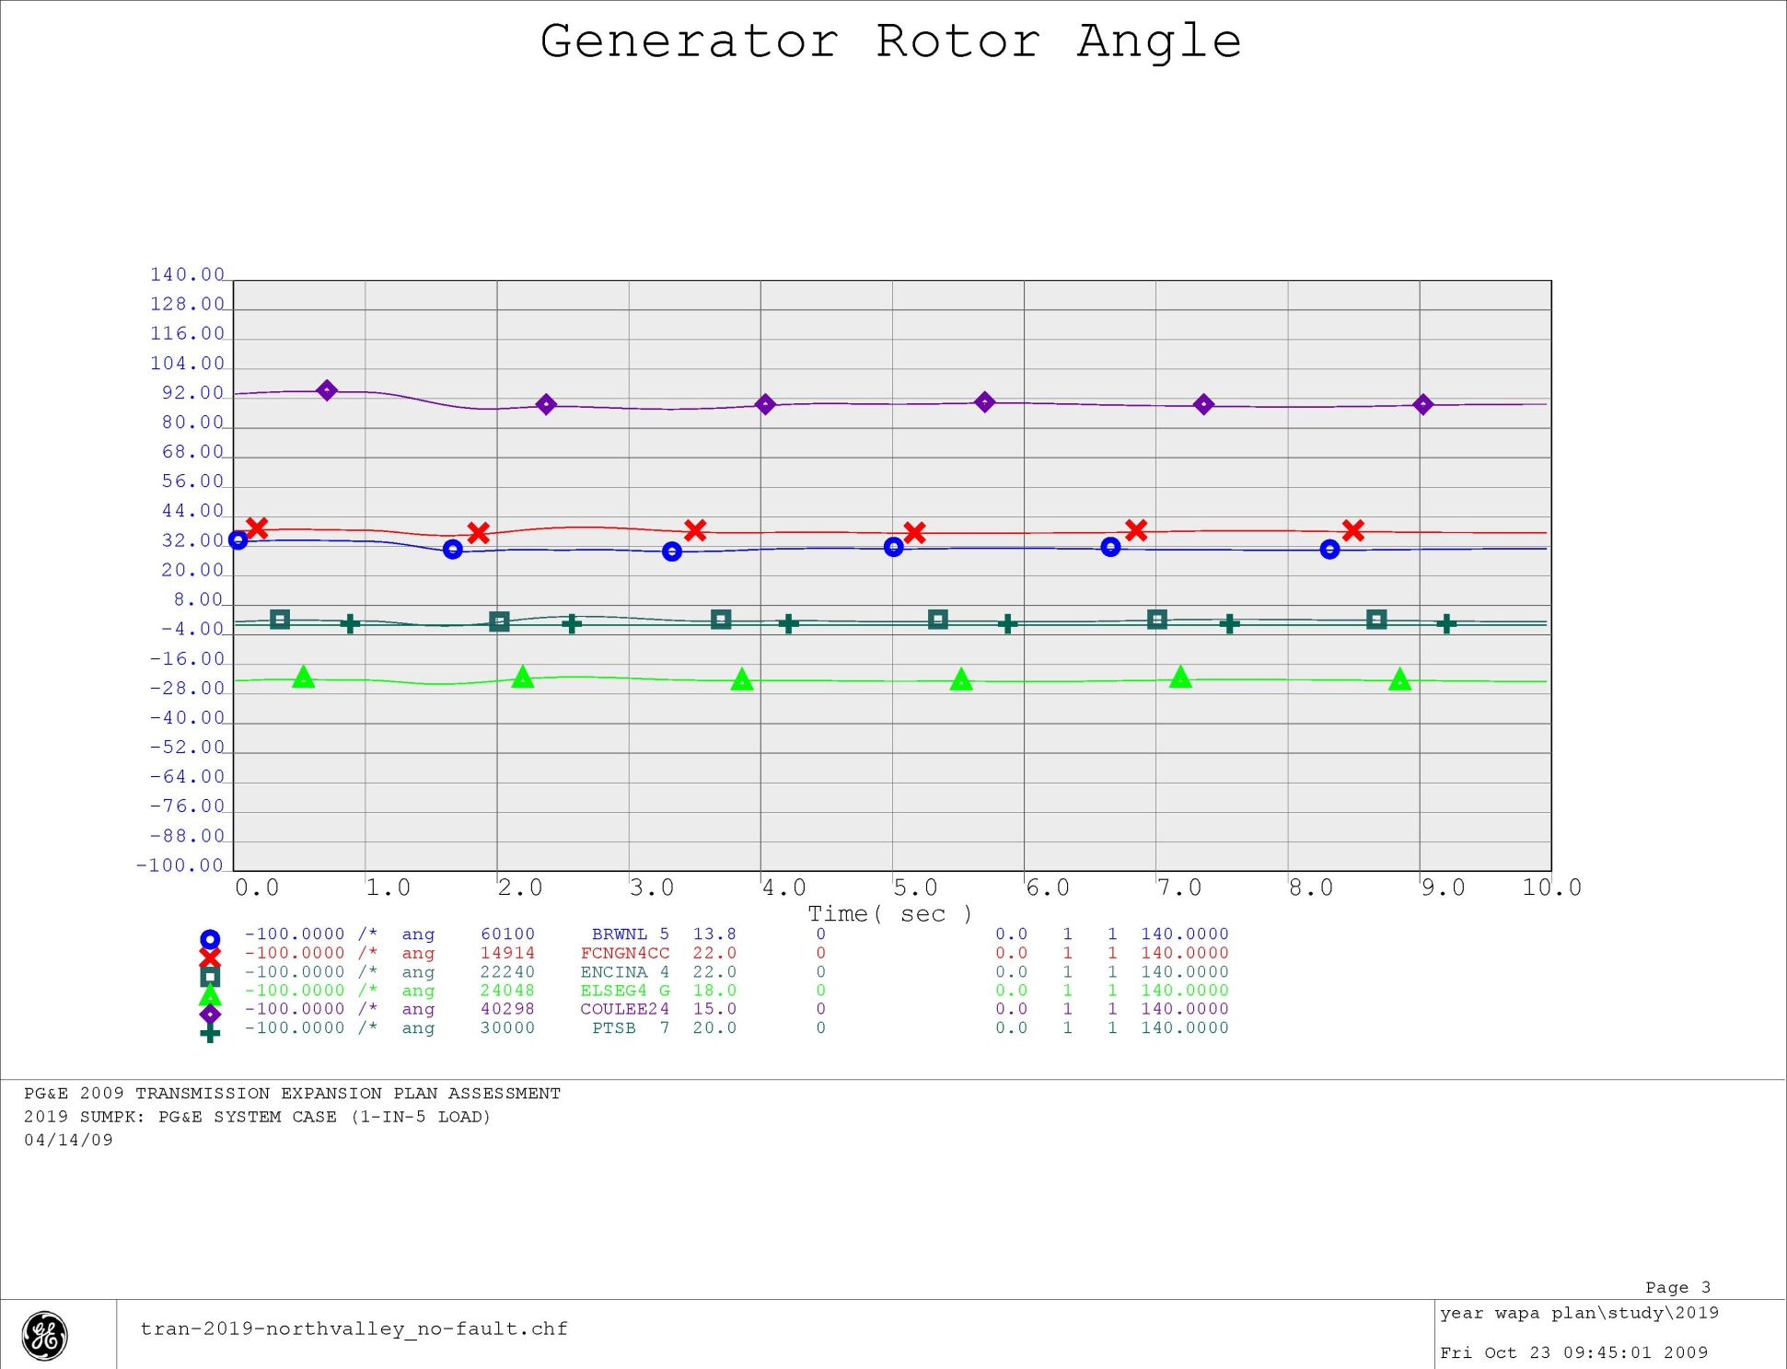
Figure 3-14

