Western Area Power Administration Sierra Nevada Region

2009
Annual Ten-Year Transmission Plan Assessment Report

Report Attachment 5
NERC Planning Standard TPL-003

October 30, 2009

For information or questions regarding this Transmission Assessment Report, please contact Larry Tobias via (916) 353-4766 or email at Tobias@wapa.com

Attachment 5: Category C (NERC Planning Standard TPL-003): Double Element Outages, (N-2) Power Flow , Post-Transient and Dynamic Stability Plots

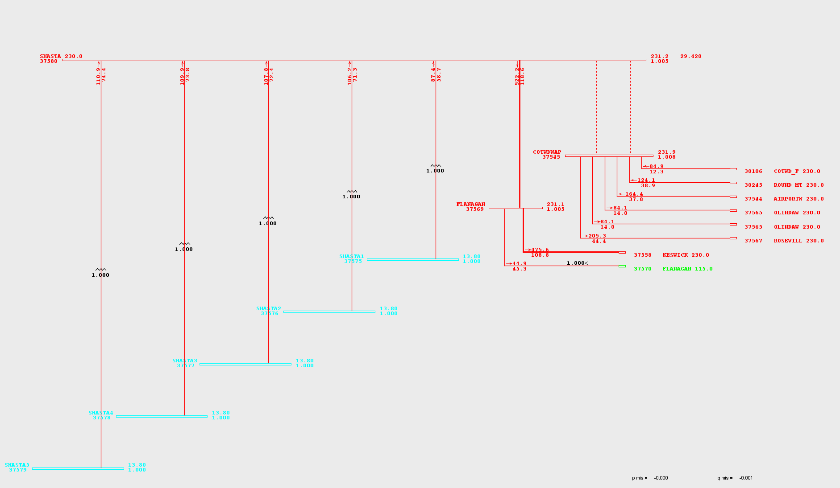
Figure 5-1

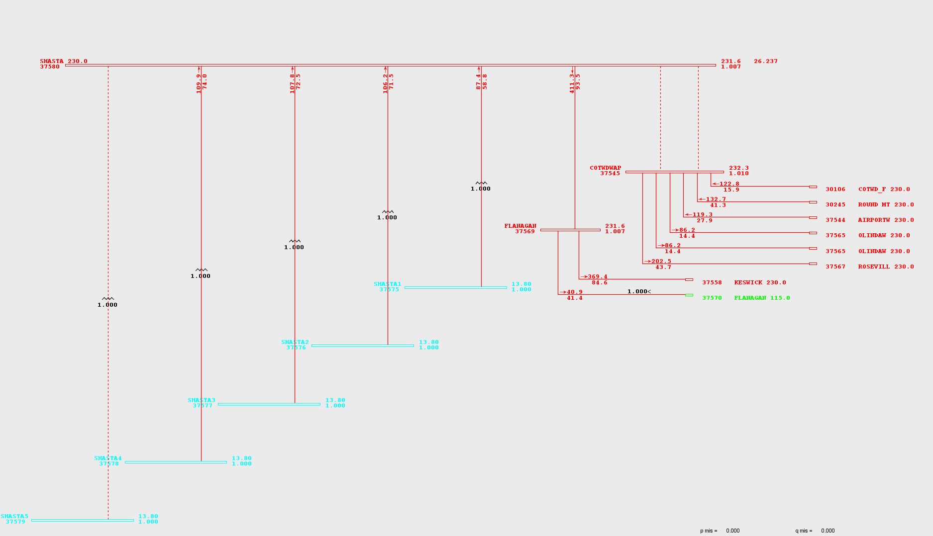
Figure 5-2

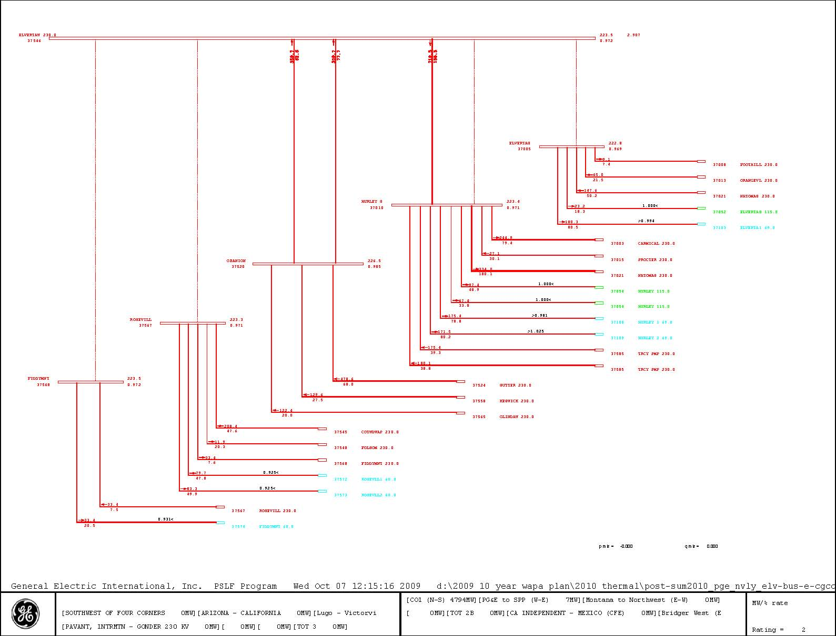
Figure 5-3
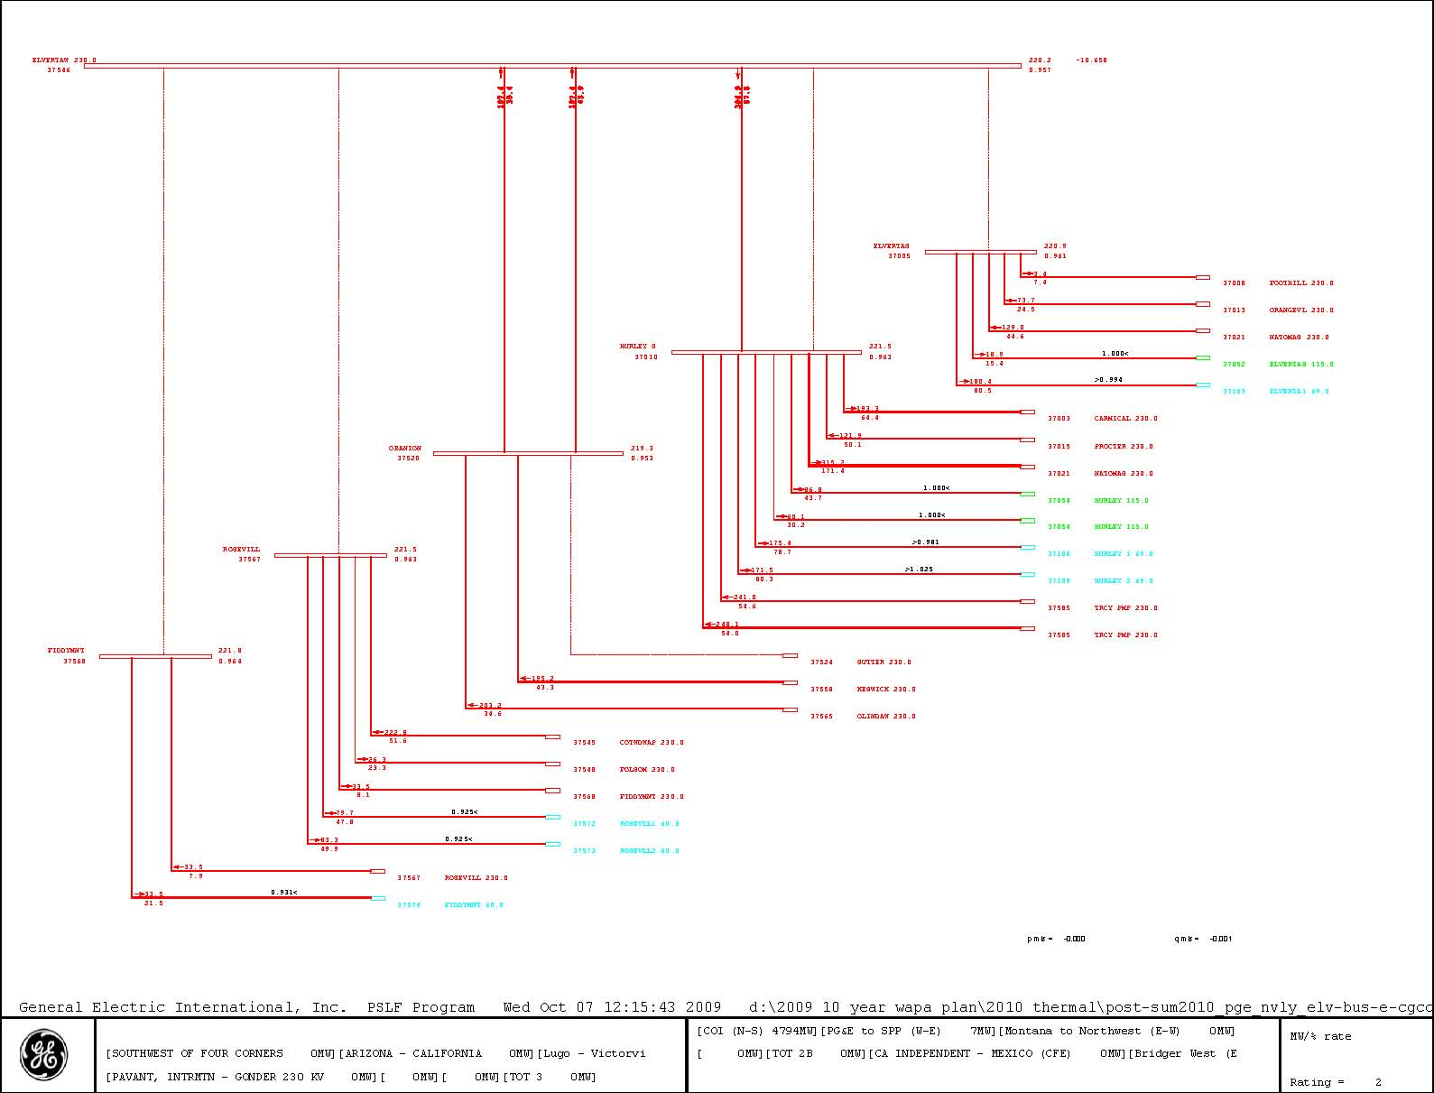
Figure 5-4
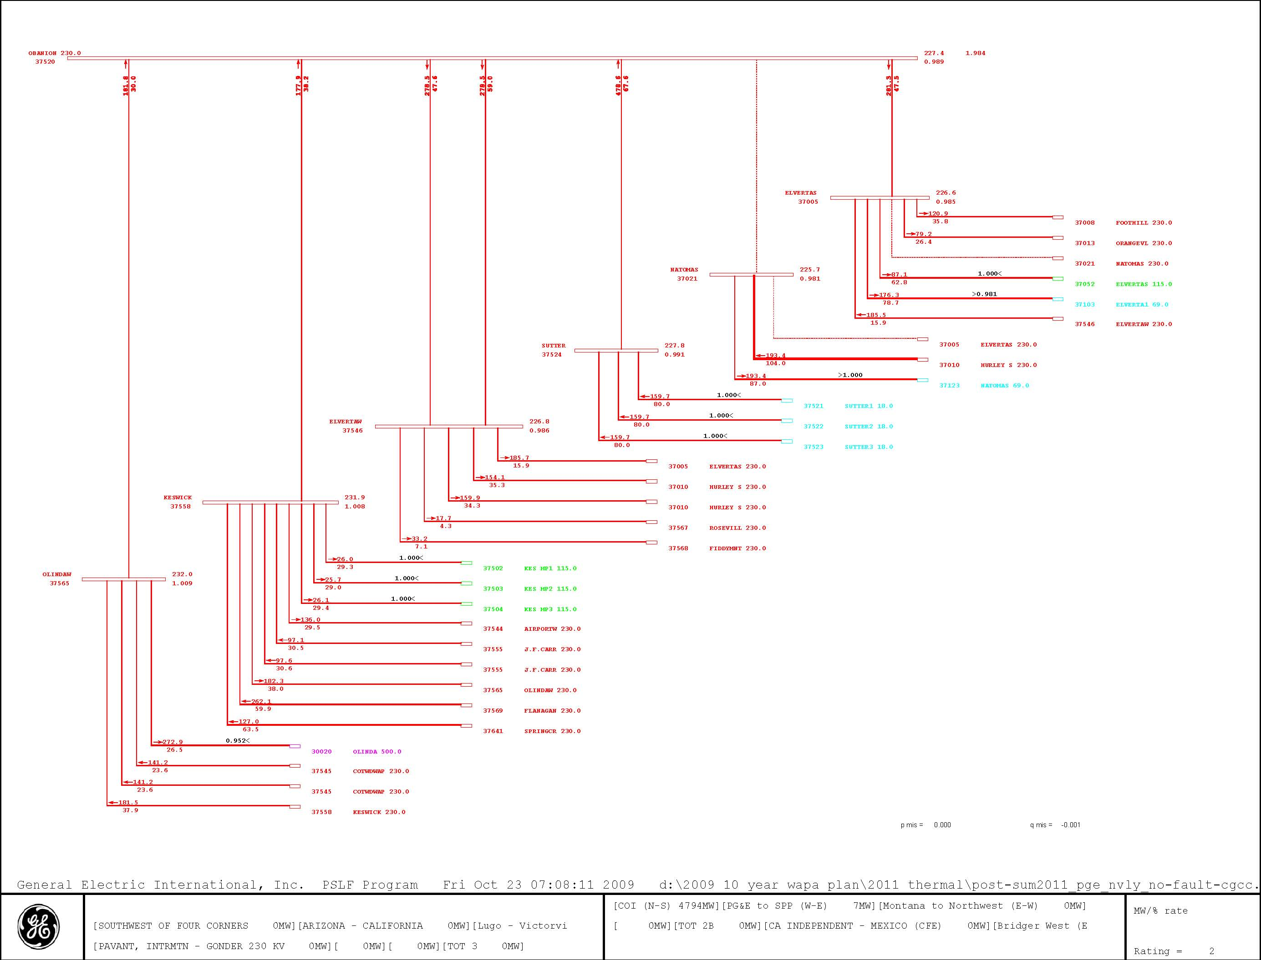
Figure 5-5

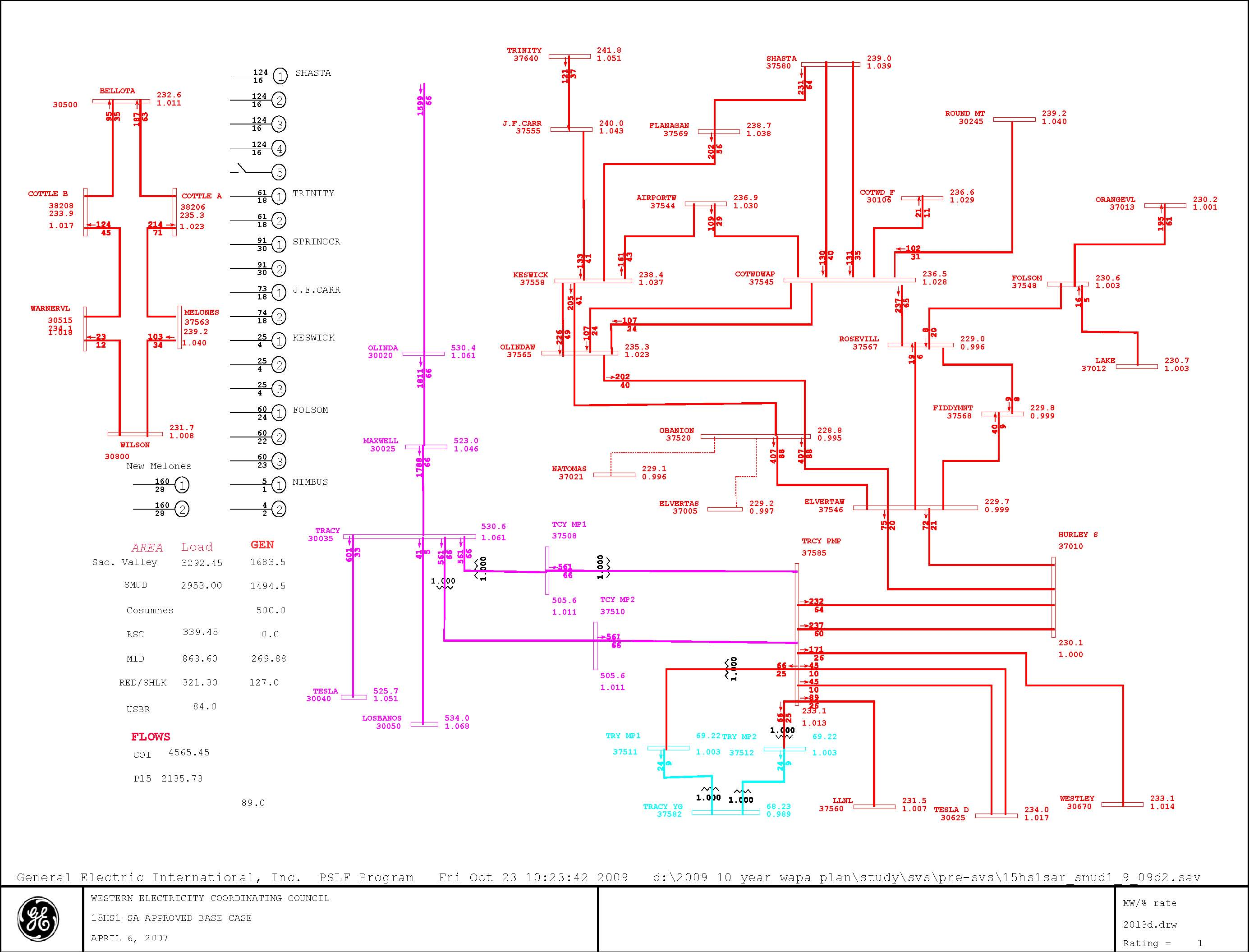
Figure 5-6
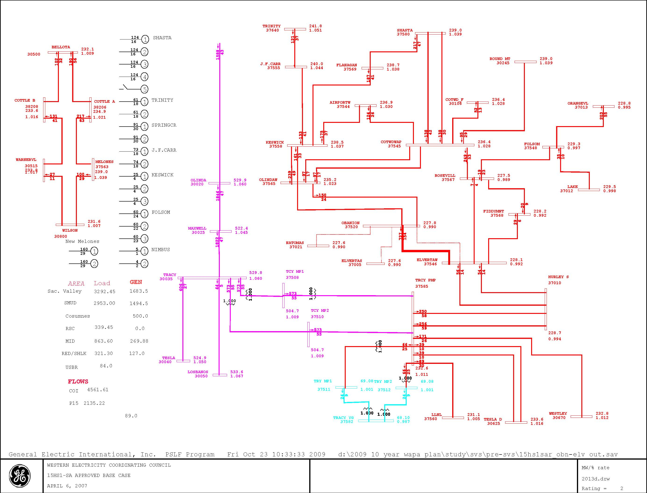
Figure 5-7
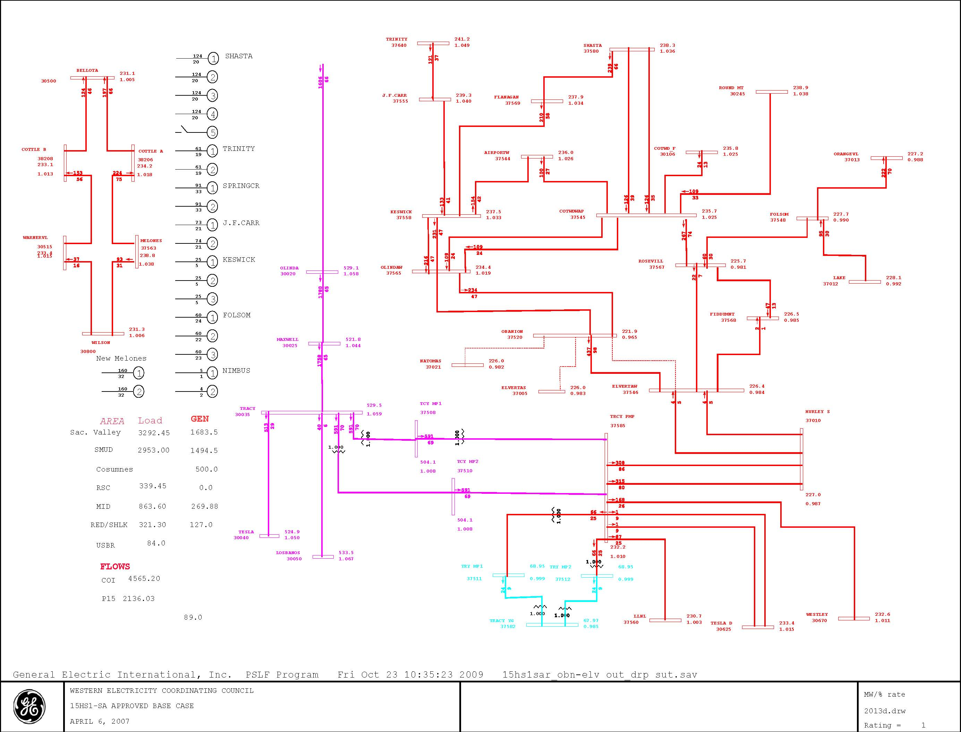
Figure 5-8
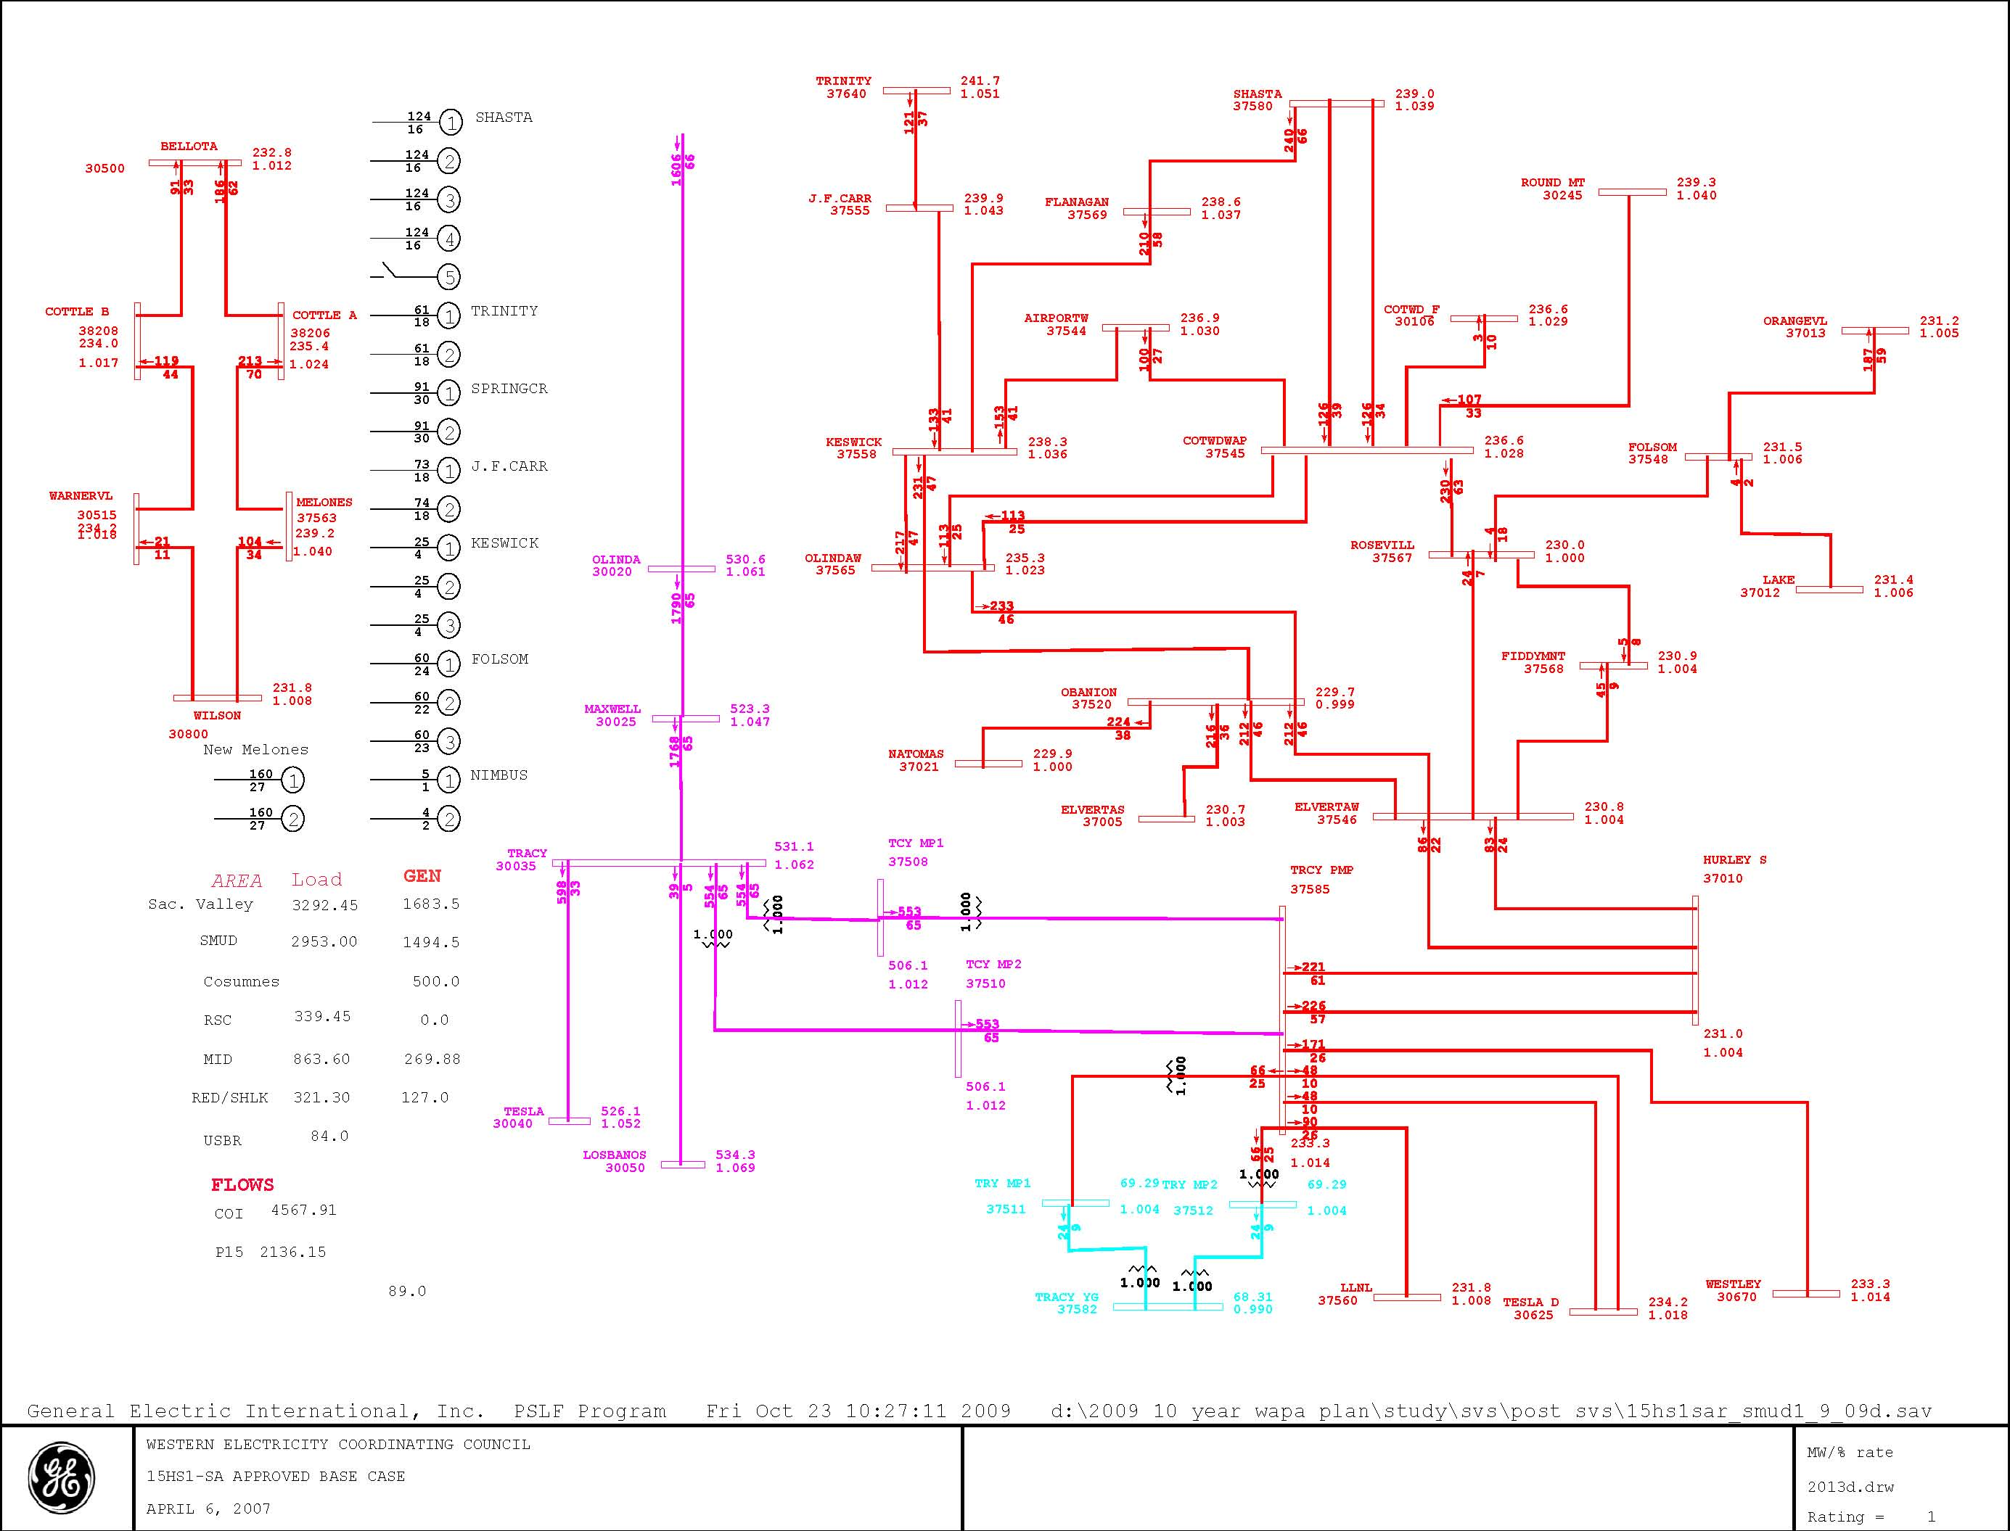
Figure 5-9
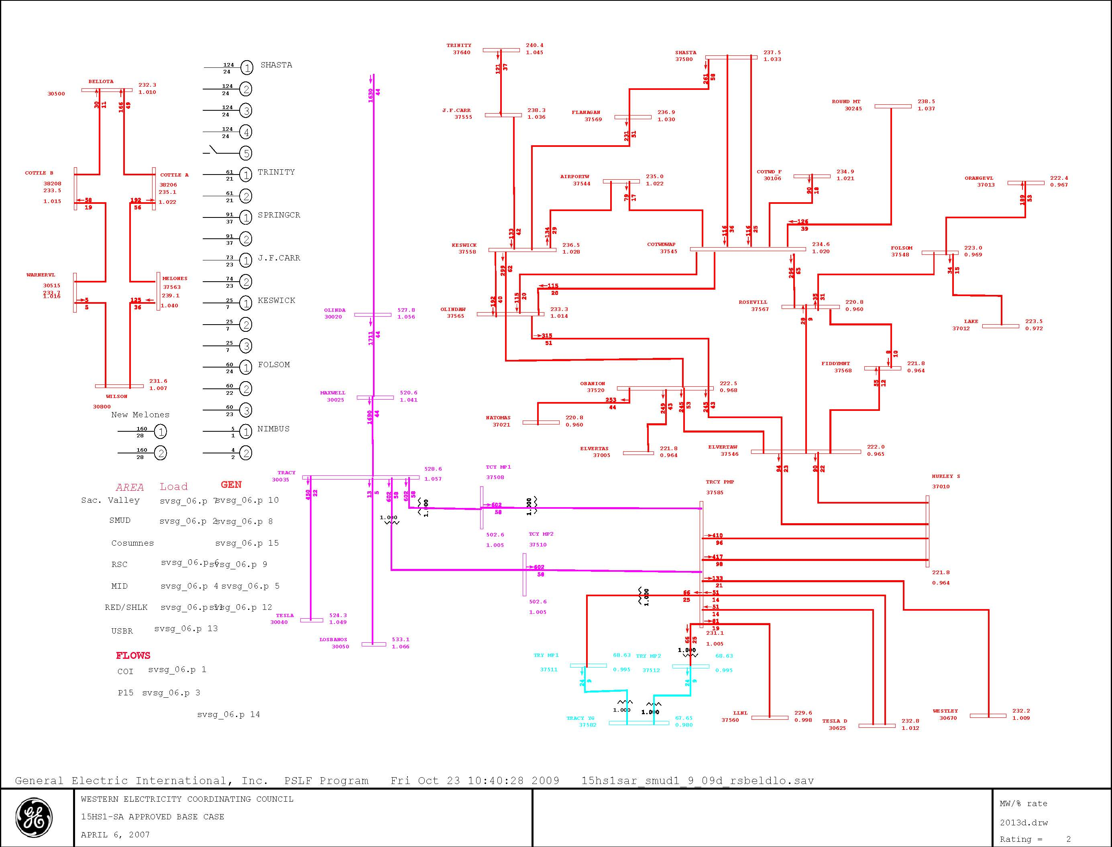
Figure 5-10
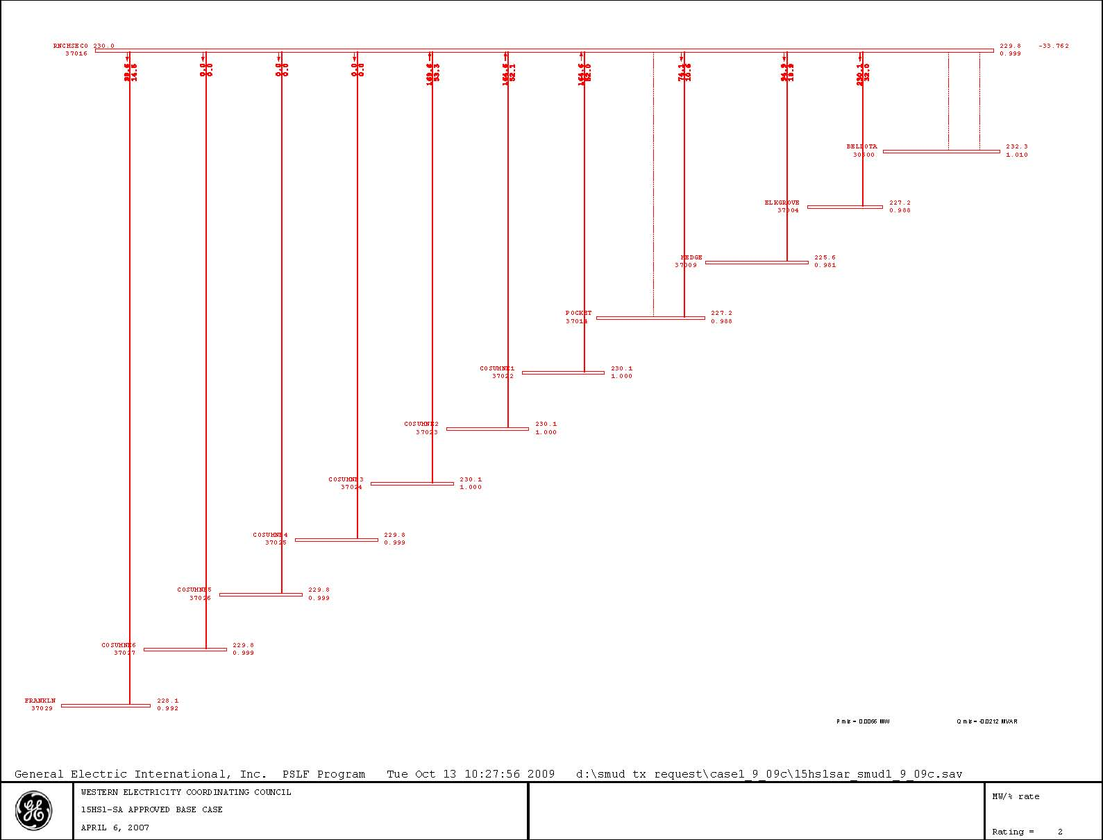
Figure 5-11
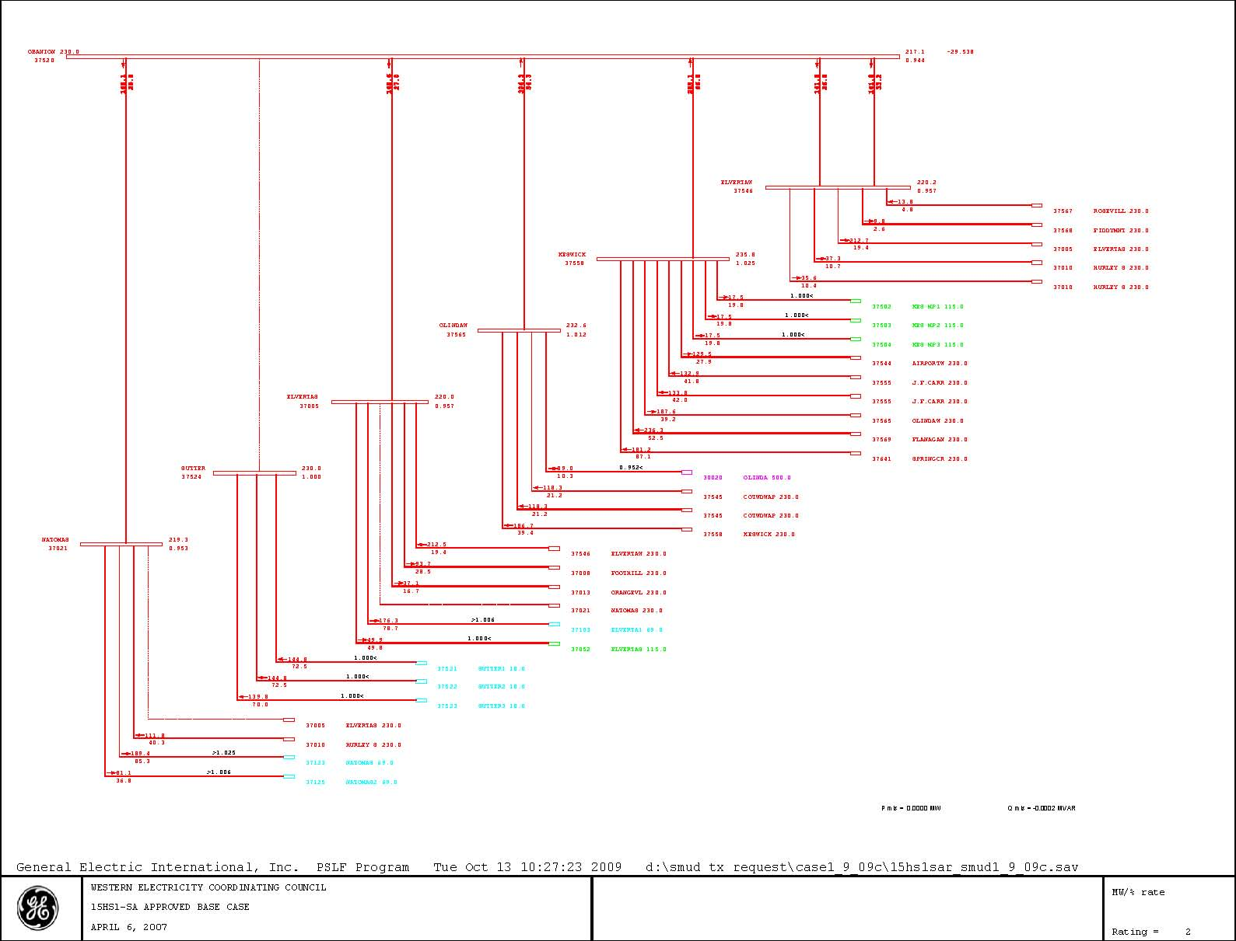
Figure 5-12
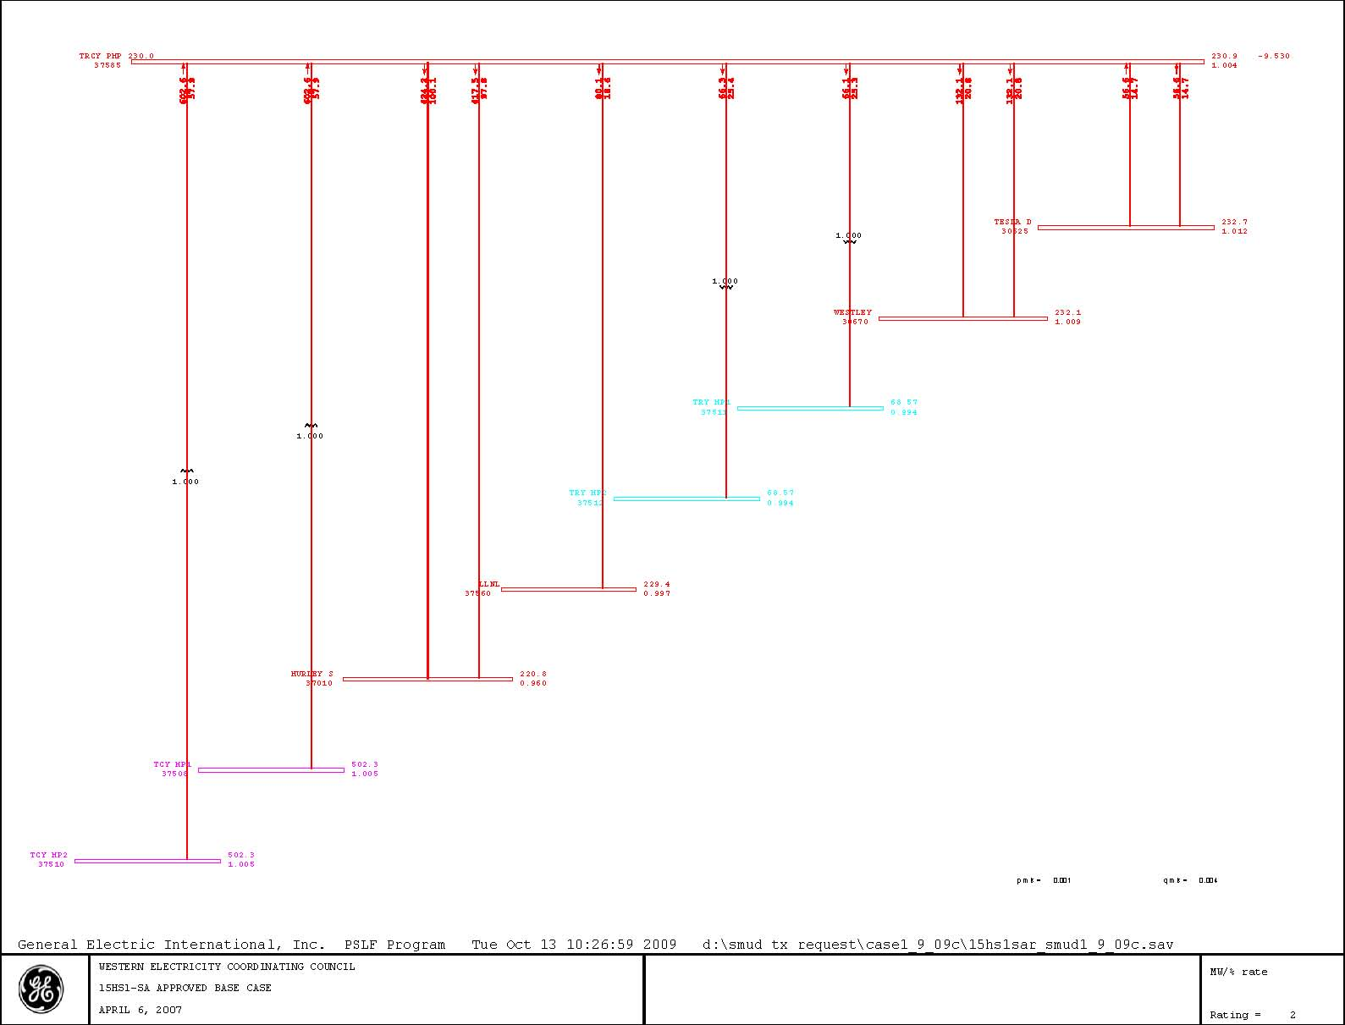
Figure 5-13
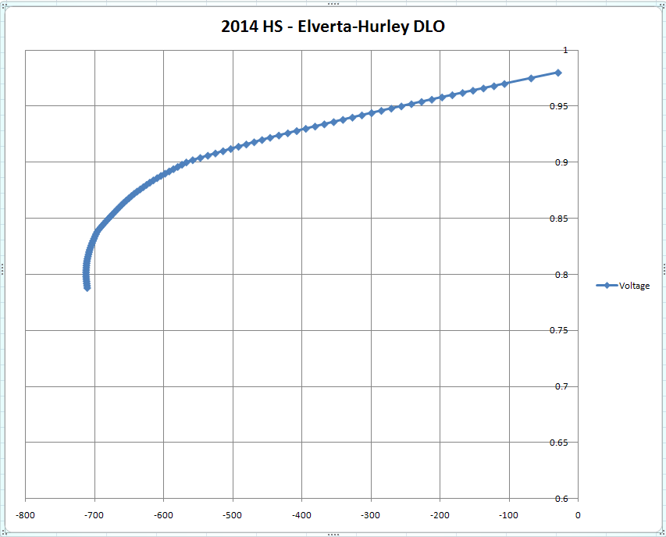
Figure 5-14 ElvertaW Voltage
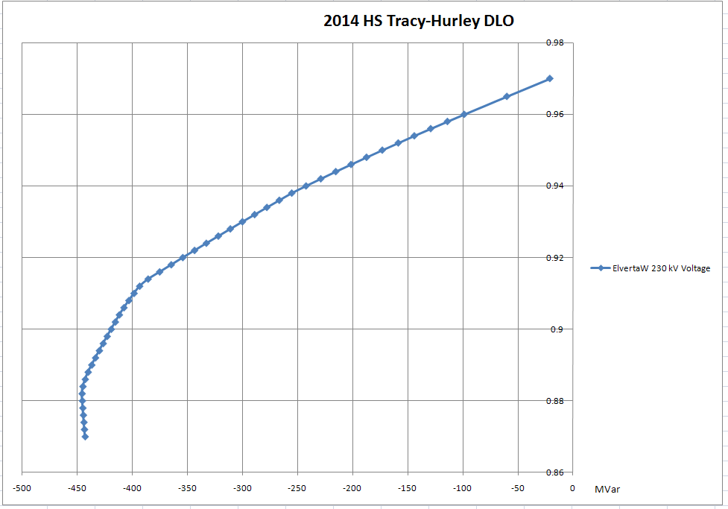
Figure 5-15 ElvertaW Voltage

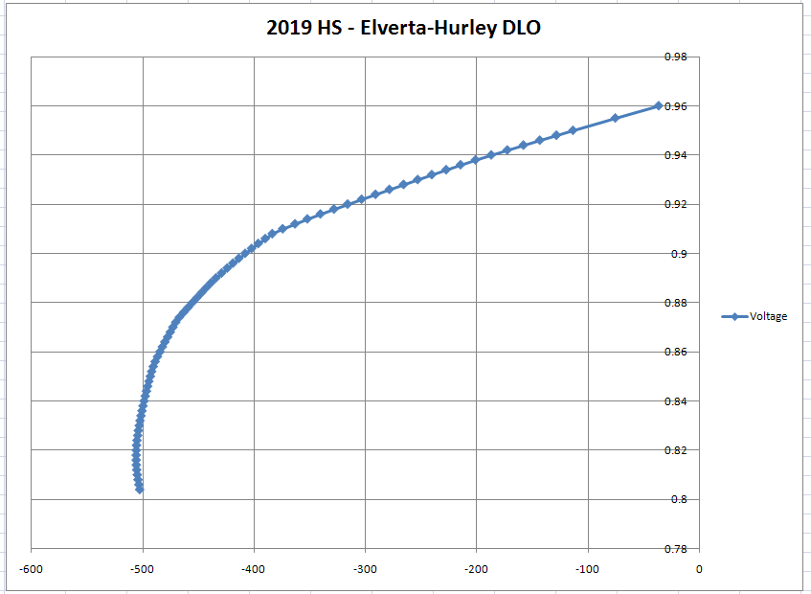
Figure 5-16 ElvertaW Voltage

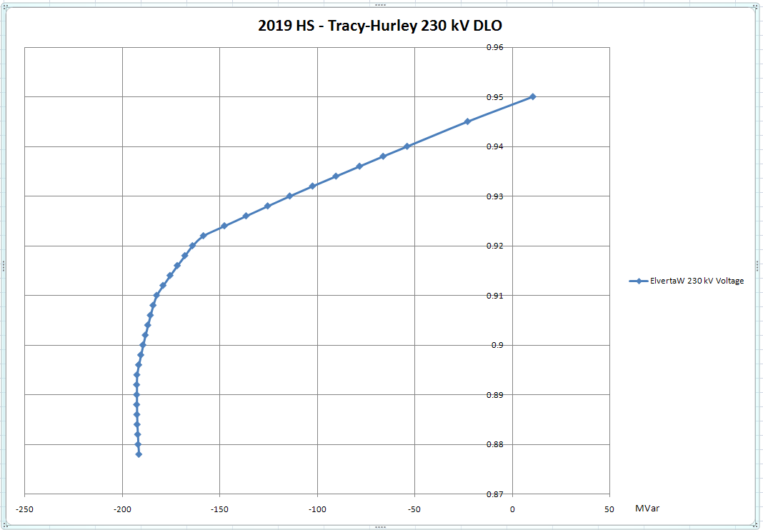
Figure 5-17 ElvertaW Voltage
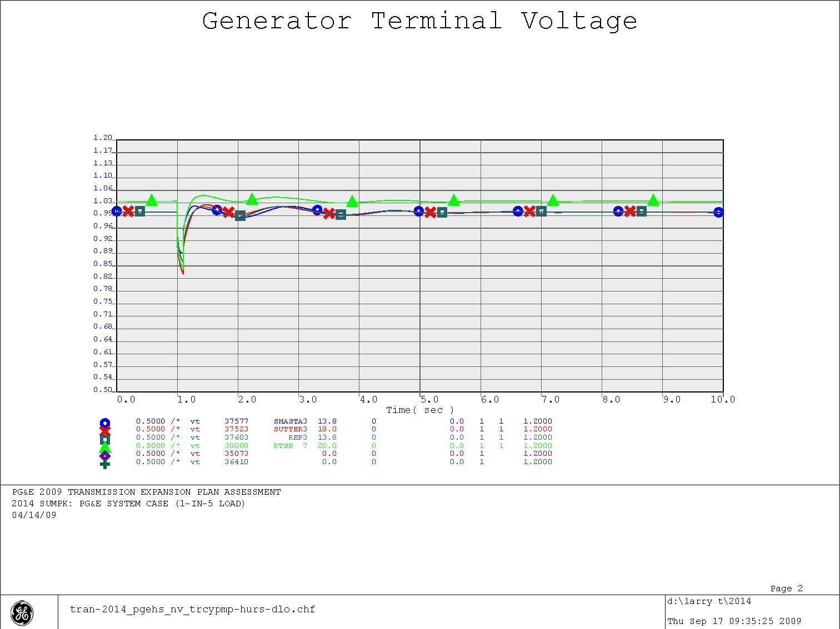
Figure 5-18
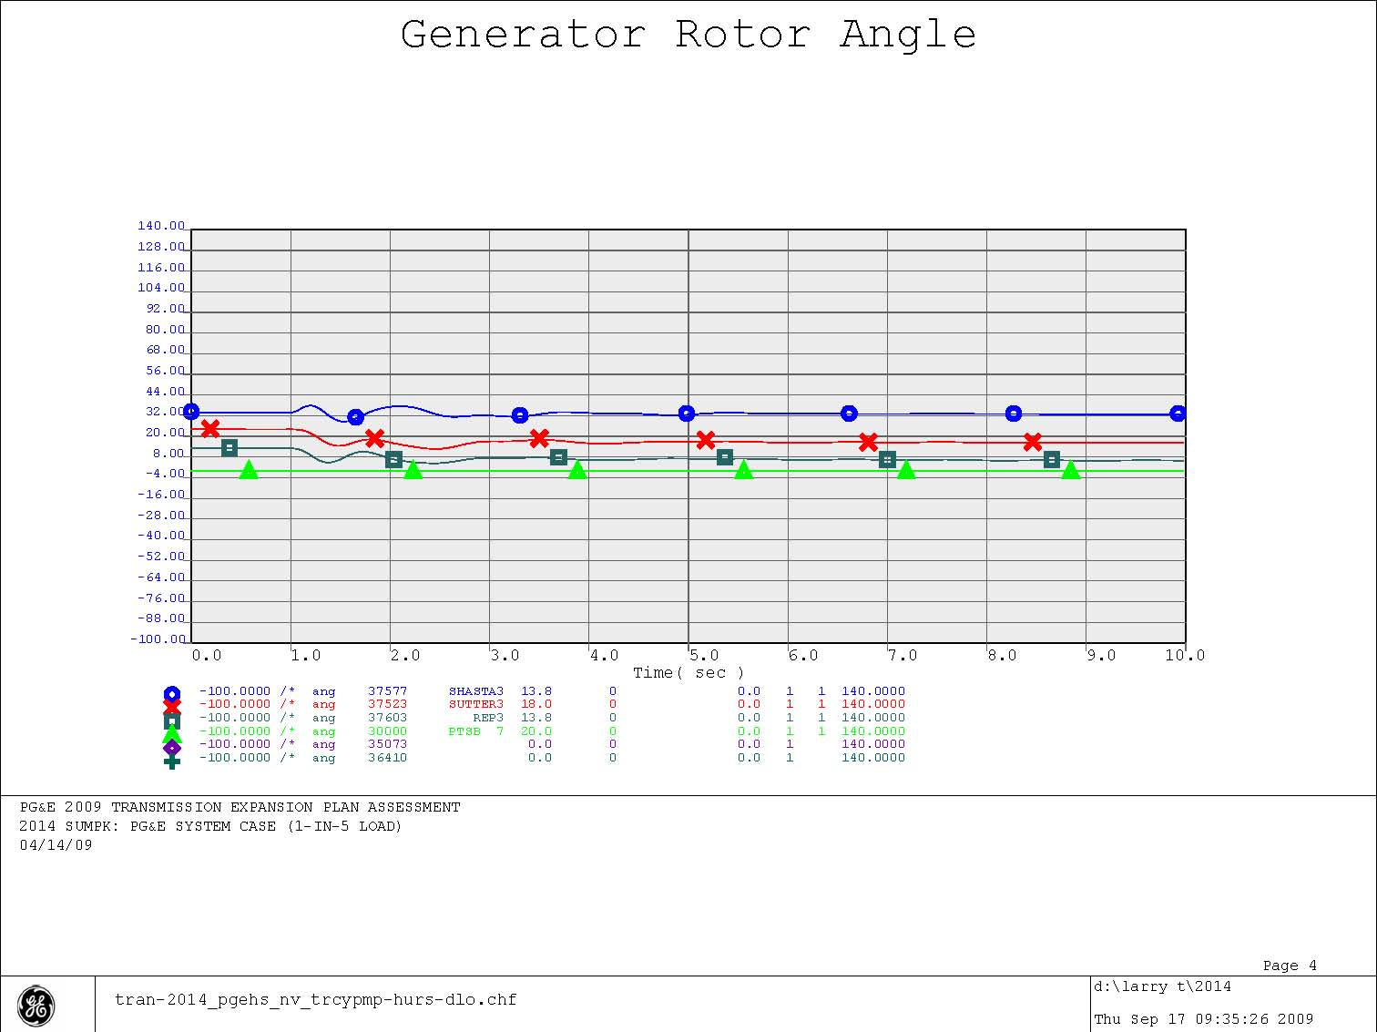
Figure 5-19
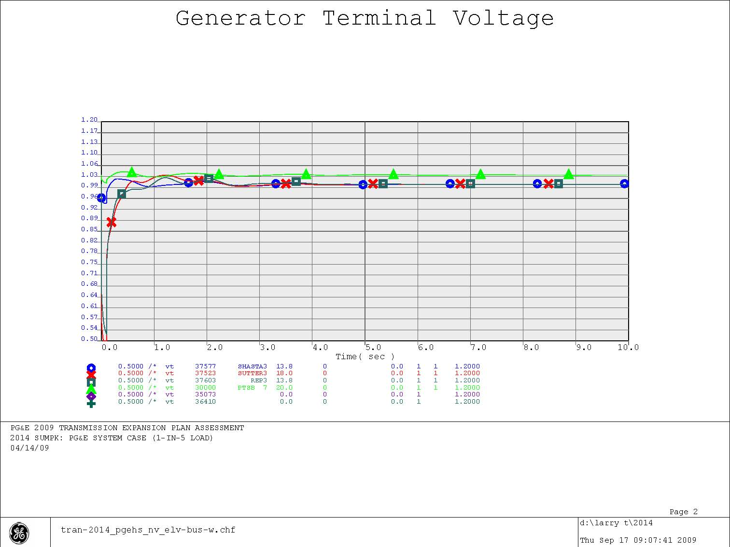
Figure 5-20

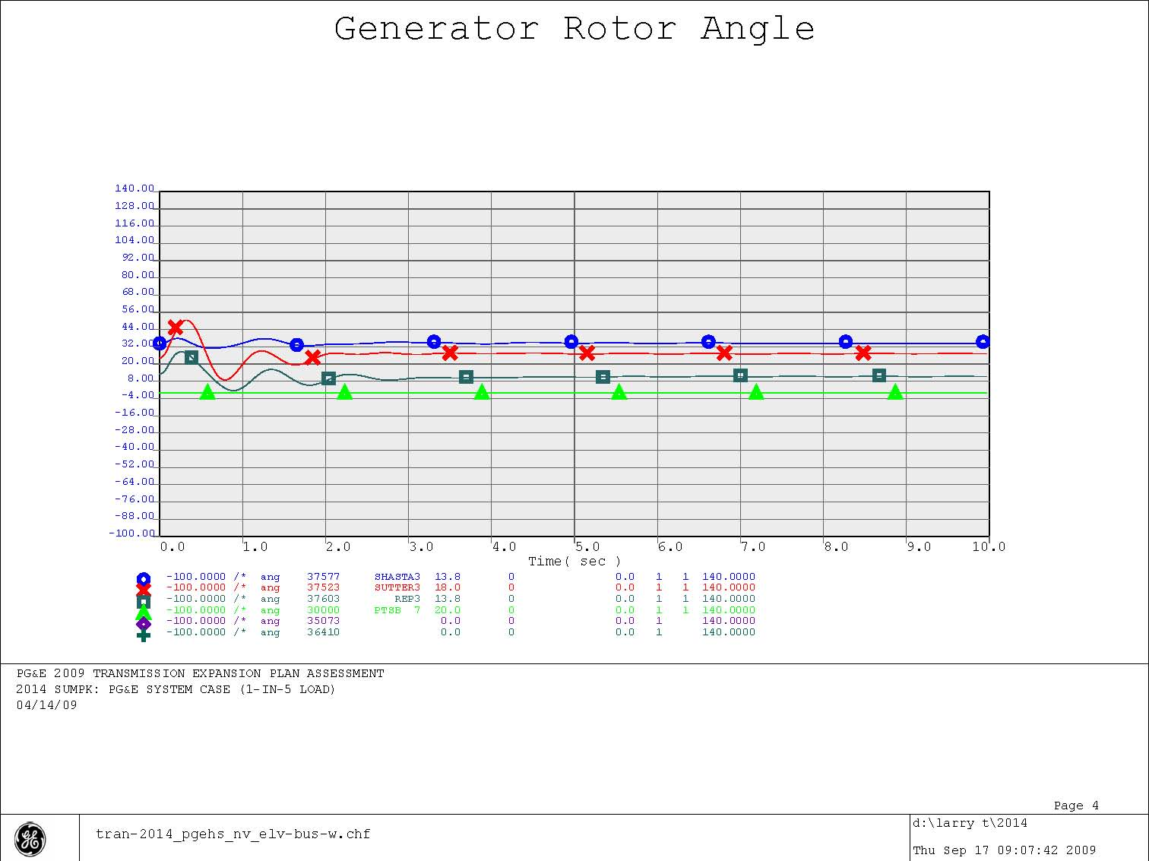
Figure 5-21

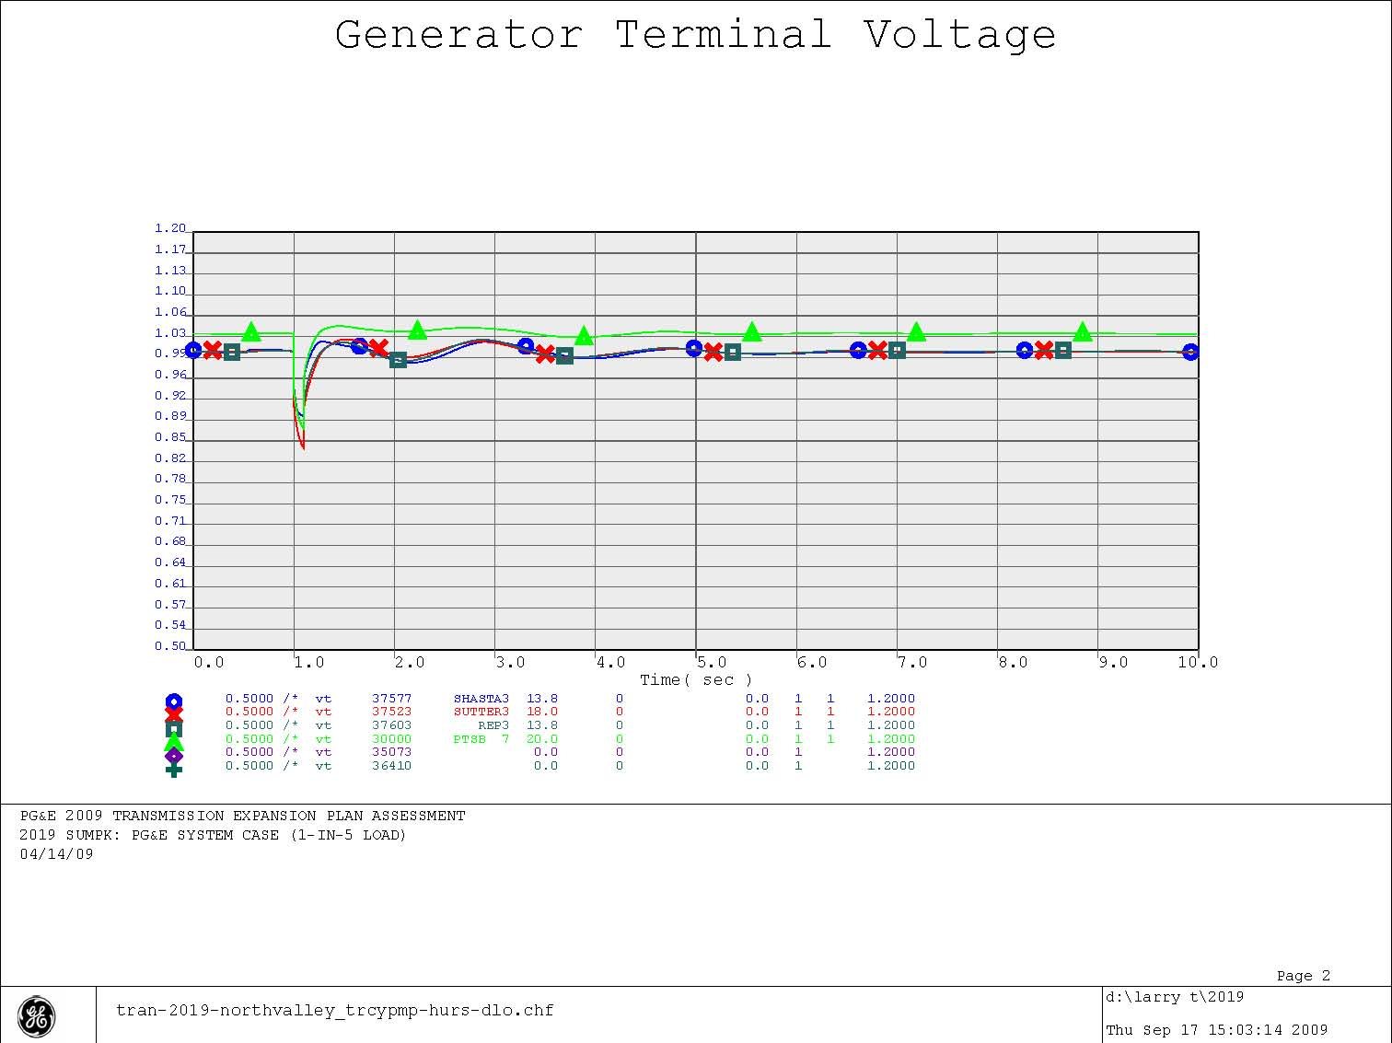
Figure 5-22
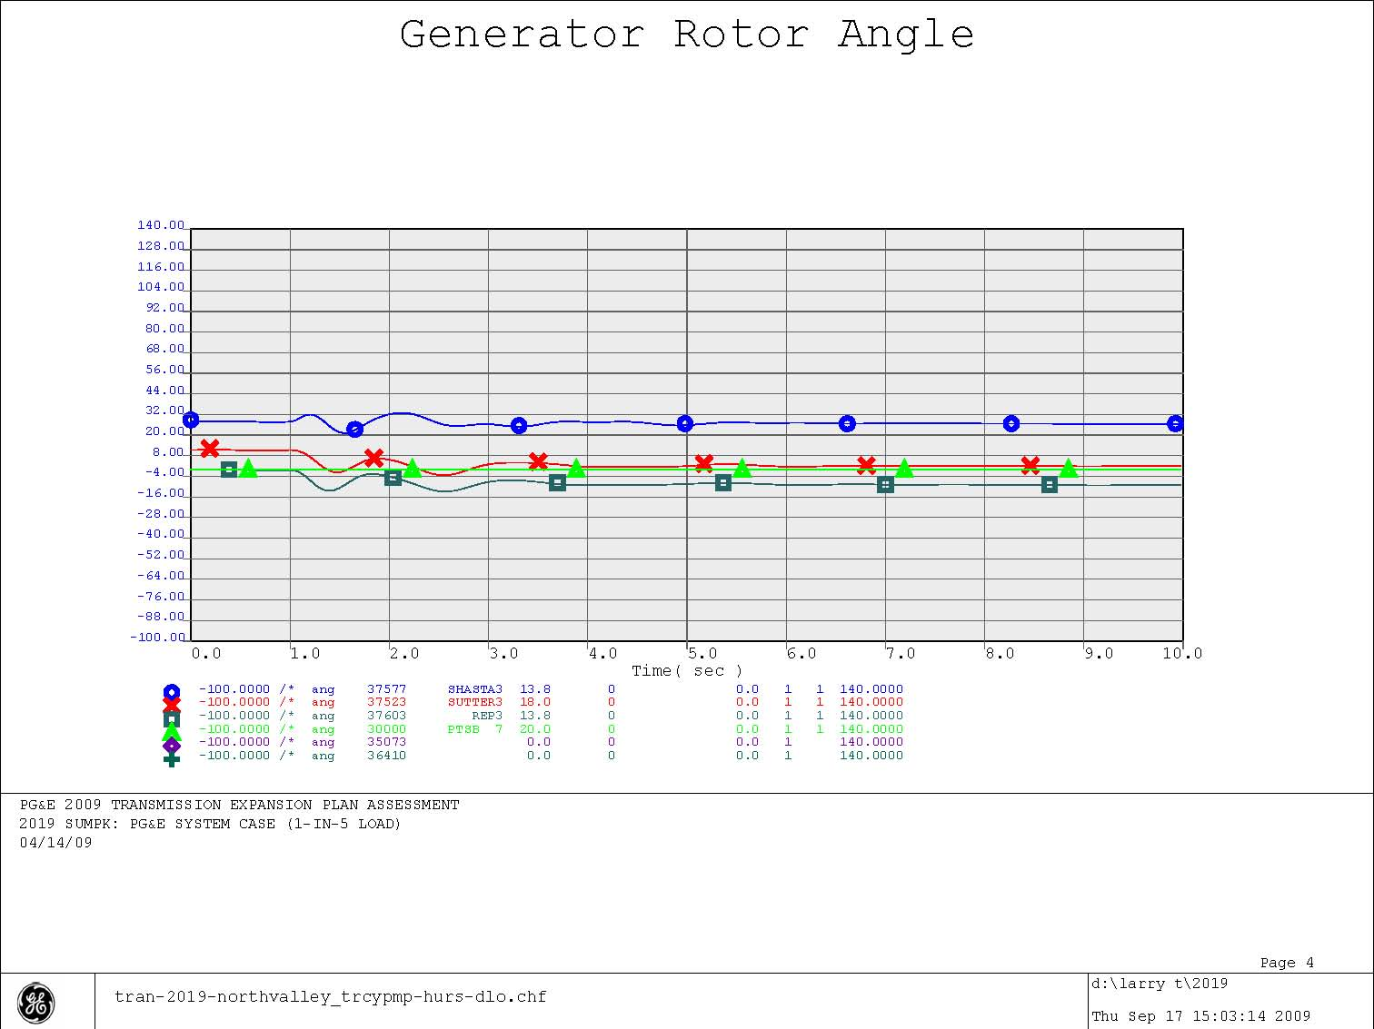
Figure 5-23
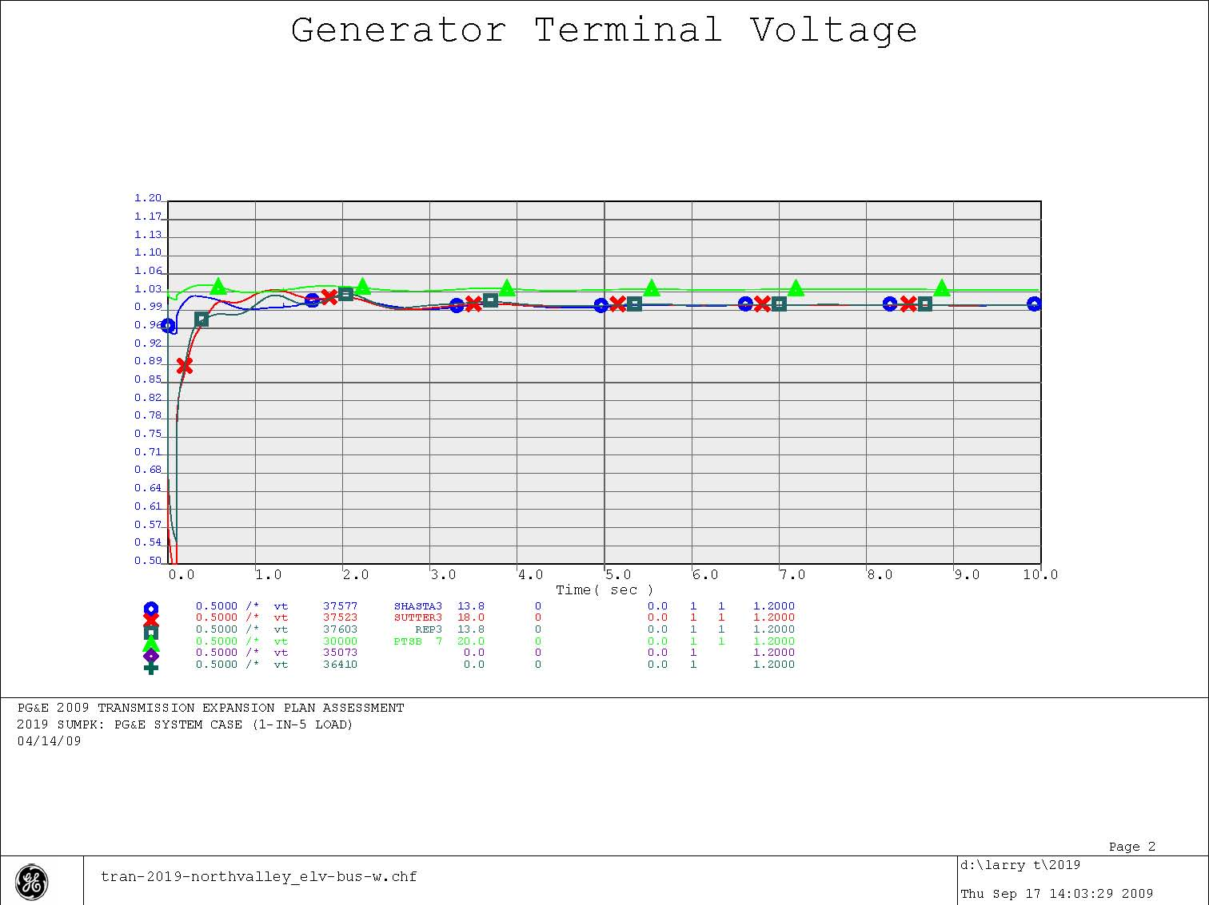
Figure 5-24
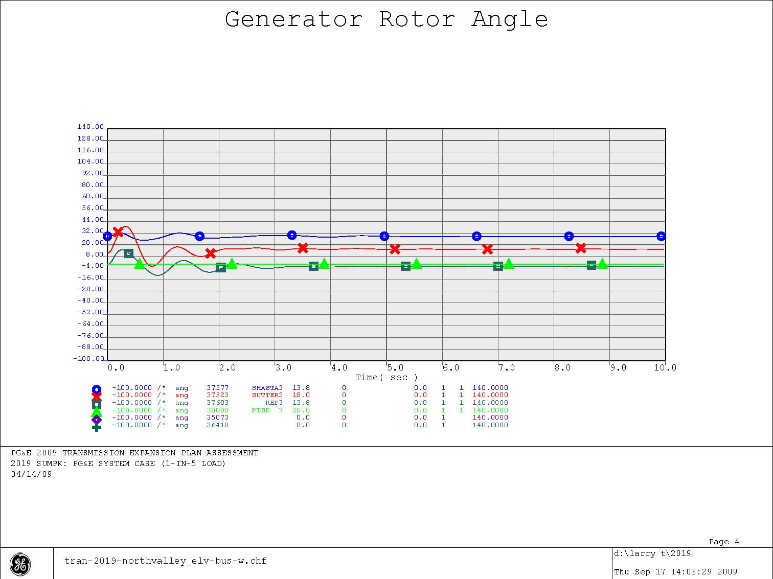
Figure 5-25

