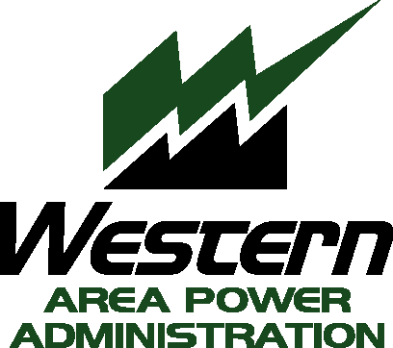
Sierra Nevada Region
Transmission Customer Meeting Agenda
Thursday, April 28, 2016 – 9:00 – 9:45 a.m.
Lake Natoma Inn, 702 Gold Lake Drive, Folsom, CA 95630

Kevin Howard, Vice President of Power Operations

- Welcome
- System Improvement Project Update
- Real Time Contingency Analysis (RTCA) and Planning Coordinator (PC) Updates

Jennifer Henn, Public Utilities Specialist

- Transmission Rates Update

