Wolverine Power Supply Cooperative, Inc.
Attachment O Annual Informational Filing
Section II.D.1 – II.D.8 Annual Update Requirements
2016 Update (for June 1, 2017 posting)

- Data-populated Formula Rate Template titled “Wolverine Power Supply - V33_Attach O - Form 1_ER15-1490 (Eff 06 01 15) – Updated for 2016 YE FF1” has been separately posted with this summary.

- Wolverine’s 2016 Formula Rate Template is based on Wolverine’s 2016 FERC Form 1.

- See Wolverine’s data populated Formula Rate Template titled “Wolverine Power Supply - V33_Attach O - Form 1_ER15-1490 (Eff 06 01 15) – Updated for 2016 YE FF1” and accompanying Workpapers 1 – 9.

- See Wolverine’s data populated Formula Rate Template titled “Wolverine Power Supply - V33_Attach O - Form 1_ER15-1490 (Eff 06 01 15) – Updated for 2016 YE FF1” and accompanying Workpapers 1 – 9.

- Changes in the formula references to Wolverine’s Formula Rate Template for 2016 have been identified in the generic Attachment O revisions, identified in the table below.

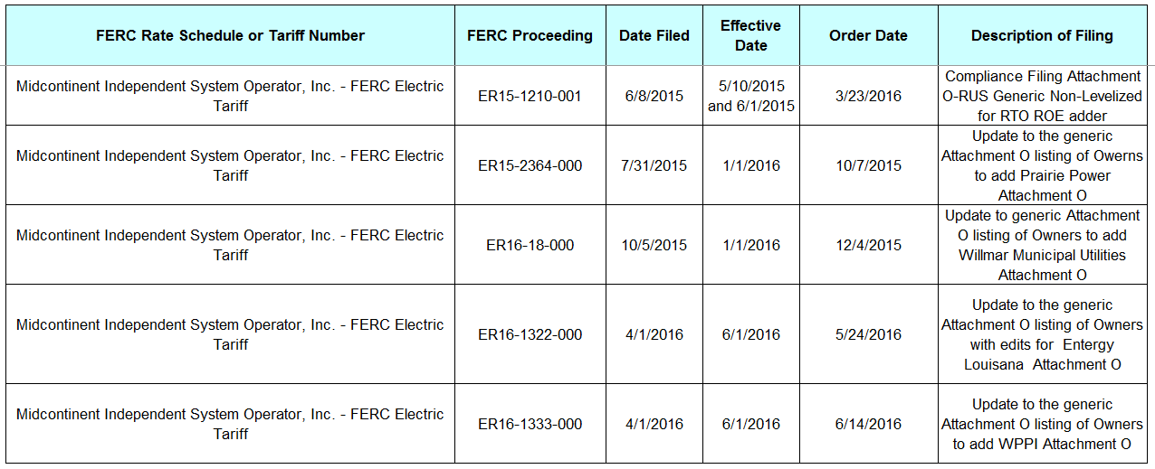

Changes in the formula references to Wolverine’s Formula Rate Template for 2016 have been identified in the generic Attachment GG revisions, identified in the table below.

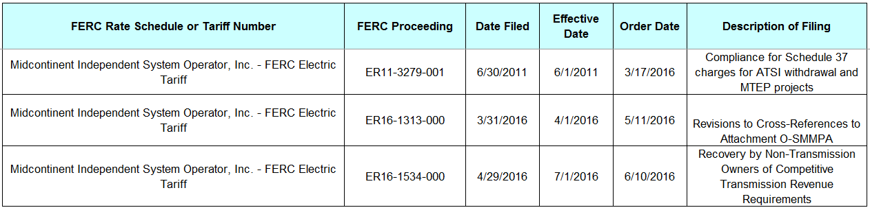

- See Wolverine’s data populated Formula Rate Template titled “Wolverine Power Supply - V33_Attach O - Form 1_ER15-1490 (Eff 06 01 15) – Updated for 2016 YE FF1” and accompanying Workpapers 1 – 9.

- See Wolverine’s data populated Formula Rate Template titled “Wolverine Power Supply - V33_Attach O - Form 1_ER15-1490 (Eff 06 01 15) – Updated for 2016 YE FF1” and accompanying Workpapers 1 – 9.

- a.
- In 2016, Wolverine did not implement any new accounting standards or policies that affects the inputs to the formula rate.
- In 2016, Wolverine did not implement any new accounting practices for unusual or unconventional items where FERC has not provided specific accounting direction.
- In 2016, Wolverine discovered errors in the amount of depreciation recorded in Account 403 for prior years. The majority of the errors date back to a one-time event in 2000, shortly after the implementation of Wolverine’s current accounting system. The errors resulted in the understatement of depreciation expense and the overstatement of net margins for 2000 through 2015. On the balance sheet, these errors resulted in understatement of accumulated depreciation and overstatement of patronage capital for 2000 through 2015.
- In 2016, Wolverine did not implement any new estimation methods or policies that change prior estimates.
- In 2016, Wolverine did not incur changes to income tax elections.

b. Items have been included in the formula rate on a historic basis.

c. In 2016, Wolverine did not incur any reorganization or merger transactions.

d. The depreciation errors described in 8(a)(iii) above caused misstatement of several inputs to Wolverine’s Attachment O formula rate calculation, the overall effect of which resulted in annual under-collections of Wolverine’s transmission revenue requirement since its implementation of the Attachment O formula rate. The misstated items are summarized as follows:
- Annual transmission depreciation expense was excluded from the Attachment O formula rate calculation, which caused an under-collection of transmission revenue.
- Accumulated Depreciation was under-stated, which caused an over-statement of Transmission Rate Base. The over-statement of Transmission Rate Base led to an over-collection of transmission revenue through Wolverine’s Attachment O revenue requirement.
- Proprietary Capital (called patronage capital within cooperatives) was over-stated, which caused an over-collection of transmission revenue through Wolverine’s Attachment O revenue requirement.

In no year did Wolverine over-state its transmission revenue requirement. Rather, in each year since Wolverine’s implementation of the Attachment O formula rate calculation, the foregone revenues due to its misstatement and under-collection of annual transmission depreciation expense substantially offset any over-collection of transmission revenue due to its over-statement of Transmission Rate Base and Proprietary Capital. Consequently, the net effect of the accounting misstatement was that Wolverine under-collected its transmission revenue requirement in each year since its implementation of the Attachment O formula rate. As a Historical Rate filer using the standard Attachment O rate template, Wolverine’s Attachment O does not contain a provision for a “true-up” of under/over-collection of transmission revenue, and Wolverine is not seeking to adjust any prior year recovery. On a prospective basis, Wolverine has adjusted its affected transmission asset records to appropriately depreciate its transmission assets, restated its balance sheet accounts of Accumulated Depreciation and Proprietary Capital for the errors, and will begin collecting for these assets in its 2016 Attachment O update (effective June 1, 2017).

