



Load Customer Upload (LCU)
User’s Manual

Project Name | Load Customer Upload (LCU)
Project Number | P200607 | Version # | 2.0
Date | August 22, 2008
Author(s) | David Kalkbrenner
Project Lead | Ryan Plaisance, Sharon Mann
Customer | AFC Stakeholders, WPP Project
TABLE OF CONTENTS

REVISION CHART 3
DOCUMENT STORAGE 3
General Information 4
Introduction 4
LCU Website User Interface Specifications: 4
Navigating the Load Customer Upload Website 5
Accessing the Load Customer Upload Website 5
Supported File Formats and Upload Methods 7
Upload Method - LOAD FORECAST file ONLY 8
Upload Method - LOAD FORECAST file ONLY (continued..) 11
Upload Method - UNIT COMMITMENT and LOAD FORECAST files 17
Upload Method - UNIT COMMITMENT and LOAD FORECAST files (continued..) 18
Upload Method - UNIT COMMITMENT and LOAD FORECAST files (continued..) 19
Upload Method – UNIT COMMITMENT and LOAD FORECAST files (continued..) 21
Upload Method – UNIT COMMITMENT and LOAD FORECAST files (continued..) 24
Upload Method – RESERVATION STACK and LOAD FORECAST files 30
Upload Method – RESERVATION STACK and LOAD FORECAST files (continued..) 31
Upload Method – RESERVATION STACK and LOAD FORECAST files (continued..) 32
Upload Method – RESERVATION STACK and LOAD FORECAST files (continued..) 34
Upload Method – RESERVATION STACK and LOAD FORECAST files (continued..) 37
Logging Out \ Closing the Load Customer Upload Website 43
CONCLUSION 46

REVISION CHART

This chart contains a history of this document’s revisions.

Version | Brief Description of Version | Revised By | Date Completed
1.0 | Initial Version | David Kalkbrenner | April 10, 2007
1.1 | Updated website links | Cliff Lemoine | April 13, 2007
1.2 | Added file validation requirements, website exit procedures, and other minor corrections. | David Kalkbrenner | April 16, 2007
1.3 | Added Introduction / Conclusion Sections | David Kalkbrenner | April 17, 2007
1.4 | Modified validation rules and file upload process due to new FTP logic used. | David Kalkbrenner | May, 17, 2007
2.0 | Revisions for LCU Task 3B | David Kalkbrenner | August 22, 2008

DOCUMENT STORAGE

Copies of all documentation relative to this project will be stored, in electronic and printed, format in the Transmission Technology Delivery Department.

General Information

Introduction

Entergy Transmission prepared a proposal to change the dispatch methodology used in the AFC process. The proposal was reviewed and voted on Sep 19th, 2006 by AFC Stakeholders and was approved for implementation. Under this proposal Network Customers are asked to provide forecasted load and dispatch data to Entergy transmission for inclusion in the AFC process. The purpose of the Load Customer Upload website is to allow the network customers to have the ability to upload the required data files into the AFC process.

The initial version of the Load Customer Upload website released in May 2007, allowed the network customer to only submit file formats for Load Forecast and Unit Commitment. An enhanced version of the LCU website is scheduled to be released in 2008 that will adhere to the Task 3B requirements. This Task 3B version of LCU will allow uploads of files in the following formats: Load Forecast, Unit Commitment, Hourly Dispatch, and Reservation Stack.

The processes covered in this user’s manual will be limited to general file validation rules and requirements for the supported file formats and the basic operation of the LCU website only. Additional technical information and data file format requirements can be found in the NC LF UC Data Input Functional Specification document that was supplied at the February 2006 AFC Stakeholder meeting.

LCU Website User Interface Specifications:

The minimum requirements needed to access and utilize the Load Customer Upload website are:
- a modern computer with an internet connection. (a high speed connection is recommended)
- a monitor that will support a screen resolution of 800 x 600 or better.
- a recent web-browser such as Microsoft’s Internet Explorer.
- a client digital security certificate (the same certificate used to access Entergy’s OASIS node)

Navigating the Load Customer Upload Website

Accessing the Load Customer Upload Website
- Open Internet Explorer. (double click the icon)

- Type one of the following URLs or website addresses into the web browser’s address box.

During the Market Trials or for testing versions not yet in Production, use the following URL:

https://wpp-test.entergytransmission.com/lcu (For Testing Only)

Once testing has been completed, to use the current Production version of the website, the following URL should be used:

https://wpp.entergytransmission.com/lcu (Current Production Version)

- The Load Customer Upload website will display.

Links to the Load Customer Upload production website will also be provided on Entergy’s OASIS website
at: http://oasis.e-terrasolutions.com/

Please note, access to the LCU websites will be governed by server and client certificates. Users will be expected to utilize the same certificate for the LCU website as is used for Entergy’s OASIS access.

Microsoft Internet Explorer is the web browser referenced in this document although most recent browsers that support the Secure Sockets Layer (SSL) protocol will work with the LCU website.

Logging In – The Initial Home Page

Upon entering the Load Customer Upload website, the system will automatically determine the correct company name related to the user by accessing the user’s digital certificate. Using this company name, the user will be automatically logged into the LCU website. This login process will govern the ability that each authorized user may only upload data files associated with their own company, thus preventing a network customer from submitting files for any other company.

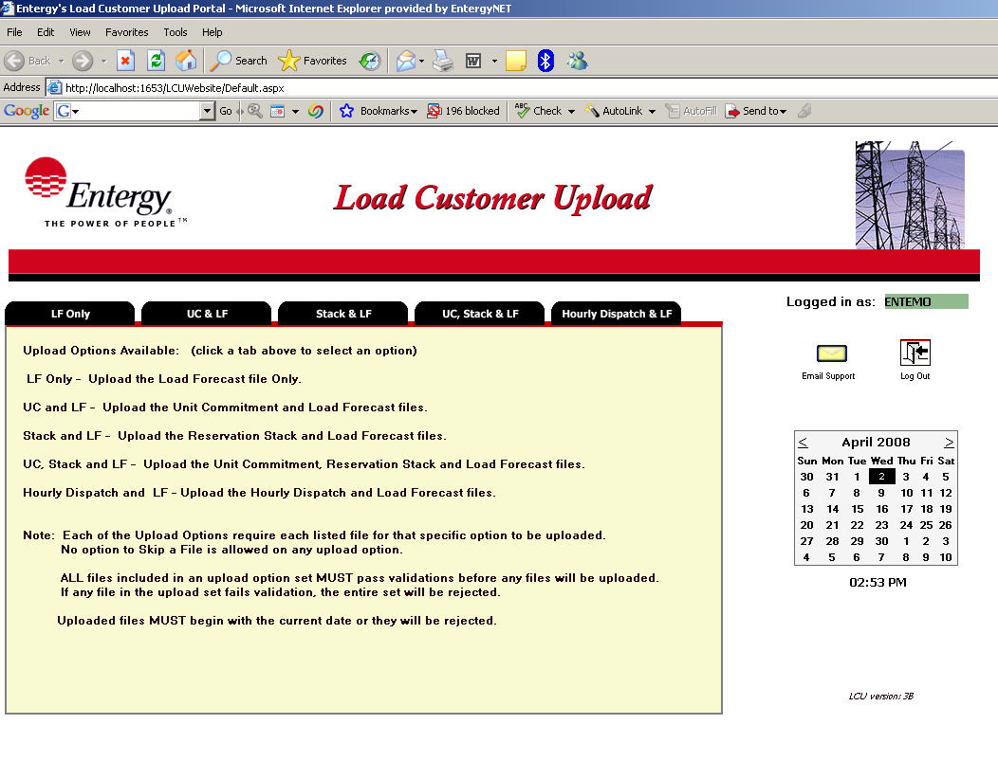
Figure 1.

The “Logged in as:” will be populated with the company name read from the digital certificate.

Figure 1 is an example of the Load Customer Upload website displayed after the initial login is complete.

Each labeled tab is a link to a supported Upload Method on the LCU website.

Supported File Formats and Upload Methods

Currently five different Upload Methods are allowed by the Load Customer Upload website. Each of these upload methods use a combination of the four supported file formats.

The supported file formats include:

- Load Forecast

- Unit Commitment

- Hourly Dispatch

- Reservation Stack

The allowed Upload Methods include:

- LF Only – Upload the Load Forecast file only.

- UC & LF - Upload the Unit Commitment and Load Forecast files.

- Stack & LF – Upload the Reservation Stack and Load Forecast files.

- UC, Stack & LF – Upload the Unit Commitment, Reservation Stack, and Load Forecast files.

- Hourly Dispatch & LF – Upload the Hourly Dispatch and Load Forecast files.

Each upload method requires all files listed within that method to be uploaded. An option to skip the upload of any specific file is not allowed as in previous versions. Any incomplete uploads or uploads containing file validation errors will not be submitted into the AFC process.

Additional information concerning file validation errors and the requirements for successful uploads will be covered in the Validation Rules section of each upload method.

Upload Method - LOAD FORECAST file ONLY

The ‘Load Forecast Only’ upload method is selected by clicking on the tab that is labeled ‘LF Only’ on the main LCU home page.

The LCU website user is then prompted for the Load Forecast data file to be uploaded.

The simplest means to select a file to Upload is to click the ‘Browse’ button and navigate to any folder location available to the LCU website user’s desktop.

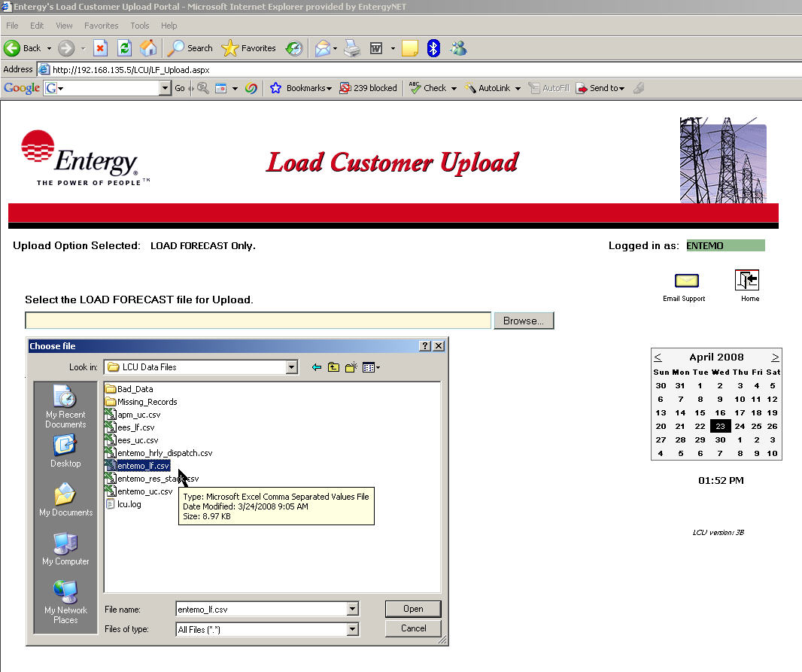
Figure 2.

The user may “double-click” on the desired file and the file name will populate in the appropriate submit file name box as shown in Figure 2 above.

Another technique is to type the complete path and file name in the submit box. The complete path of the file must be typed or the file will not submit. Ex: c:\[network_customer_name]\lf.csv (the [network_customer_name] should be replaced with the user’s company name code)

Upload Method - LOAD FORECAST file ONLY (continued..)

Click the Submit File button when a file has been selected.

The LCU website will ONLY allow a file named [network_customer_name]_lf.csv to be submitted as a Load Forecast data file. Any other file selected will display an error message with a chance to retry the file submission. (See Figure 3 below)

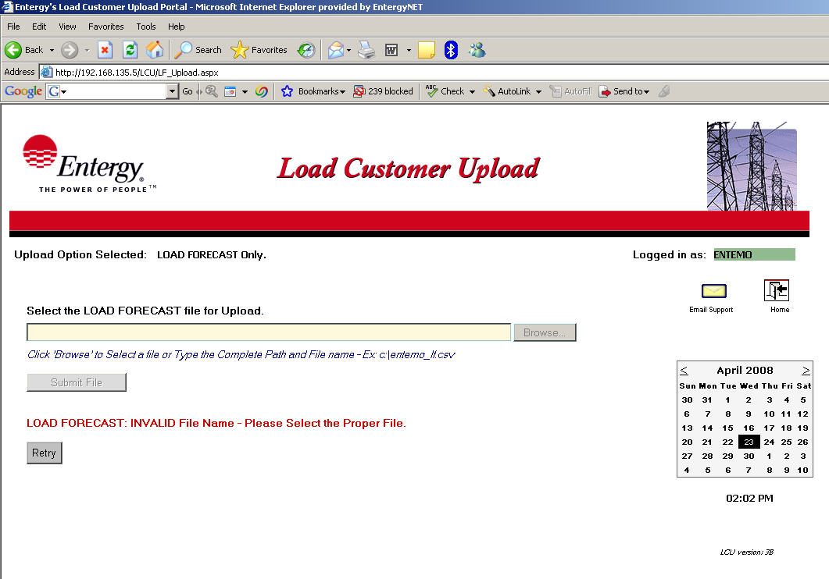
Figure 3.

Please note, the file names used in the examples above are for illustrative purposes only. The exact file names provided must adhere to the file name definitions outlined in the General Requirements section of the Functional Specifications Document.

Upload Method - LOAD FORECAST file ONLY (continued..)

After the Load Forecast file is submitted, validation tests are performed to check for the proper file format as outlined in the General Requirements section of the Functional Specifications Document. Load Forecast files must adhere to the following requirements to be accepted by the LCU website for processing:

Load Forecast File Validation Rules:

- File name must be ‘[network_customer_name]_lf.csv’ where [network_customer_name] is replaced with the customer’s Entergy OASIS company code.

- The file must have at least one record excluding any header records.

- The recommended number of records is 288 which consist of 11 days of hourly data and 24 days of daily data. The file will be accepted with missing time points however LCU will display a warning message for deviations from the recommended number of records.

- The date on the first entry of the file should be the current date and no records within the file can be previous to the current date.

- A data record must consist of the following fields beginning with the first column or character position of each record:

hour, nc name, MW

All fields are required fields.

- hour (the beginning hour date and time) must in dd-mmm-yyyy-hh-mm format.7

- nc name (the network customer’s name) is an alpha-numeric field that must be 16 characters or less. The nc name field in the CSV file must match the network customer’s company code as derived from client’s digital certificate used for the Entergy OASIS site.

- MW (the MW dispatch for the given hour) must be a number between 0 and 9999.

Upload Method - LOAD FORECAST file ONLY (continued..)

After the LCU website user submits the Load Forecast file, an informational message is displayed listing the status of the file validation as to whether it has Passed, Passed with Warnings, or Failed the validation tests. (See Figure 4 below)

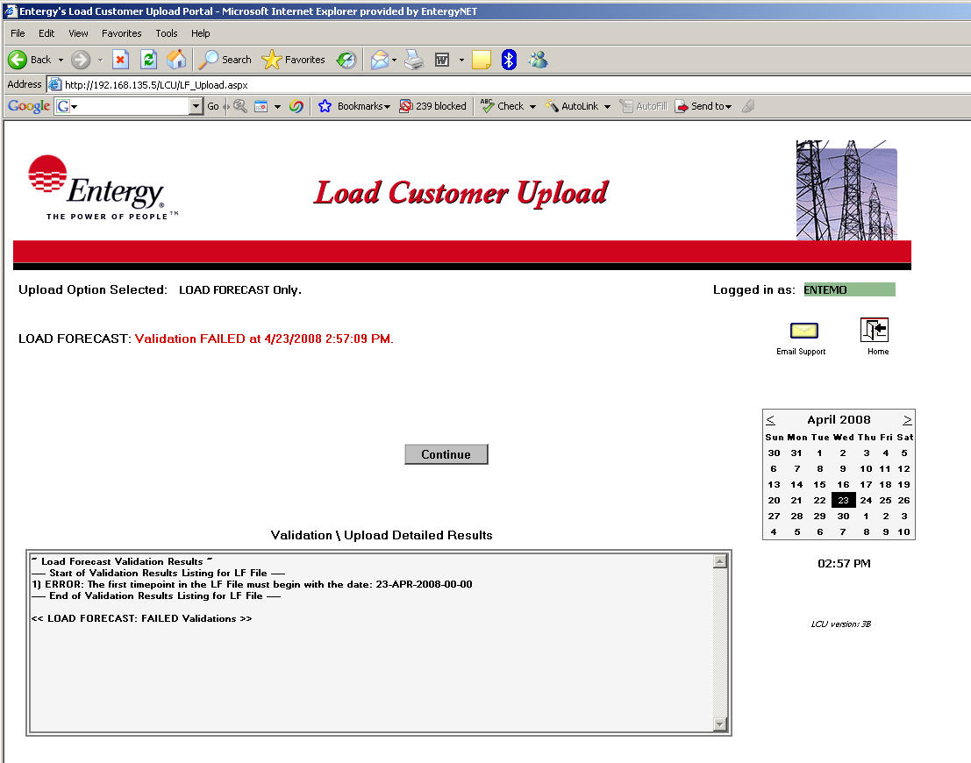
Figure 4.

A successful validation message will display in “green” while a file that encountered any validation errors will display in “red”. The file name and the date and time it was processed will be displayed along with the results status message. All validations will display detailed information in the “Validation \ Upload Detailed Results section for a more complete explanation and cause of the validation error.

Please note, validations performed at “upload” time are limited to ensure a complete set of records are included in the particular file. Further validation of the content in the data files are performed as part of the AFC process. Acceptance of the data files at this point in the procedure simply confirms that the file is readable and appears to adhere to the applicable file format for that file type.

Upload Method - LOAD FORECAST file ONLY (continued..)

Shown below are examples of the Validation \ Upload Detailed Results that are updated and displayed after any file has been submitted and validated. Detailed validation results of each file submitted are listed showing a brief description of any errors that may have occurred and what line number or row of the CSV data file caused that particular error. These error descriptions can be referenced when manually editing and correcting the file before it can be resubmitted for processing.

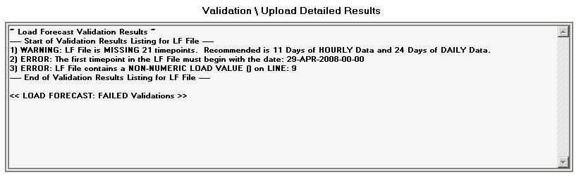
Figure 5. (Results showing Failed Validation Details)

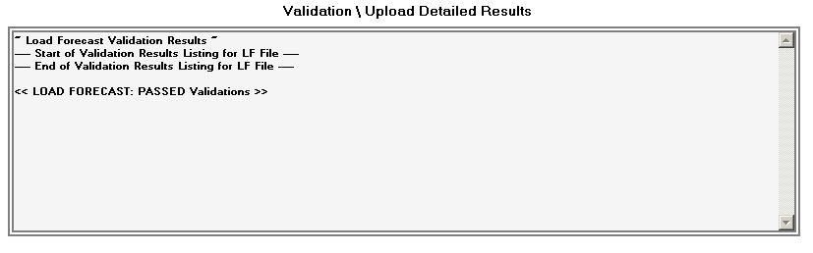
Figure 6. (Results showing Passed Validation Details)

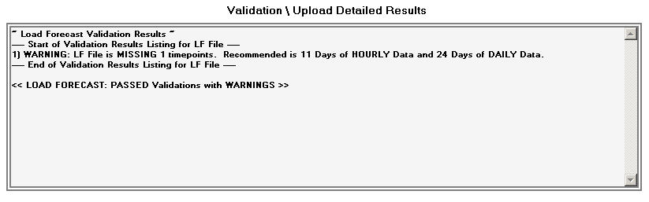
Figure 7. (Results showing Passed with WARNINGS Validation Details)

Upload Method - LOAD FORECAST file ONLY (continued..)

After advancing through the process of submitting the Load Forecast file, a Continue button will display. Clicking the Continue button will begin the process of moving a successfully validated file into the Entergy AFC System.

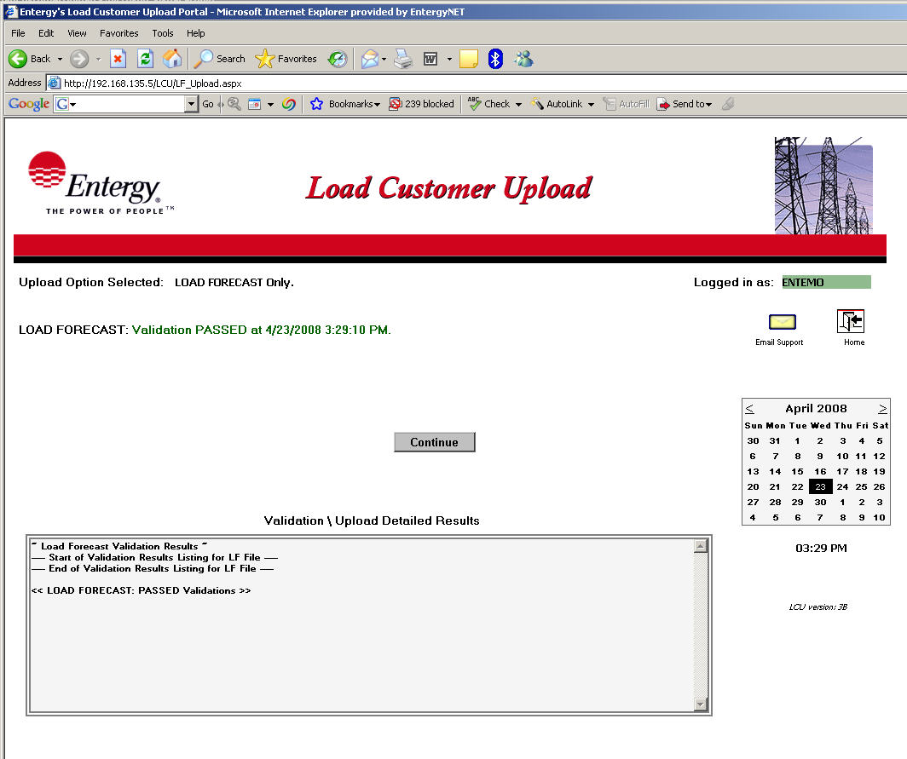

Figure 8.

Click the Continue button to advance to the next step of the process.

A button labeled Next will then display.

Upload Method - LOAD FORECAST file ONLY (continued..)

Click the Next button. If the Load Forecast file was successfully validated it will now be uploaded via an FTP process into the Entergy AFC System. It could take several seconds for the LCU website to complete the upload process.

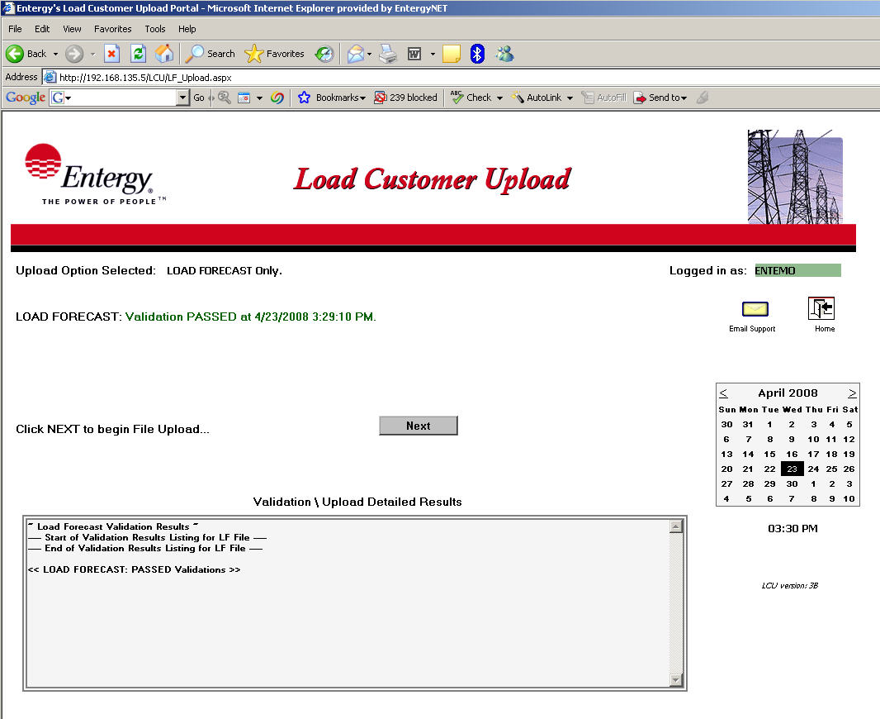

Figure 9.

A Finish button will now display.

Upload Method - LOAD FORECAST file ONLY (continued..)

The final step in the Load Customer Upload process is to click the Finish button. Remember to review the Validation \ Upload Detailed Results to verify the upload status prior to clicking Finish as these results will no longer be displayed past this step.

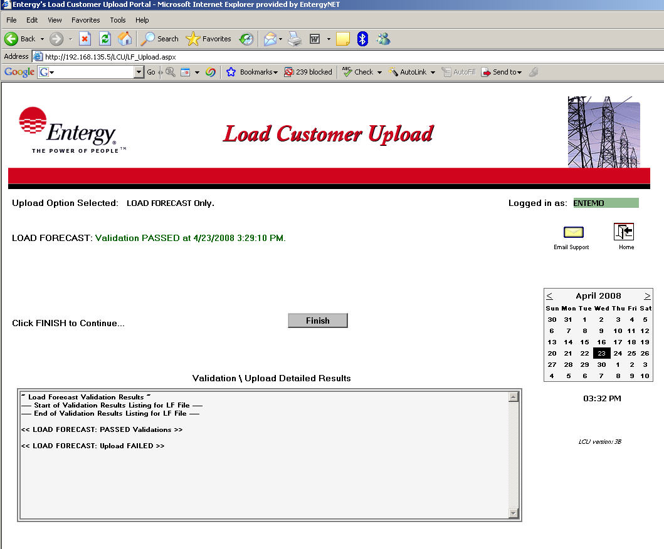

Figure 10.

The Load Forecast Only upload method is now complete. The website will return to the initial Home page at the conclusion of this step.

Upload Method:

Unit Commitment
and
Load Forecast
Files

Upload Method - UNIT COMMITMENT and LOAD FORECAST files

The Unit Commitment and Load Forecast upload method is selected when the website user clicks the tab on the LCU main page that is labeled ‘UC & LF’

The LCU website user is then prompted for the Unit Commitment data file to be selected for upload.

The simplest means to select a file to Upload is to click the ‘Browse’ button and navigate to any folder location available to the LCU website user’s desktop.

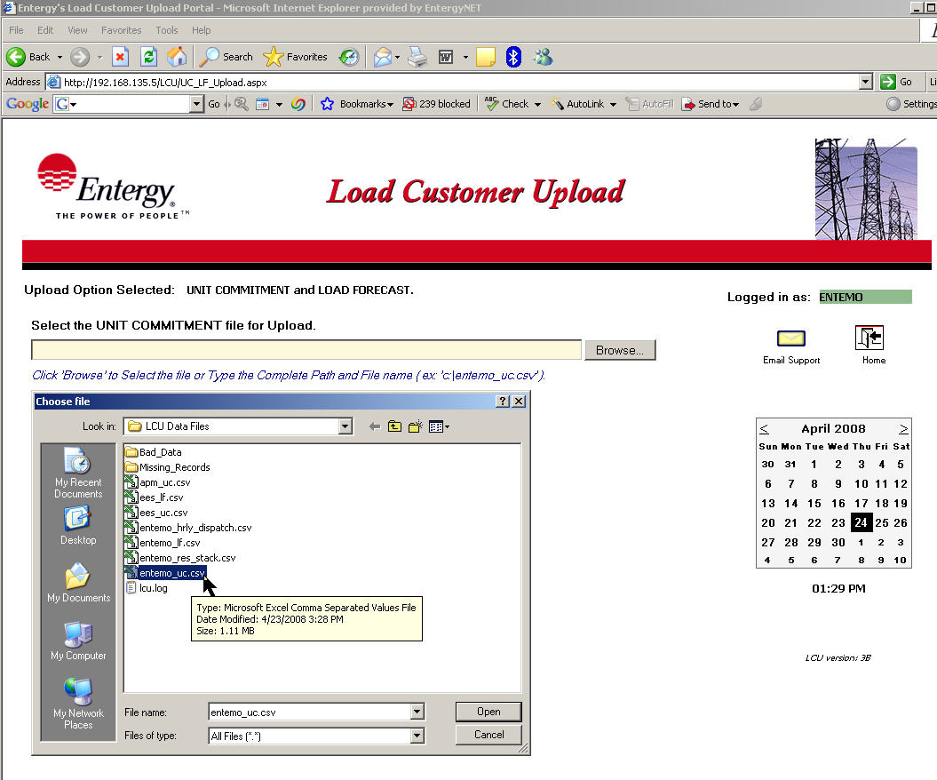

Figure 1.

The user may then “double-click” on the desired file and the file name will populate in the appropriate submit file name box as shown in Figure 1 above.

Another technique is to type the complete path and file name in the submit box. The complete path of the file must be typed or it will not submit. Ex: c:\[network_customer_name]_uc.csv (the [network_customer_name] should be replaced with the user’s company name code)

Upload Method - UNIT COMMITMENT and LOAD FORECAST files (continued..)

Click the Submit File button when a file has been selected.

The LCU website will ONLY allow a file named [network customer name]_uc.csv to be submitted as a Unit Commitment data file. Any other file selected will display an error message with a chance to retry the file submission. (See Figure 2 below)

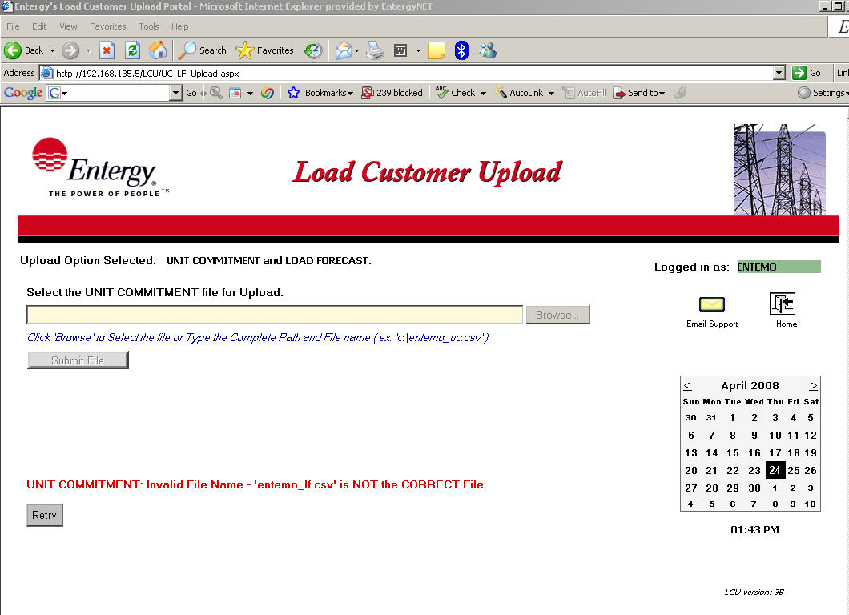

Figure 2.

Please note, the file names used above are for illustrative purposes only. The exact file names provided must adhere to the file name definitions outlined in the General Requirements section of the Functional Specifications Document.

Upload Method - UNIT COMMITMENT and LOAD FORECAST files (continued..)

After the Unit Commitment file is submitted, validation tests are performed to check for the proper file format as outlined in the General Requirements section of the Functional Specifications Document. Unit Commitment files must adhere to the following requirements to be accepted by the LCU website for processing:

Validation Rules required for the Unit Commitment File:

- File name must be ‘[network_customer_name]_uc.csv’ where [network_customer_name] is replaced with the customer’s Entergy OASIS company code.

- Must have at least one record excluding any header records.

- The recommended number of records is 288 per plant which consist of 11 days of hourly data and 24 days of daily data. The file will be accepted with missing time points however LCU will display a warning message for deviations from the recommended number of records.

- The date on the first entry of the file should be the current date and no

- A data record must consist of the following fields beginning with the first column or character position of each record:

hour, plant, unit, MW, status, min MW, max MW

All fields are required fields.

- hour (the beginning hour date and time) must in dd-mmm-yyyy-hh-mm format.

- plant (plant identifier) is an alpha-numeric field that must be 6 characters or less.

- unit (generator or unit identifier) is an alpha-numeric field that must be 4 characters or less.

- MW (the MW dispatch for the given hour) must be a number between 0 and 9999 inclusive and within the bounds of the max and min MW parameters.

- status (unit availability for the given hour) must be either a ‘0’ (unit is not available) or a ‘1’ (unit is available).

- min MW (the minimum MW dispatch for the given hour) must be a number between 0 and 9999 and less than max MW.

- max MW (the maximum MW dispatch for the unit during the given hour) must be a number between 0 and 9999 and greater than min MW.

Upload Method – UNIT COMMITMENT and LOAD FORECAST files (continued..)

After the LCU website user submits the Unit Commitment file, an informational message is displayed listing the status of the file validation as to whether it has Passed, Passed with Warnings, or Failed the validation tests. (See Figure 4 below)

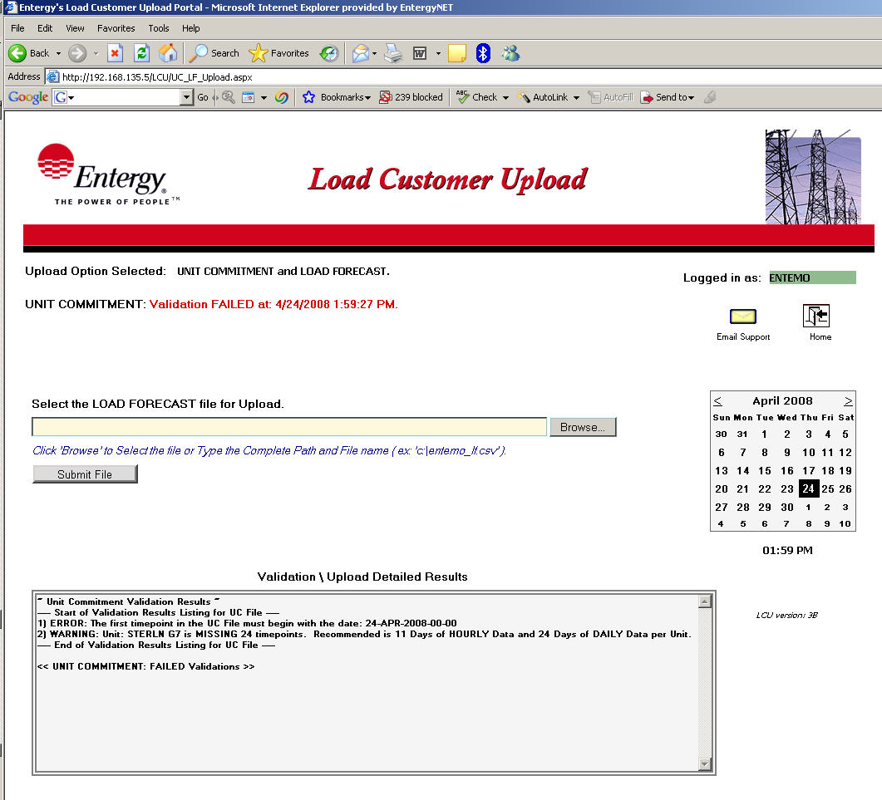
Figure 4.

A successful validation message will display in “green” while a file that encountered any validation errors will display in “red”. The file name and the date and time it was processed will be displayed along with the results status message. All validations will display detailed information in the “Validation \ Upload Detailed Results section for a more complete explanation and cause of the validation error.

Please note, validations performed at “upload” time are limited to ensure a complete set of records are included in the particular file. Further validation of the content in the data files are performed as part of the AFC process. Acceptance of the data files at this point in the procedure simply confirms that the file is readable and appears to adhere to the applicable file format for that file type.

Upload Method – UNIT COMMITMENT and LOAD FORECAST files (continued..)

The LCU website user is then prompted for the Load Forecast data file to be uploaded.

The simplest means to select a file to Upload is to click the ‘Browse’ button and navigate to any folder location available to the LCU website user’s desktop.

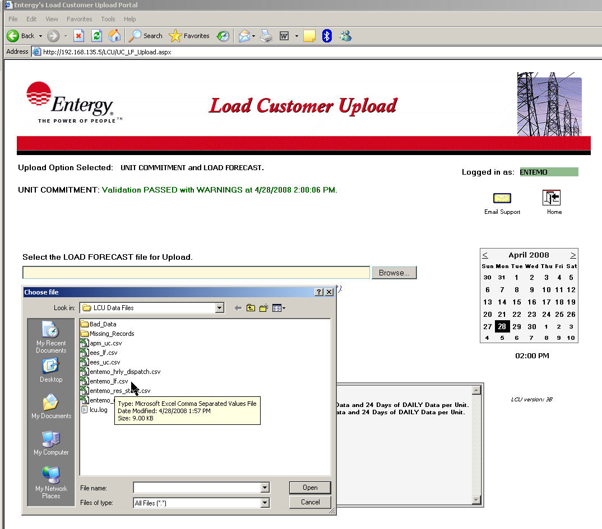
Figure 2.

The user may “double-click” on the desired file and the file name will populate in the appropriate submit file name box as shown in Figure 2 above.

Another technique is to type the complete path and file name in the submit box. The complete path of the file must be typed or the file will not submit. Ex: c:\[network_customer_name]\lf.csv (the [network_customer_name] should be replaced with the user’s company name code)

Upload Method – UNIT COMMITMENT and LOAD FORECAST files (continued..)

Click the Submit File button when a file has been selected.

The LCU website will ONLY allow a file named [network_customer_name]_lf.csv to be submitted as a Load Forecast data file. Any other file selected will display an error message with a chance to retry the file submission. (See Figure 3 below)

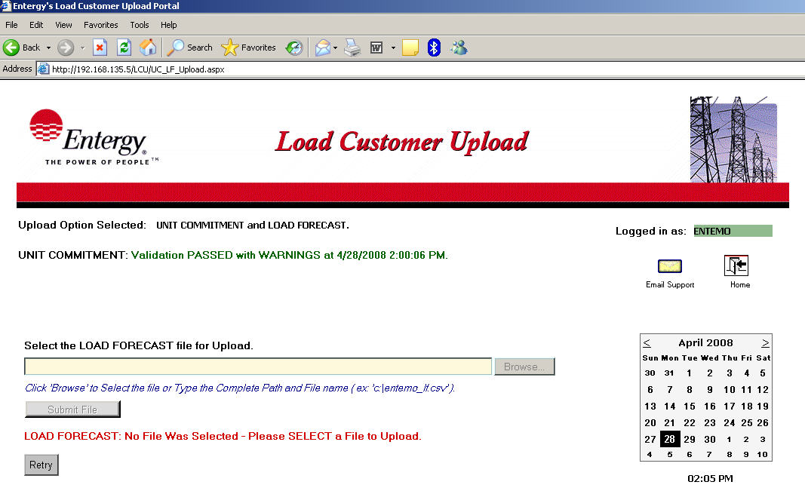
Figure 3.

Please note, the file names used in the examples above are for illustrative purposes only. The exact file names provided must adhere to the file name definitions outlined in the General Requirements section of the Functional Specifications Document.

Upload Method – UNIT COMMITMENT and LOAD FORECAST files (continued..)

After the Load Forecast file is submitted, validation tests are performed to check for the proper file format as outlined in the General Requirements section of the Functional Specifications Document. Load Forecast files must adhere to the following requirements to be accepted by the LCU website for processing:

Load Forecast File Validation Rules:

- File name must be ‘[network_customer_name]_lf.csv’ where [network_customer_name] is replaced with the customer’s Entergy OASIS company code.

- The file must have at least one record.

- The recommended number of records is 288 which consist of 11 days of hourly data and 24 days of daily data. The file will be accepted with missing time points however LCU will display a warning message for deviations from the recommended number of records.

- The date on the first entry of the file should be the current date and no record with the file can be previous to the current date.

- A data record must consist of the following fields beginning with the first column or character position of each record:

hour, nc name, MW

All fields are required fields.

- hour (the beginning hour date and time) must in dd-mmm-yyyy-hh-mm format.

- nc name (the network customer’s name) is an alpha-numeric field that must be 16 characters or less. The nc name field in the CSV file must match the network customer’s company code as derived from client’s digital certificate used for the Entergy OASIS site.

- MW (the MW dispatch for the given hour) must be a number between 0 and 9999.

Upload Method – UNIT COMMITMENT and LOAD FORECAST files (continued..)

After the LCU website user submits the Load Forecast file, an informational message is displayed listing the status of the file validation as to whether it has Passed or Failed the validation tests. (See Figure 4 below)

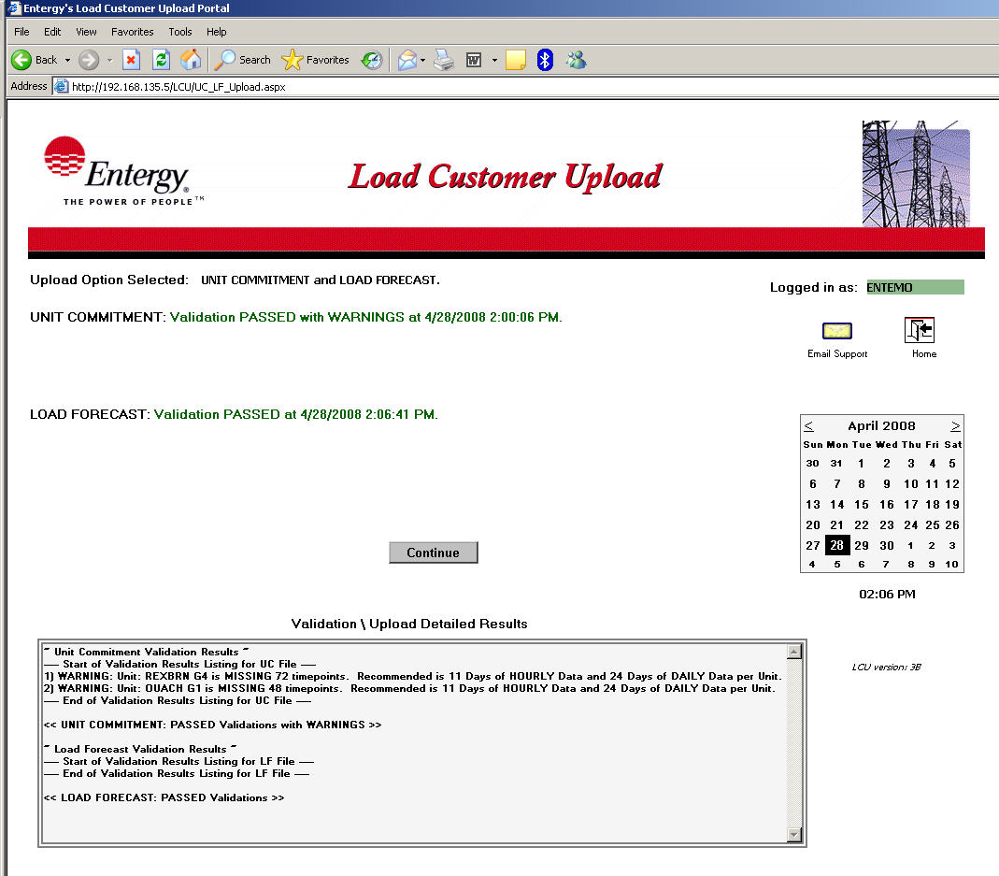
Figure 4.

A successful validation message will display in “green” while a file that encountered any validation errors will display in “red”. The file name and the date and time it was processed will be displayed along with the results status message. All validations will display detailed information in the “Validation \ Upload Detailed Results section for a more complete explanation and cause of the validation error.

Please note, validations performed at “upload” time are limited to ensure a complete set of records are included in the particular file. Further validation of the content in the data files are performed as part of the AFC process. Acceptance of the data files at this point in the procedure simply confirms that the file is readable and appears to adhere to the applicable file format for that file type.

Upload Method – UNIT COMMITMENT and LOAD FORECAST files (continued..)

Shown below are examples of the Validation \ Upload Detailed Results that are updated and displayed after any file has been submitted and validated. Detailed validation results of each file submitted are listed showing a brief description of any errors that may have occurred and what line number or row of the CSV data file caused that particular error. These error descriptions can be referenced when manually editing and correcting the file before it can be resubmitted for processing.

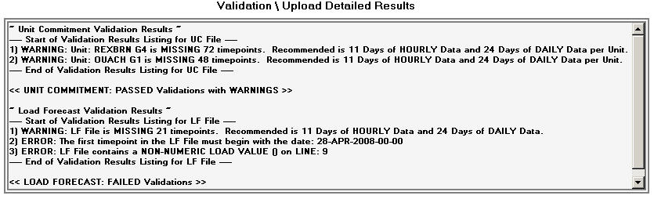
Figure 5. (Results showing Failed Load Forecast Validations)

Figure 6. (Results showing Passed Load Forecast Validations)

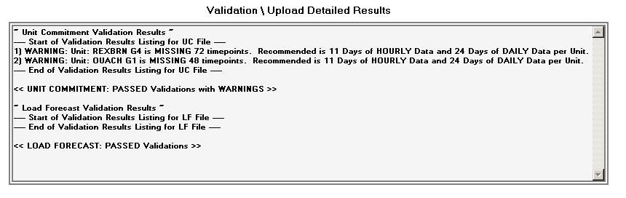
Figure7. (Results showing Passed w/ Warnings Load Forecast Validations)

Upload Method – UNIT COMMITMENT and LOAD FORECAST files (continued..)

After advancing through the process of submitting the Load Forecast file, a Continue button will display. Clicking the Continue button will begin the process of moving a successfully validated file into the Entergy AFC System.

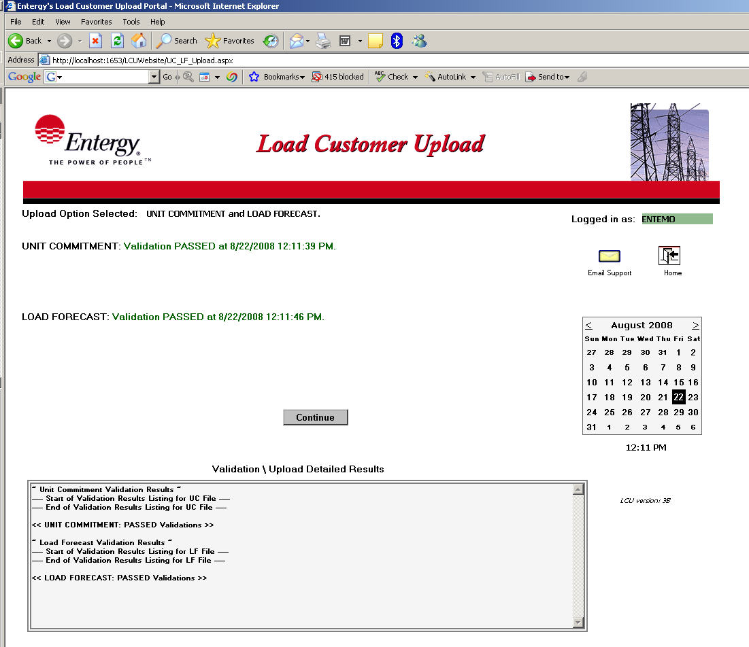

Figure 8.

Click the Continue button to advance to the next step of the process.

A Next button will then display.

Upload Method – UNIT COMMITMENT and LOAD FORECAST files (continued..)

Click the Next button. If the Load Forecast file was successfully validated it will now be uploaded via FTP into the Entergy AFC System. It could take several seconds for the LCU website to complete the upload process.

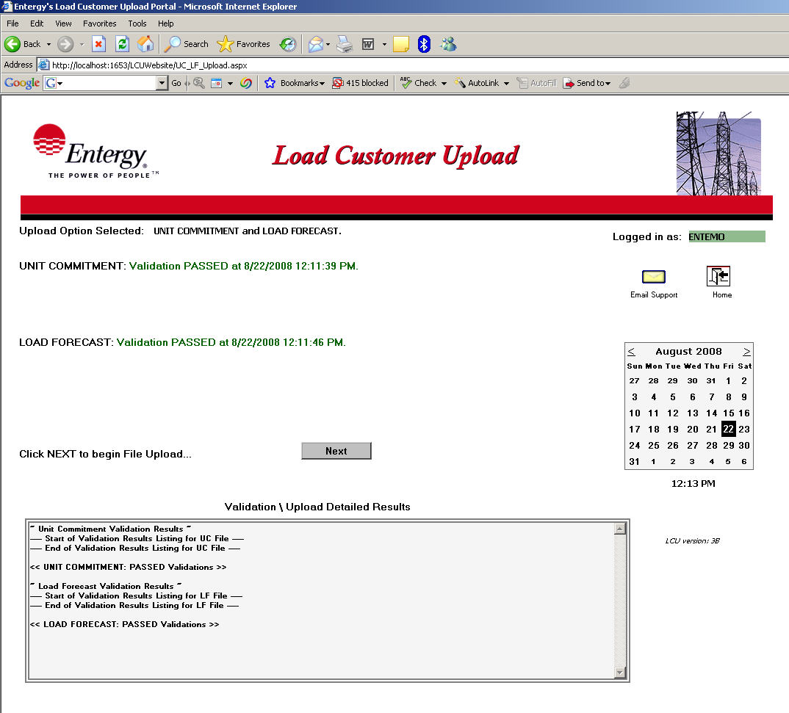

Figure 9.

A Finish button will now display.

Upload Method – UNIT COMMITMENT and LOAD FORECAST files (continued..)

The final step in the Load Customer Upload process is to click the Finish button. Remember to review the Validation \ Upload Detailed Results to verify the upload status prior to clicking Finish as these results will no longer be displayed past this step.

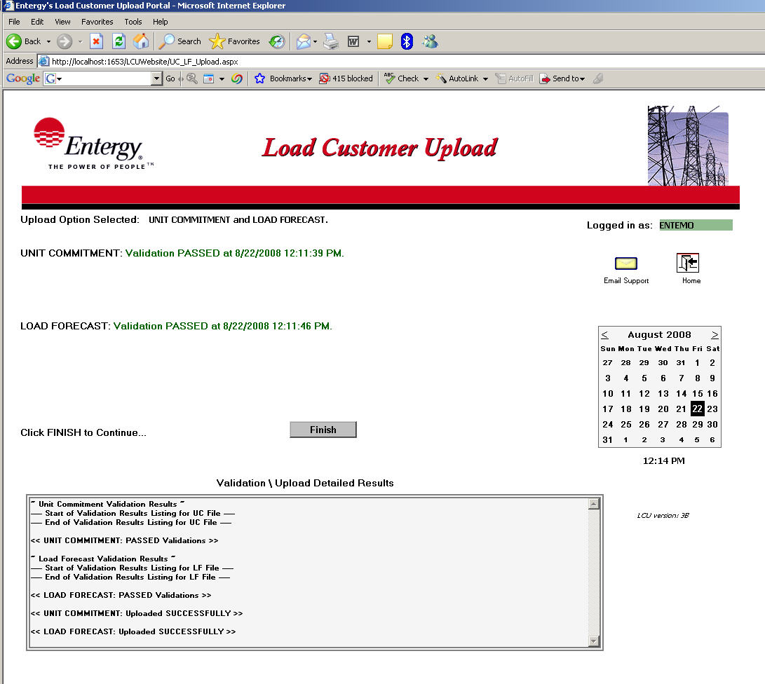

Figure 10.

The Unit Commitment and Load Forecast Upload method is now finished. The website will return to the initial Home page at the completion of this step by clicking the Finish button.

Upload Method:

Reservation Stack
and
Load Forecast
Files

Upload Method – RESERVATION STACK and LOAD FORECAST files

The Reservation Stack and Load Forecast upload method is selected when the website user clicks the tab on the LCU main page that is labeled ‘Stack & LF’

The LCU website user is then prompted for the Reservation Stack data file to be selected for upload.

The simplest means to select a file to Upload is to click the ‘Browse’ button and navigate to any folder location available to the LCU website user’s desktop.

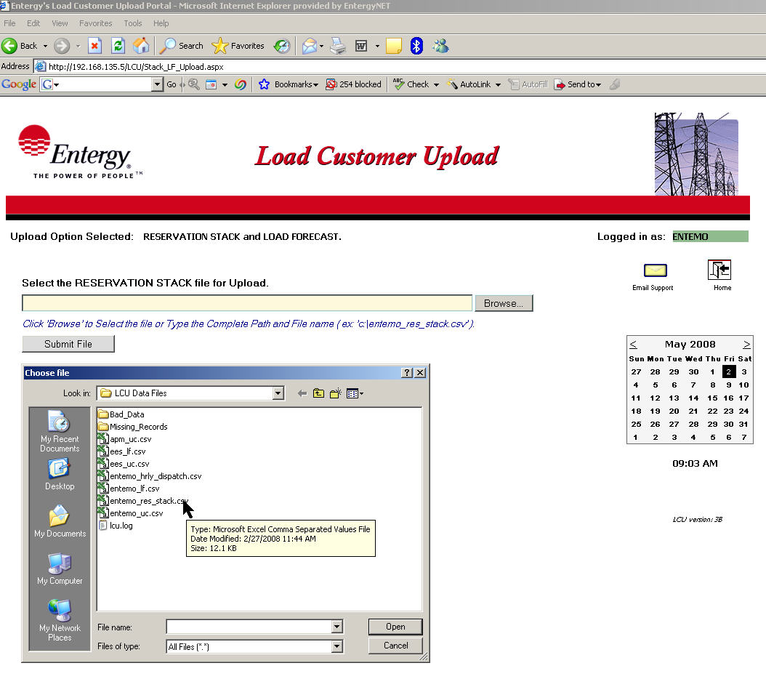

Figure 1.

The user may then “double-click” on the desired file and the file name will populate in the appropriate submit file name box as shown in Figure 1 above.

Another technique is to type the complete path and file name in the submit box. The complete path of the file must be typed or it will not submit. Ex: c:\[network_customer_name]_res_stack.csv (the [network_customer_name] should be replaced with the user’s company name code)

Upload Method – RESERVATION STACK and LOAD FORECAST files (continued..)

Click the Submit File button when a file has been selected.

The LCU website will ONLY allow a file named [network customer name]_res_stack.csv to be submitted as a Reservation Stack data file. Any other file selected will display an error message with a chance to retry the file submission. (See Figure 2 below)

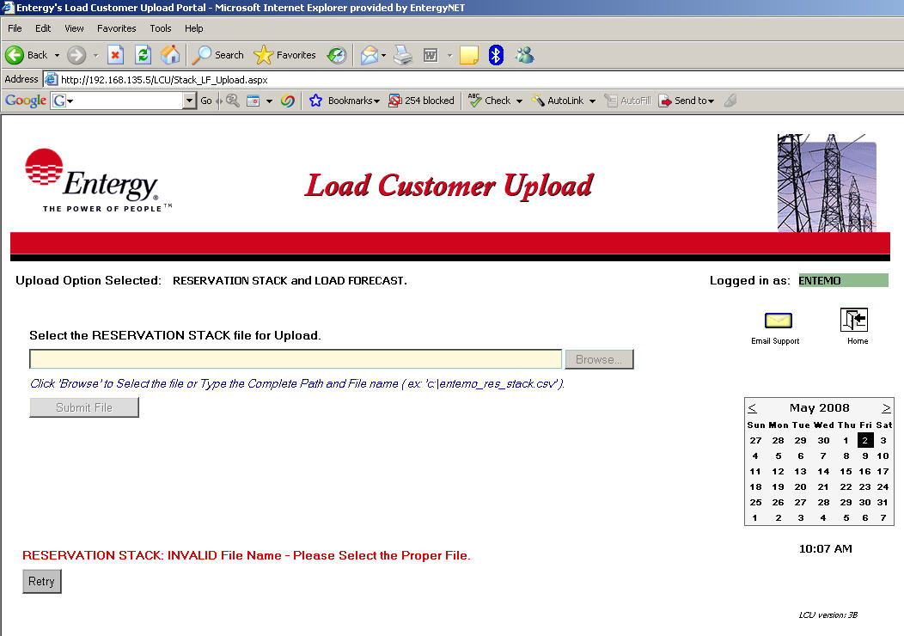

Figure 2.

Please note, the file names used above are for illustrative purposes only. The exact file names provided must adhere to the file name definitions outlined in the General Requirements section of the Functional Specifications Document.

Upload Method – RESERVATION STACK and LOAD FORECAST files (continued..)

After the Reservation Stack file is submitted, validation tests are performed to check for the proper file format as outlined in the General Requirements section of the Functional Specifications Document. Reservation Stack files must adhere to the following requirements to be accepted by the LCU website for processing:

Validation Rules required for the Reservation Stack File:

- File name must be ‘[network_customer_name]_res_stack.csv’ where [network_customer_name] is replaced with the customer’s Entergy OASIS company code.

- Must have at least one record excluding any header records.

- Each TSR listed in the file should be a valid OASIS TSR. If any TSR is found to be invalid, then the entire file will be rejected.

- The date on all records within the file should be for the current date or later. Records with dates previous to the current date will cause the file to be rejected..

- A data record must consist of the following fields beginning with the first column or character position of each record:

start_date, peak, TSR #

All fields are required fields.

- Start_date (the beginning date of the reservation) must in dd-mon-yyyy format.

- peak (peak hour) Must be either a 0 or 1. A value of 0 denotes an Off Peak Hour, while a value of 1 is for a Peak Hour.

- TSR # (Transmission Service Request) is a numeric field which must be a valid TSR # in OASIS.

Upload Method – RESERVATION STACK and LOAD FORECAST files (continued..)

After the LCU website user submits the Reservation Stack file, an informational message is displayed listing the status of the file validation as to whether it has Passed, Passed with Warnings, or Failed the validation tests. (See Figure 4 below)

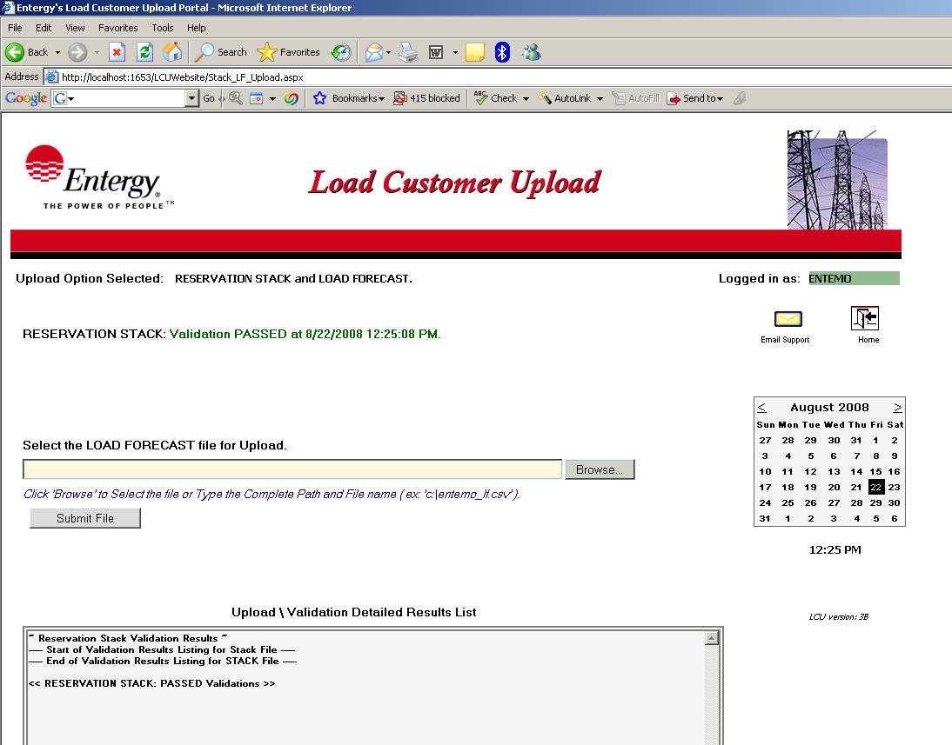

Figure 4.

A successful validation message will display in “green” while a file that encountered any validation errors will display in “red”. The file name and the date and time it was processed will be displayed along with the results status message. All validations will display detailed information in the “Validation \ Upload Detailed Results section for a more complete explanation and cause of the validation error.

Please note, validations performed at “upload” time are limited to ensure a complete set of records are included in the particular file. Further validation of the content in the data files are performed as part of the AFC process. Acceptance of the data files at this point in the procedure simply confirms that the file is readable and appears to adhere to the applicable file format for that file type.

Upload Method – RESERVATION STACK and LOAD FORECAST files (continued..)

The LCU website user is then prompted for the Load Forecast data file to be uploaded.

The simplest means to select a file to Upload is to click the ‘Browse’ button and navigate to any folder location available to the LCU website user’s desktop.

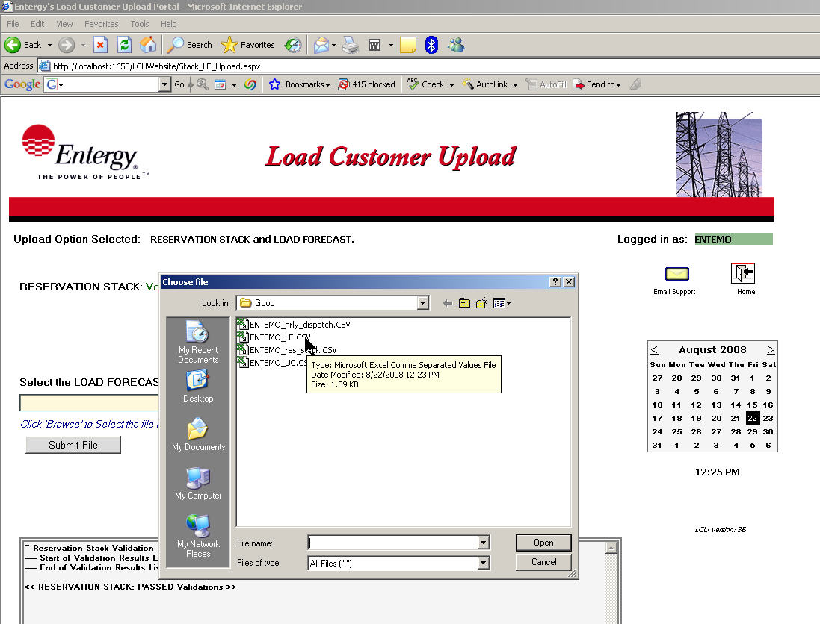

Figure 2.

The user may “double-click” on the desired file and the file name will populate in the appropriate submit file name box as shown in Figure 2 above.

Another technique is to type the complete path and file name in the submit box. The complete path of the file must be typed or the file will not submit. Ex: c:\[network_customer_name]\lf.csv (the [network_customer_name] should be replaced with the user’s company name code)

Upload Method – RESERVATION STACK and LOAD FORECAST files (continued..)

Click the Submit File button when a file has been selected.

The LCU website will ONLY allow a file named [network_customer_name]_lf.csv to be submitted as a Load Forecast data file. Any other file selected will display an error message with a chance to retry the file submission. (See Figure 3 below)

Figure 3.

Please note, the file names used in the examples above are for illustrative purposes only. The exact file names provided must adhere to the file name definitions outlined in the General Requirements section of the Functional Specifications Document.

Upload Method – RESERVATION STACK and LOAD FORECAST files (continued..)

After the Load Forecast file is submitted, validation tests are performed to check for the proper file format as outlined in the General Requirements section of the Functional Specifications Document. Load Forecast files must adhere to the following requirements to be accepted by the LCU website for processing:

Load Forecast File Validation Rules:

- File name must be ‘[network_customer_name]_lf.csv’ where [network_customer_name] is replaced with the customer’s Entergy OASIS company code.

- The file must have at least one record.

- The recommended number of records is 288 which consist of 11 days of hourly data and 24 days of daily data. The file will be accepted with missing time points however LCU will display a warning message for deviations from the recommended number of records.

- The date on the first entry of the file should be the current date.

- A data record must consist of the following fields beginning with the first column or character position of each record:

hour, nc name, MW

All fields are required fields.

- hour (the beginning hour date and time) must in dd-mmm-yyyy-hh-mm format.

- nc name (the network customer’s name) is an alpha-numeric field that must be 16 characters or less. The nc name field in the CSV file must match the network customer’s company code as derived from client’s digital certificate used for the Entergy OASIS site.

- MW (the MW dispatch for the given hour) must be a number between 0 and 9999.

Upload Method – RESERVATION STACK and LOAD FORECAST files (continued..)

After the LCU website user submits the Load Forecast file, an informational message is displayed listing the status of the file validation as to whether it has Passed or Failed the validation tests. (See Figure 4 below)

Figure 4.

A successful validation message will display in “green” while a file that encountered any validation errors will display in “red”. The file name and the date and time it was processed will be displayed along with the results status message. All validations will display detailed information in the “Validation \ Upload Detailed Results section for a more complete explanation and cause of the validation error.

Please note, validations performed at “upload” time are limited to ensure a complete set of records are included in the particular file. Further validation of the content in the data files are performed as part of the AFC process. Acceptance of the data files at this point in the procedure simply confirms that the file is readable and appears to adhere to the applicable file format for that file type.

Upload Method – RESERVATION STACK and LOAD FORECAST files (continued..)

Shown below are examples of the Validation \ Upload Detailed Results that are updated and displayed after any file has been submitted and validated. Detailed validation results of each file submitted are listed showing a brief description of any errors that may have occurred and what line number or row of the CSV data file caused that particular error. These error descriptions can be referenced when manually editing and correcting the file before it can be resubmitted for processing.

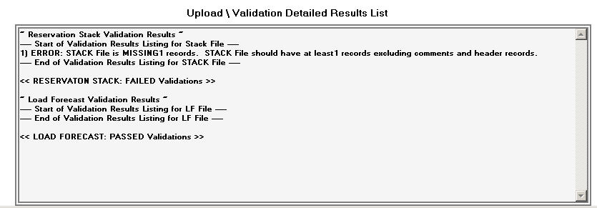
Figure 5. (Results showing Failed Validation Details)

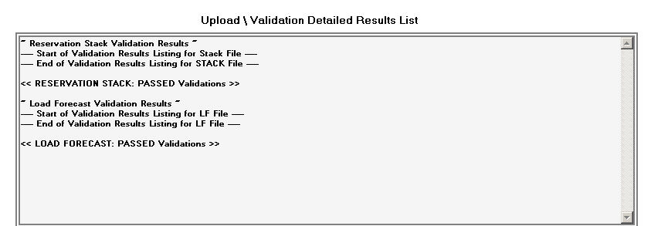
Figure 6. (Results showing Passed Validation Details)

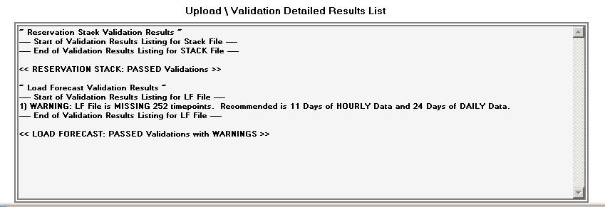
Figure 7. (Results showing Passed with WARNINGS Validation Details)

Upload Method – RESERVATION STACK and LOAD FORECAST files (continued..)

After advancing through the process of submitting the Load Forecast file, a Continue button will display. Clicking the Continue button will begin the process of moving a successfully validated file into the Entergy AFC System.

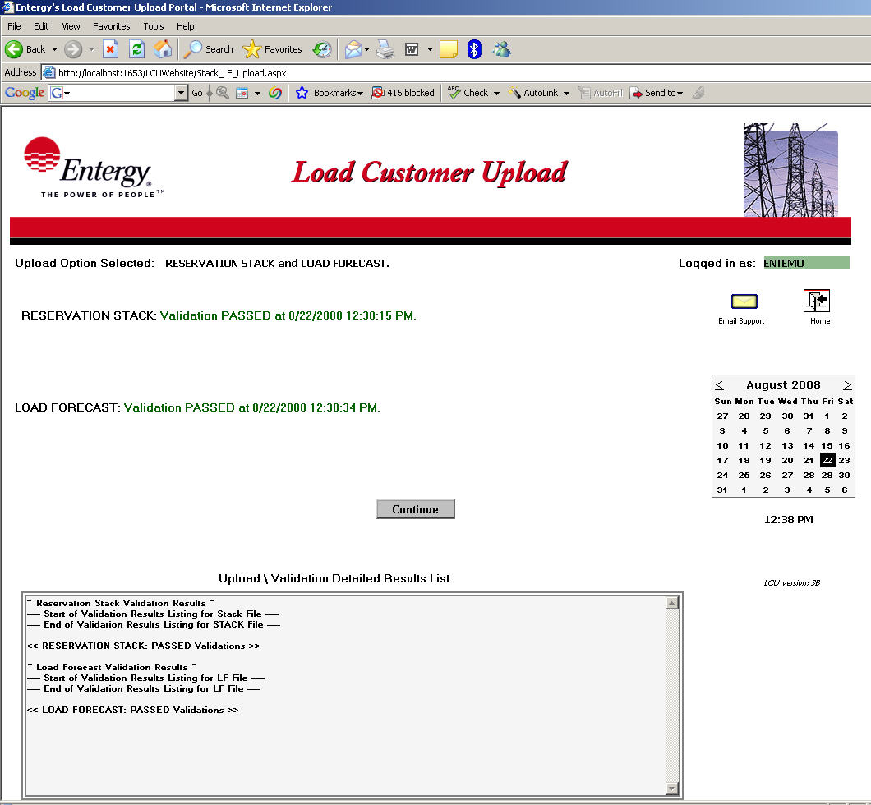

Figure 8.

Click the Continue button to advance to the next step of the process.

A Next button will then display.

Upload Method – RESERVATION STACK and LOAD FORECAST files (continued..)

Click the Next button. If the Load Forecast file was successfully validated it will now be uploaded via FTP into the Entergy AFC System. It could take several seconds for the LCU website to complete the upload process.

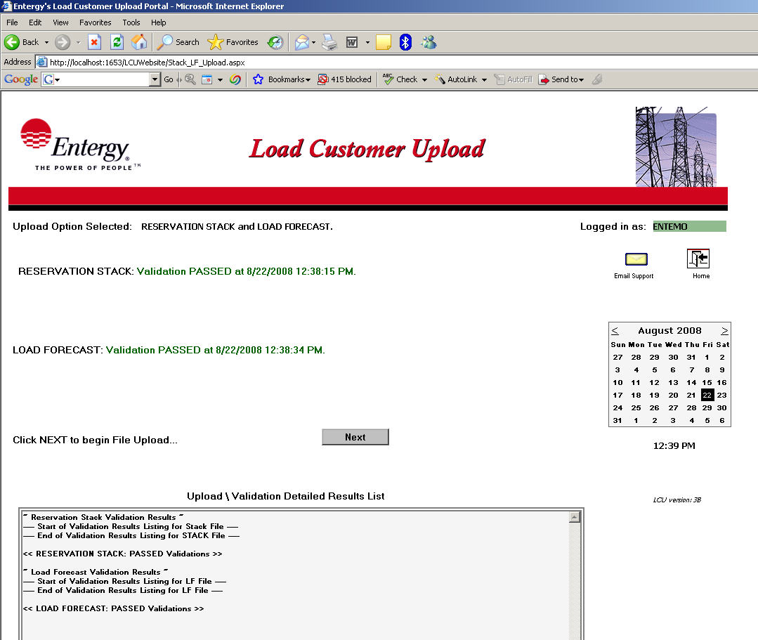

Figure 9.

A Finish button will now display.

Upload Method – RESERVATION STACK and LOAD FORECAST files (continued..)

The final step in the Load Customer Upload process is to click the Finish button. Remember to review the Validation \ Upload Detailed Results to verify the upload status prior to clicking Finish as these results will no longer be displayed past this step.

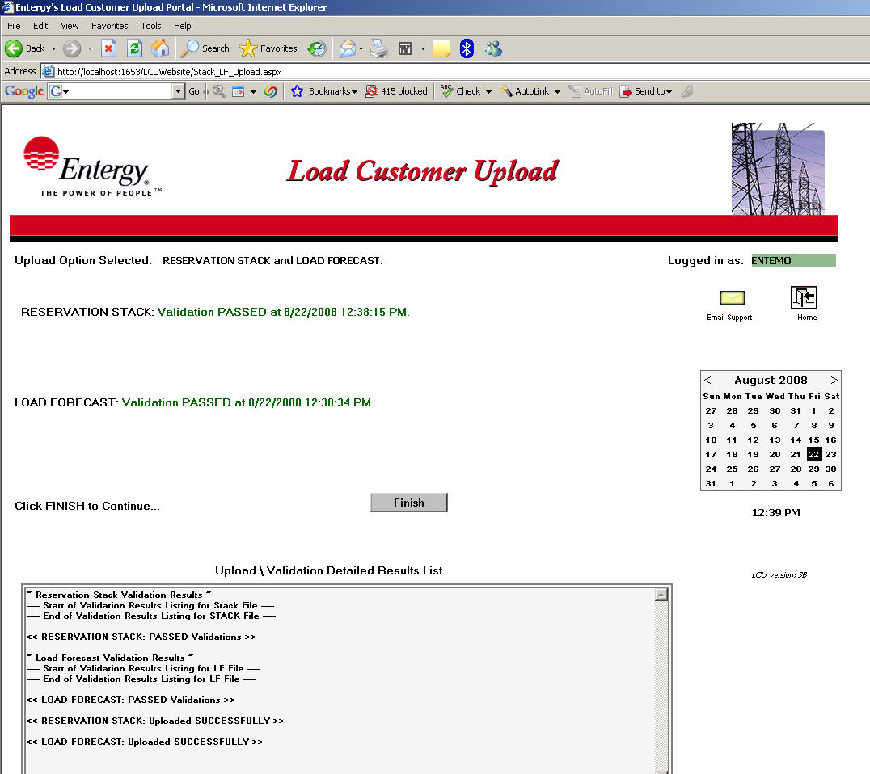

Figure 10.

The Reservation Stack and Load Forecast Upload method is now finished. The website will return to the initial Home page at the completion of this step by clicking the Finish button.

Hourly Dispatch and LF

Upload Method – HOURLY DISPATCH and LOAD FORECAST files

The Hourly Dispatch and Load Forecast upload method is selected when the website user clicks the tab on the LCU main page that is labeled ‘Hourly Dispatch & LF’

The LCU website user is then prompted for the Hourly Dispatch data file to be selected for upload.

The simplest means to select a file to Upload is to click the ‘Browse’ button and navigate to any folder location available to the LCU website user’s desktop.

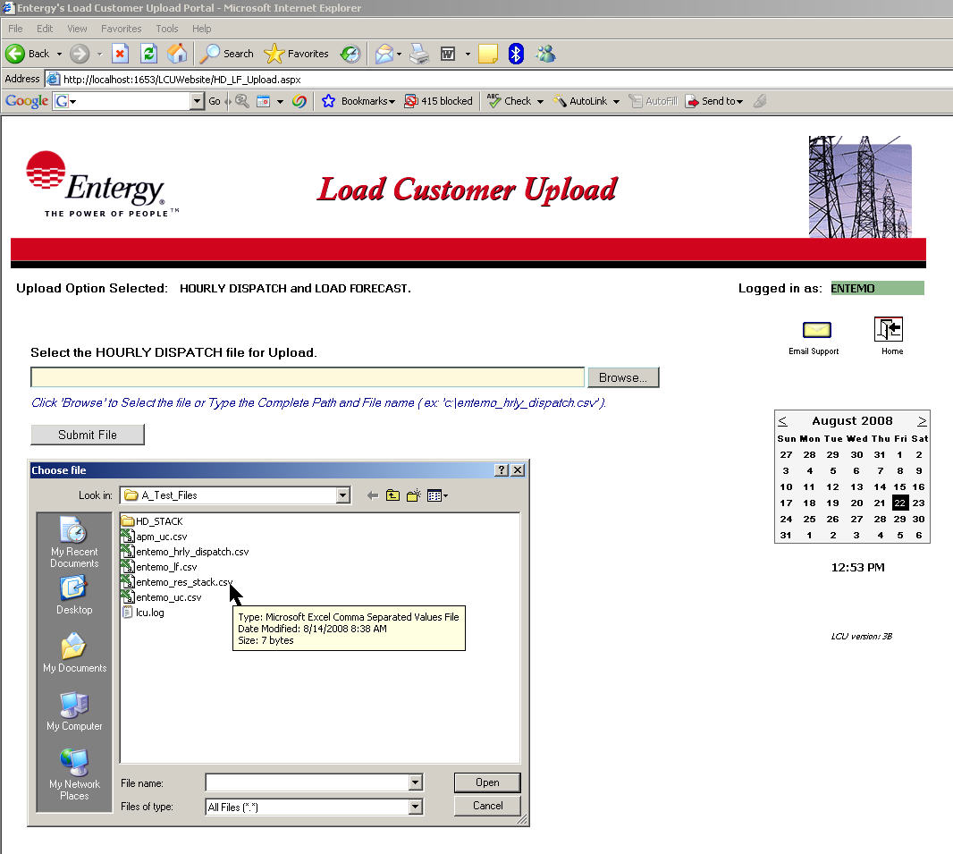

Figure 1.

The user may then “double-click” on the desired file and the file name will populate in the appropriate submit file name box as shown in Figure 1 above.

Another technique is to type the complete path and file name in the submit box. The complete path of the file must be typed or it will not submit. Ex: c:\[network_customer_name]_hrly_dispatch.csv (the [network_customer_name] should be replaced with the user’s company name code)

Upload Method – HOURLY DISPATCH and LOAD FORECAST files (continued..)

Click the Submit File button when a file has been selected.

The LCU website will ONLY allow a file named [network customer name]_hrly_dispatch.csv to be submitted as a Hourly Dispatch data file. Any other file selected will display an error message with a chance to retry the file submission. (See Figure 2 below)

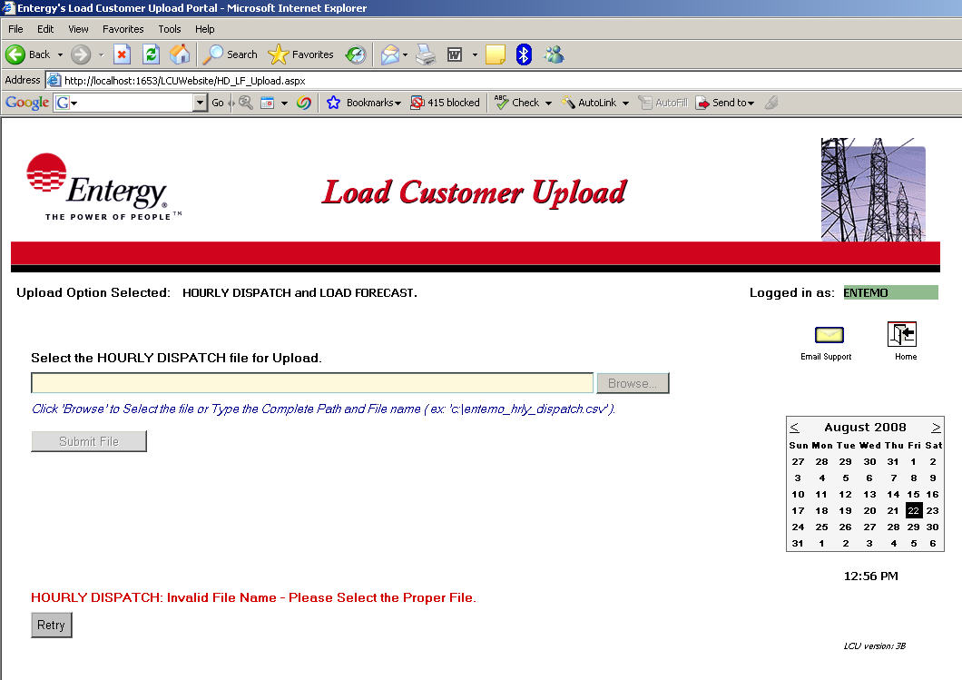

Figure 2.

Please note, the file names used above are for illustrative purposes only. The exact file names provided must adhere to the file name definitions outlined in the General Requirements section of the Functional Specifications Document.

Upload Method – HOURLY DISPATCH and LOAD FORECAST files (continued..)

After the Hourly Dispatch file is submitted, validation tests are performed to check for the proper file format as outlined in the General Requirements section of the Functional Specifications Document. Hourly Dispatch files must adhere to the following requirements to be accepted by the LCU website for processing:

Validation Rules required for the Hourly Dispatch File:

- File name must be ‘[network_customer_name]_hrly_dispatch.csv’ where [network_customer_name] is replaced with the customer’s Entergy OASIS company code.

- Must have at least one record excluding any header records.

- Each TSR listed in the file should be a valid OASIS TSR. If any TSR is found to be invalid, then the entire file will be rejected.

- The date on all records within the file should be for the current date or later. Records with dates previous to the current date will cause the file to be rejected..

- A data record must consist of the following fields beginning with the first column or character position of each record:

start_date, TSR #, MW Dispatch

All fields are required fields.

- Start_date (the beginning date of the reservation) must in dd-mon-yyyy-hh-mm format.

- TSR # (Transmission Service Request) is a numeric field which must be a valid TSR # in OASIS.

- MW Dispatch – value must be equal to or less than the actual MW value of the TSR.

Upload Method – HOURLY DISPATCH and LOAD FORECAST files (continued..)

After the LCU website user submits the Hourly Dispatch file, an informational message is displayed listing the status of the file validation as to whether it has Passed, Passed with Warnings, or Failed the validation tests. (See Figure 4 below)

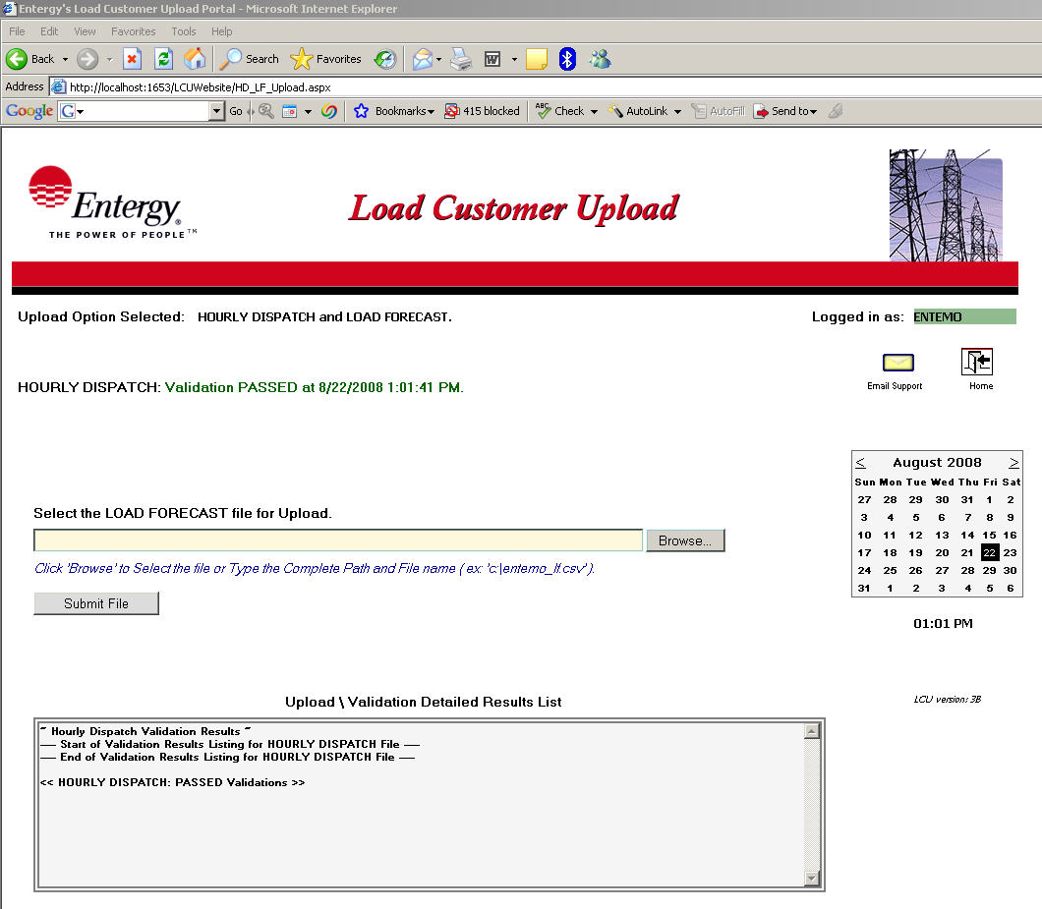

Figure 4.

A successful validation message will display in “green” while a file that encountered any validation errors will display in “red”. The file name and the date and time it was processed will be displayed along with the results status message. All validations will display detailed information in the “Validation \ Upload Detailed Results section for a more complete explanation and cause of the validation error.

Please note, validations performed at “upload” time are limited to ensure a complete set of records are included in the particular file. Further validation of the content in the data files are performed as part of the AFC process. Acceptance of the data files at this point in the procedure simply confirms that the file is readable and appears to adhere to the applicable file format for that file type.

Upload Method – HOURLY DISPATCH and LOAD FORECAST files (continued..)

The LCU website user is then prompted for the Load Forecast data file to be uploaded.

The simplest means to select a file to Upload is to click the ‘Browse’ button and navigate to any folder location available to the LCU website user’s desktop.

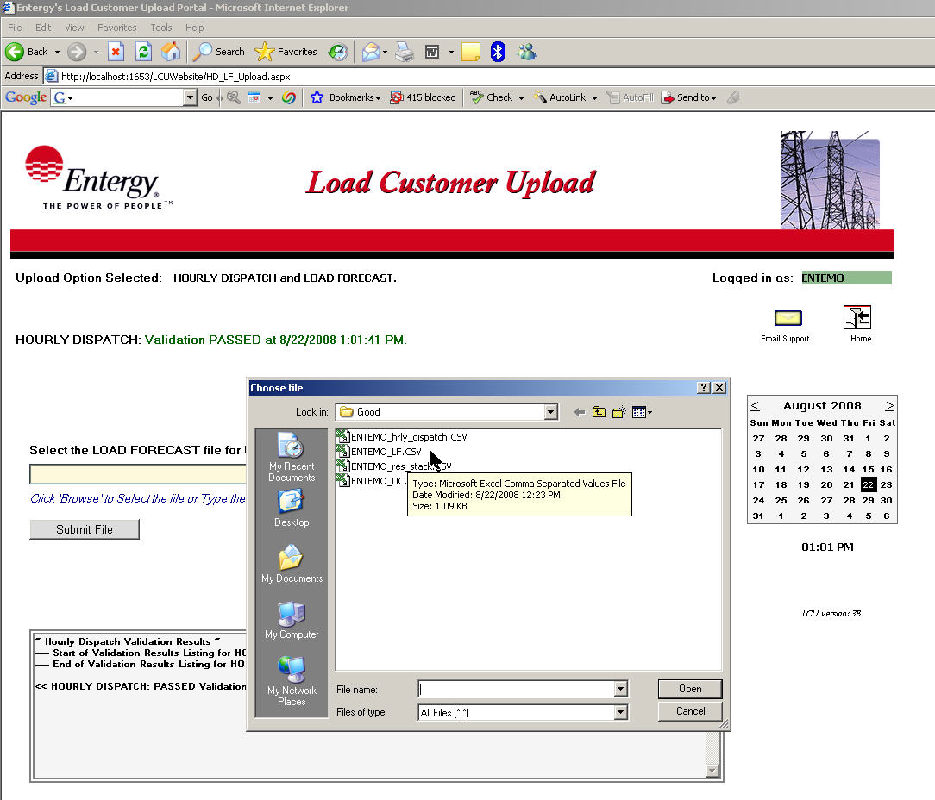

Figure 2.

The user may “double-click” on the desired file and the file name will populate in the appropriate submit file name box as shown in Figure 2 above.

Another technique is to type the complete path and file name in the submit box. The complete path of the file must be typed or the file will not submit. Ex: c:\[network_customer_name]\lf.csv (the [network_customer_name] should be replaced with the user’s company name code)

Upload Method – HOURLY DISPATCH and LOAD FORECAST files (continued..)

Click the Submit File button when a file has been selected.

The LCU website will ONLY allow a file named [network_customer_name]_lf.csv to be submitted as a Load Forecast data file. Any other file selected will display an error message with a chance to retry the file submission. (See Figure 3 below)

Figure 3.

Please note, the file names used in the examples above are for illustrative purposes only. The exact file names provided must adhere to the file name definitions outlined in the General Requirements section of the Functional Specifications Document.

Upload Method – HOURLY DISPATCH and LOAD FORECAST files (continued..)

After the Load Forecast file is submitted, validation tests are performed to check for the proper file format as outlined in the General Requirements section of the Functional Specifications Document. Load Forecast files must adhere to the following requirements to be accepted by the LCU website for processing:

Load Forecast File Validation Rules:

- File name must be ‘[network_customer_name]_lf.csv’ where [network_customer_name] is replaced with the customer’s Entergy OASIS company code.

- The file must have at least one record.

- The recommended number of records is 288 which consist of 11 days of hourly data and 24 days of daily data. The file will be accepted with missing time points however LCU will display a warning message for deviations from the recommended number of records.

- The date on the first entry of the file should be the current date and no records within the file can be dated prior to the current date.

- A data record must consist of the following fields beginning with the first column or character position of each record:

hour, nc name, MW

All fields are required fields.

- hour (the beginning hour date and time) must in dd-mmm-yyyy-hh-mm format.

- nc name (the network customer’s name) is an alpha-numeric field that must be 16 characters or less. The nc name field in the CSV file must match the network customer’s company code as derived from client’s digital certificate used for the Entergy OASIS site.

- MW (the MW dispatch for the given hour) must be a number between 0 and 9999.

Upload Method – HOURLY DISPATCH and LOAD FORECAST files (continued..)

After the LCU website user submits the Load Forecast file, an informational message is displayed listing the status of the file validation as to whether it has Passed or Failed the validation tests. (See Figure 4 below)

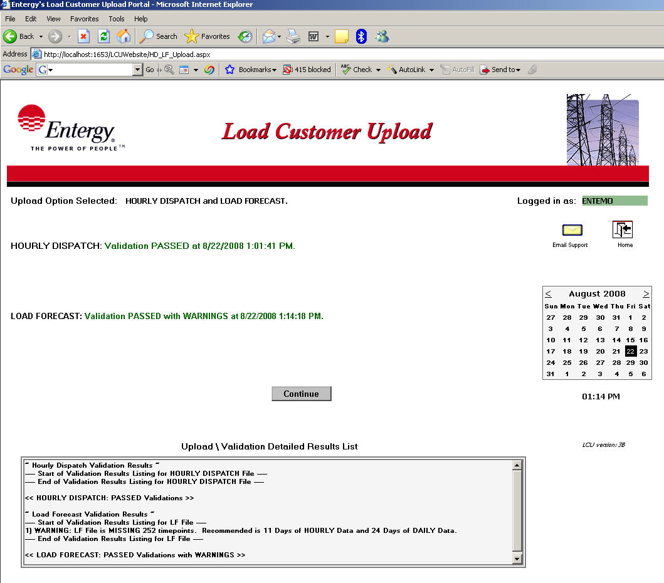
Figure 4.

A successful validation message will display in “green” while a file that encountered any validation errors will display in “red”. The file name and the date and time it was processed will be displayed along with the results status message. All validations will display detailed information in the “Validation \ Upload Detailed Results section for a more complete explanation and cause of the validation error.

Please note, validations performed at “upload” time are limited to ensure a complete set of records are included in the particular file. Further validation of the content in the data files are performed as part of the AFC process. Acceptance of the data files at this point in the procedure simply confirms that the file is readable and appears to adhere to the applicable file format for that file type.

Upload Method – HOURLY DISPATCH and LOAD FORECAST files (continued..)

Shown below are examples of the Validation \ Upload Detailed Results that are updated and displayed after any file has been submitted and validated. Detailed validation results of each file submitted are listed showing a brief description of any errors that may have occurred and what line number or row of the CSV data file caused that particular error. These error descriptions can be referenced when manually editing and correcting the file before it can be resubmitted for processing.

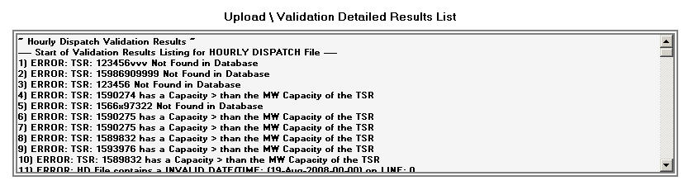
Figure 5. (Results showing Failed Validation Details)

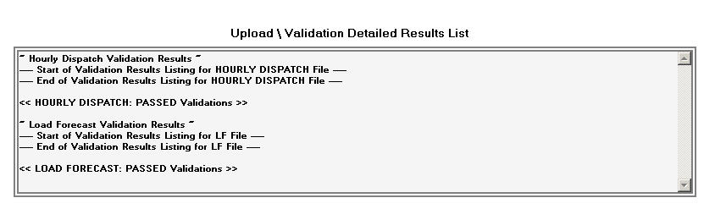
Figure 6. (Results showing Passed Validation Details)

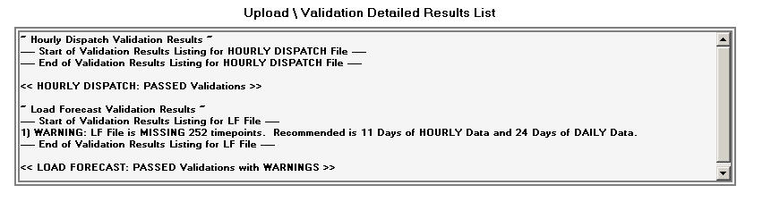
Figure 7. (Results showing Passed with WARNINGS Validation Details)

Upload Method – HOURLY DISPATCH and LOAD FORECAST files (continued..)

After advancing through the process of submitting the Load Forecast file, a Continue button will display. Clicking the Continue button will begin the process of moving a successfully validated file into the Entergy AFC System.

Figure 8.

Click the Continue button to advance to the next step of the process.

A Next button will then display.

Upload Method – HOURLY DISPATCH and LOAD FORECAST files (continued..)

Click the Next button. If the Load Forecast file was successfully validated it will now be uploaded via FTP into the Entergy AFC System. It could take several seconds for the LCU website to complete the upload process.

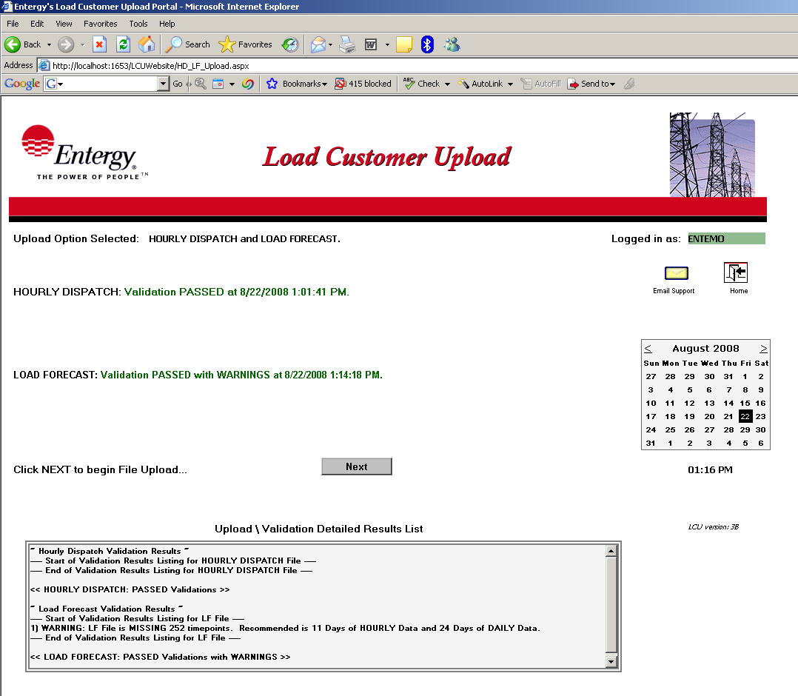

Figure 9.

A Finish button will now display.

Upload Method – HOURLY DISPATCH and LOAD FORECAST files (continued..)

The final step in the Load Customer Upload process is to click the Finish button. Remember to review the Validation \ Upload Detailed Results to verify the upload status prior to clicking Finish as these results will no longer be displayed past this step.

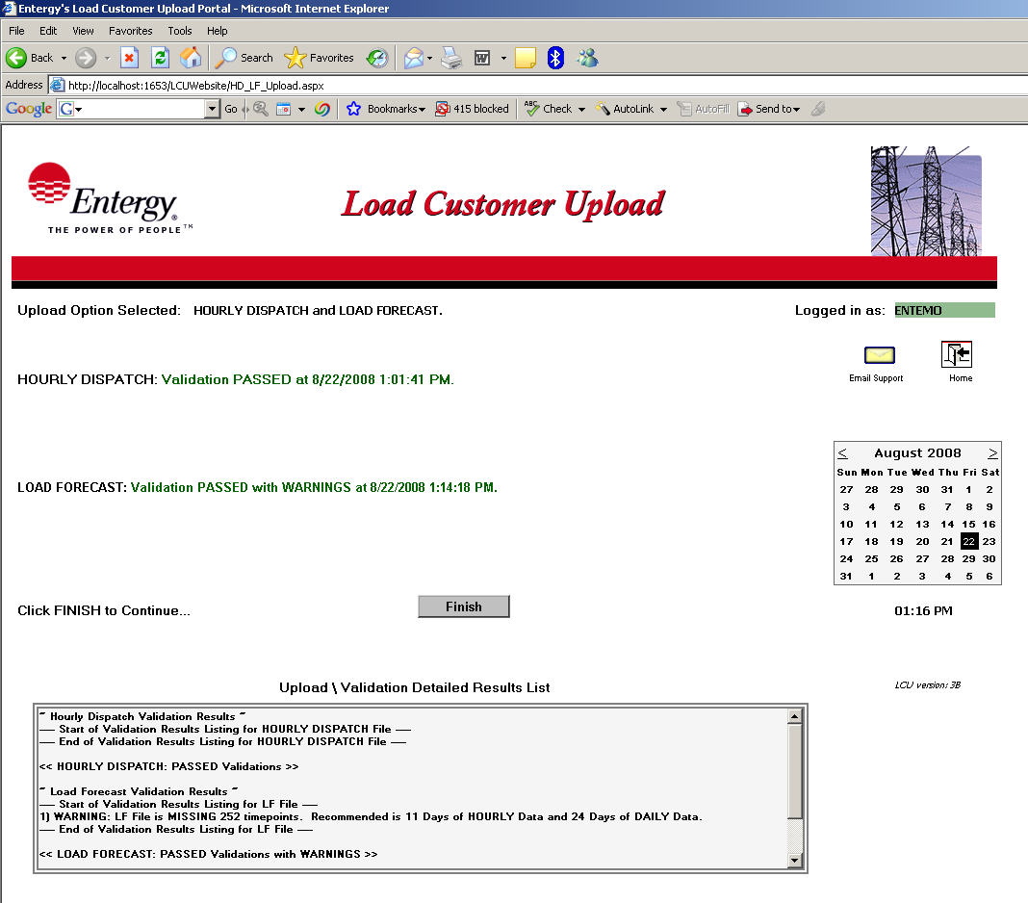

Figure 10.

The Hourly Dispatch and Load Forecast Upload method is now finished. The website will return to the initial Home page at the completion of this step by clicking the Finish button.

Logging Out \ Closing the Load Customer Upload Website

To ensure a successful completion to any specific session on the Load Customer Upload website, it is highly recommended that the website user always exit the site by clicking the:

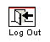

icon found in the upper right corner of the LCU main page. (See Figure 10 below).

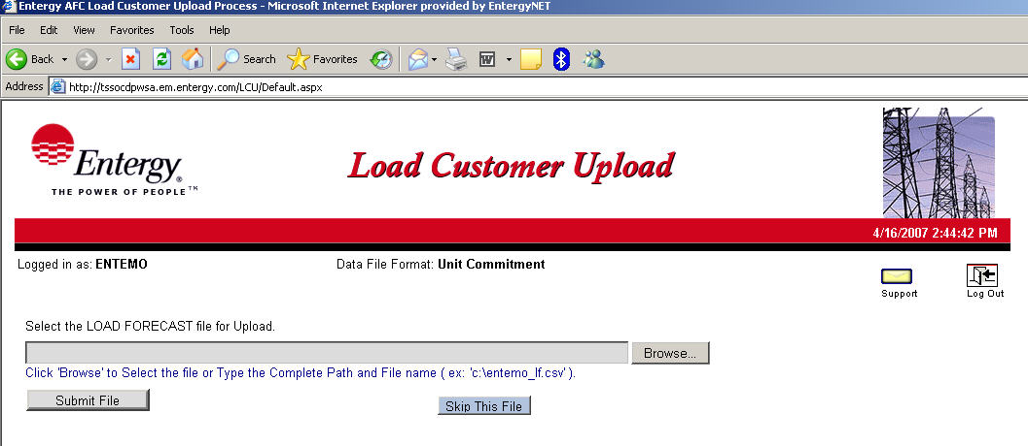
Figure 10.

By clicking the Log Out icon, the proper exit procedures will be performed while exiting the website. The Log Out icon will only be displayed if the particular web session running is at an appropriate place within the application for exiting. If the Log Out icon is not displayed, the user should then continue with the upload process until the Log Out icon is displayed again.

All files submitted by a LCU website user will not be accepted into the Entergy AFC process until after the Finish button has been pressed and processing was completed successfully.

Although it is never recommended, the LCU website may be exited anytime by simply closing the internet web browser. Incomplete transmissions of data files or unexpected results could occur when the recommended procedures for exiting the LCU website are not followed.

Submit Support Request / Message to Entergy

A request for technical support or an email message may be sent to Entergy’s LCU support team.
The following form will display anytime the yellow envelope icon labeled Support is clicked.

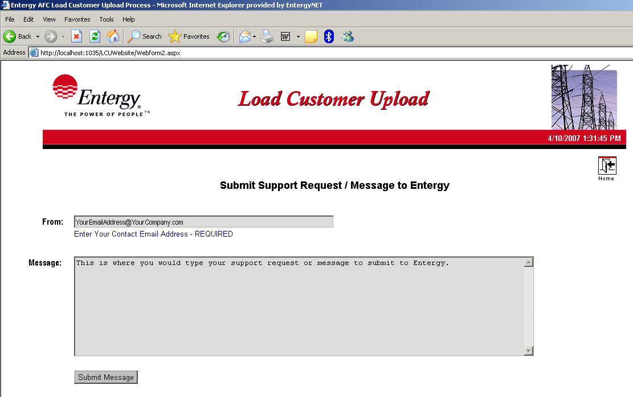
Figure 11.

From: Type your contact email address in the “From” box. A valid email address format is required.

Message: Type your request for support or email message in the “Message” box. (Required field)

After completing the email form as outlined above, click the Submit Message button and the message will be sent to Entergy’s LCU support team and to the contact email address entered on the form.

Clicking the Home button at any time will cancel the Support Request and return the LCU website user to the initial Upload page.

Load Customer Upload Security - Digital Certificates

The user’s digital certificate is checked and validated upon initial loading of the Load Customer Upload website. If the digital certificate does not exist or for any reason does not pass validation, the following screen will be displayed and the website user will not be allowed access to the LCU upload portal. A Support button is available if an email request to Entergy’s support team is required to help resolve this issue.

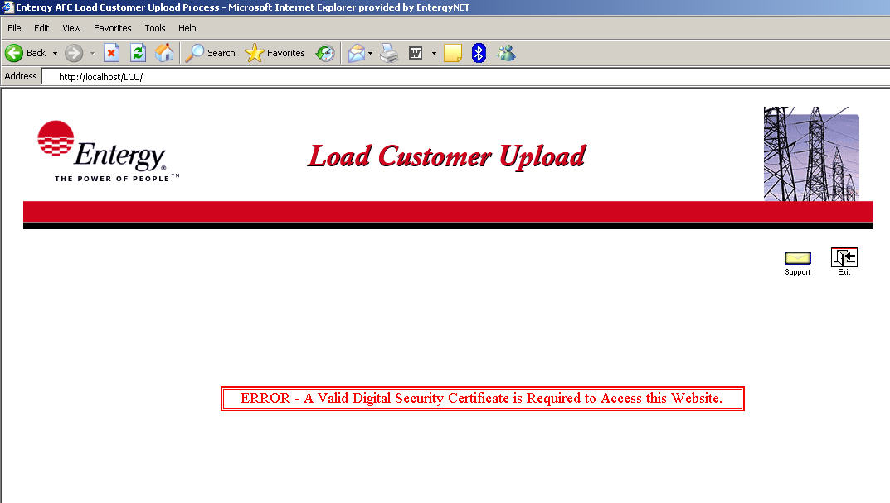
Figure 12.

CONCLUSION

In summary, this document described the following:

- Requirements needed to use the Load Customer Upload (LCU) website.
- How to access and login to LCU.
- Basic steps on selecting and uploading the required files for each of the supported upload methods.
- General rules and requirements for successful file validation.
- Checking validation results for submitted files.
- Uploading validated files into the AFC process.
- Logging Out/Exiting the LCU website.
- Submitting an email request for support to the LCU support team.
- Invalid Digital Certificate display

For additional technical information and requirements, please refer to NC LF UC Data Input Specifications document.

The Entergy Load Customer Upload support team may also be contacted for additional information and assistance by clicking the yellow envelope icon labeled Support in the upper right corner of the LCU website.

